Sustainability and Environment Strategy

2020 – 2023

Introduction
This Strategy sets the basis for developing our key sustainability objectives from 2020 until 2023 under the following ten headings:
- Staff engagement
- Education
- Worker’s rights
- Building works, refurbishment and maintenance
- Emissions & discharges
- Biodiversity
- Travel and transport
- Waste management
- Food
- Water
At the time of this Strategy’s inception, we already have some policies and procedures in place. However, we recognise that we need to make greater efforts with sustainability and the environment. This Strategy is the first step in our improvement journey and will have regard to sector targets and good sustainability practice.

Responsibilities
Responsibility for implementing this Strategy ultimately rests with the Chief Operating Officer. The majority of actions will be with by the Director of Estates and Campus Services, supported by subject matter leads within his team.
This Strategy’s objectives and achievements will regularly be reported to the University’s Operating Board with an annual update to the University Executive Committee and Board of Governors.

Policies and strategies
This Sustainability Strategy derives from our Environmental and Sustainability Policy. It is (or will be) supported by additional policies and sub-strategies including but not limited to:
  - Biodiversity policy
  - Sustainable food policy
  - Sustainable procurement policy
  - Equal access to education policy
  - Strategy for student and staff engagement
  - Strategy for education for sustainable development
  - Carbon Management Plan
  - Green Travel Plan

Organisation
Appendix A shows an indicative approach to sustainability and the environment. This will be subject to amendment and development as the strategy progresses.

Deliverables
Appendix B sets out our key strategic areas and the associated deliverables.

Queries and information
Any queries regarding this Strategy should in the first instance be sent to estates@stmarys.ac.uk
Anthony McClaran  Vice-Chancellor | Jo Blunden  Chief Operating Officer
Version: 1.0
Last updated: 18th March 2021
Next update: 18th March 2022

Appendix A – Indicative organisation
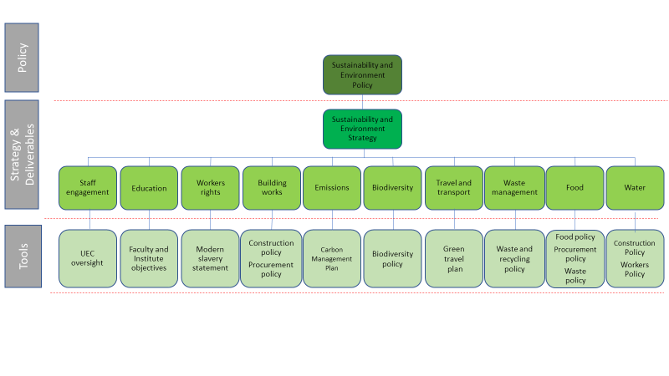

Appendix B – Deliverables

- Staff engagement
Strategic objectives: Ensuring certain employees in key departments will be allocated various initiatives in the area of sustainability. These initiatives will form part of their key objectives.
Deliverables | Timescale | Owner
A member of the University Executive Committee with be assigned a set of responsibilities relating to sustainability. | Spring 2021 | Vice-Chancellor
The names and job titles of the employees, together with the areas of responsibilities relating to sustainability, will be clearly identified on the University’s website. | Spring 2021 | Chief Operating Officer
Key staff to set baseline performance for each area of engagement | Spring 2021 | Chief Operating Officer
Publish and promote sustainability policies on internal and external websites. | Spring 2021 | Pro Vice-Chancellor, Global Engagement
Reintroduction of the Sustainability Group chaired by a member of the Senior Leadership Team. | Autumn 2021 | Chief Operating Officer

- Education
Strategic objective: Greater inclusion of biodiversity within the course content of UG and PGCE teacher training courses.
Deliverables | Timescale | Owner
Education for sustainability will be provided to all staff and students as part of their induction to life on our campuses. | Autumn 2021 | Director of Student Operations
Progress formally introducing and recognising biodiversity in respect of course content when engaging in action plans for all courses. | Summer 2022 | Deputy Provost
Staff and students involved in sustainability research will be recognised as contributing to the University’s excellence in education. | Summer 2022 | Provost

- Worker’s Rights
Strategic objective: Ensuring that pay and benefits are fair, appropriate and transparent
Deliverables | Timescale | Owner
Continue to regularly review both pay and benefits to ensure all staff are rewarded fairly. | Ongoing | Director of Human Resources
Put sustainability and ethical trading as a factor for choosing new suppliers. | Spring 2022 | Chief Financial Officer

- Building works, refurbishment and maintenance
Strategic objective: Managing the University's estate by considering appropriate sustainable construction, energy and water efficiency opportunities in the design, modification, and refurbishment of new and existing facilities and maintenance practices where practical.
Deliverables | Timescale | Owner
Consider the whole life costs for new or replacement mechanical, electrical and building design, including considerations of suitable sustainable technologies and renewable energy options. | Ongoing | Director of Estates & Campus Services
Introduce sustainable technologies wherever possible as an upgrade or replacement to existing installations. | Ongoing | Director of Estates & Campus Services
Ensure future developments on campus do not negatively impact biodiversity and ideally enhance it. | Ongoing | Director of Estates & Campus Services
Wherever possible, we will use contractors and suppliers from Richmond and neighbouring boroughs. | Ongoing | Director of Estates & Campus Services
New buildings will be constructed to exceed the energy performance requirements of Building Regulations (Part L) and be informed by BREEAM Excellent and LEED energy certification. | Ongoing | Director of Estates & Campus Services

- Emissions
Strategic objective: Using the energy necessary to heat and power our buildings as efficiently as possible and reducing the amount of energy derived from fossil fuels.
Deliverables | Timescale | Owner
Optimise energy management to reduce net carbon emissions | Ongoing | Director of Estates & Campus Services
Heat and power usage will fall annually | Ongoing | Director of Estates & Campus Services
Generate 5% of its energy from renewable sources. | Spring 2023 | Director of Estates & Campus Services
CO2 Emissions per FTE student and per m2 will be improve by x% by 2023. | Spring 2023 | Director of Estates & Campus Services

- Biodiversity
Strategic objective: Maintain and enhance our landscapes through monitoring and protecting the species found within them, providing well managed access to our landscapes for students, staff and visitors.
Deliverables | Timescale | Owner
Maintain and enhance our trees, shrubs and planting, introducing new species where possible. | Ongoing | Director of Estates & Campus Services
Protect and enhance our woodland settings, encouraging wildlife to settle. | Ongoing | Director of Estates & Campus Services
Reduce the use of artificial pesticides and herbicides on hard and soft surfaces. | Ongoing | Director of Estates & Campus Services

- Waste management
Strategic objective: Minimise the impact of waste on the environment by promoting and facilitating the consideration of the waste hierarchy (reduce, reuse, recycle, recover, dispose) whilst diverting waste away from landfill where possible and managing waste in a responsible and compliant manner.
Deliverables | Timescale | Owner
Maintain and actively progress a University Waste Strategy. | Autumn 2021 | Director of Estates & Campus Services
Promote paperless committees and meetings. | Autumn 2021 | Chief Operating Officer
Use Information Technology sustainably through use of energy efficient hardware, reducing paper and ink usage. | Ongoing | Chief Information Officer
Recycle over x% of its waste materials. | Ongoing | Director of Estates & Campus Services
Less than x% of waste will be sent to landfill. | Ongoing | Director of Estates & Campus Services

- Travel and Transport
Strategic objective: Encourage sustainable transport through provision and promotion of infrastructure and incentives including and measures to reduce the need to travel.
Deliverables | Timescale | Owner
Increase promotion and provision of alternatives to car use, ensuring improved access cycle maintenance, cycle security and cycle purchase with routine evaluation of impact undertaken. | Ongoing | Director of Estates & Campus Services
Improve washing and shower facilities for general use. | Summer 2022 | Director of Estates & Campus Services
Increase provision of electric vehicle infrastructure with access to charging points at all University car parks. | Summer 2022 | Director of Estates & Campus Services

- Food
Strategic objective: Serve healthy food prepared with minimum harm to nature and human resources as well as ensuring food and packaging waste is minimised.
Deliverables | Timescale | Owner
Promote meat-free alternatives across its catering outlets including daily options. | Ongoing | Director of Estates & Campus Services
Avoid foods derived from endangered species by using Marine Stewardship Council certified fish. | Autumn 2021 | Director of Estates & Campus Services
Ensure that 100% of its meat is Red Tractor assured. | Autumn 2021 | Director of Estates & Campus Services
Source 100% of its eggs from free range sources | Autumn 2021 | Director of Estates & Campus Services
Provide and promote opportunities for food grown on our campuses. | Spring 2022 | Director of Estates & Campus Services
Work towards Fairtrade University status. | Spring 2022 | Director of Estates & Campus Services
Expand use of recyclable or compostable food packaging and significantly reduce catering waste to landfill. | Spring 2022 | Director of Estates & Campus Services

- Water
Strategic objective: Manage our water so that the absolute minimum is used and use rain water for landscaping activities.
Deliverables | Timescale | Owner
Achieve annual reductions in its water use. | Ongoing | Director of Estates & Campus Services
Install low flow devices and auto shut off devices to all outlets. | Winter 2022 | Director of Estates & Campus Services
Invest in Smart Metering to identify excess water usage and leaks. | Winter 2022 | Director of Estates & Campus Services

We are in the process of setting our next emissions reduction target. Please see our Carbon Management Plan 2021 Review document on our website.

