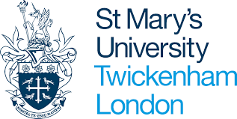

Interview checklist
BA Primary Education with QTS
BA Primary Education with QTS (work-based route) – 2-year top-up programme
Task | Due | Completed
Book interview via applicant portal | Now
Click on red ‘documents – action required” button on portal and upload any missing documents | Before interview
Read guidance on DBS and Fitness to Teach Disclosure | Before interview
Complete Primary Teaching Interview Form | Before Interview
Read the ‘Consent Statement and Use of Recorded Interview’ | Before Interview
Watch the BA Primary Programme Directors video | Before interview
Complete Target Form | Before interview
Email completed Target Form to your interviewer | Friday pm or Monday am before your interview date
Ensure you have two forms of photo ID that you can show your interviewer | Interview date

