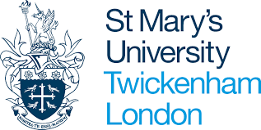

Interview checklist
PGCE Primary with QTS
PGCE Primary with PE Specialism with QTS
PGCE Primary part-time with QTS (April start)

Task | Due | Completed
Book interview via applicant portal | Now
Click on red ‘documents – action required” button on portal and upload any missing documents | Before interview
Read guidance on DBS and Fitness to Teach Disclosure | Before interview
Complete Primary Teaching Interview Form | Before Interview
Read the ‘Consent Statement and Use of Recorded Interview’ | Before Interview
Watch the PGCE Primary Programme Directors video | Before interview
Read the Teachers’ Standards | Before interview
Ensure you have two forms of photo ID that you can show your interviewer | Interview date

