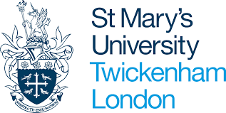

Interview checklist
PGCE Secondary with QTS
Subjects: English, Geography, History, Mathematics, Modern Foreign Language, Physical Education, Chemistry, Physics, Biology and Religious Education
Task | Due | Completed
Book interview via applicant portal | Now
Click on red ‘documents – action required” button on portal and upload any missing documents | Before interview
Read guidance on DBS and Fitness to Teach Disclosure and our Student Agreement | Before interview
Complete Secondary Teaching interview form | Before Interview
Read the ‘Consent Statement and Use of Recorded Interview’ | Before Interview
Watch the general and subject specific videos | Before interview
Complete subject specific preparation task | Before interview
Complete your subject knowledge audit | Before interview
Read the Teachers’ Standards | Before interview
Read the subject requirements of the English National Curriculum for your subject, perhaps look though the examination syllabus too | Before interview
Ensure you have two forms of photo ID that you can show your interviewer | Interview date

