Peer Observation for Professional Development (POPD) policy

Introduction

Peer observation of teaching is recognised across the UK HE sector as a means of enhancing practice through garnering feedback from colleagues, learning from observing others’ work and engaging in open and collegial conversation.

POPD aims to build self-awareness and provide a learning process which encourages peer learning, supports colleagues’ professional development and enhances teaching and student experience. The value of POPD resides in the space it creates for dialogue around pedagogic practice, and the ideas, insights and developments that can emerge through these conversations. The St Mary’s POPD policy is predicated on the sharing and development of practice and the understanding that peer observers are learning from the opportunity of reviewing a colleague’s work as well as offering constructive feedback. The POPD scheme is not to be used as a performance management tool.

This policy document sets out core principles, aims and procedures of the POPD scheme. Colleagues are encouraged to adapt the processes set out here in line with local circumstances. Appendix A includes a sample template to support POPD, and further practical guidance will be available from the CTESS website. Appendix B sets out the consultation process.

Principles

- The primary purposes of the policy are to a) promote sharing of practice and b) support colleagues’ professional development by offering insight into their teaching and pedagogy.
- Teaching observation reports will not be used for performance management purposes.
- All colleagues who teach or directly support student learning (such as colleagues offering academic study support) will be expected to participate in peer observation. This will ensure parity of opportunity and potentially enable closer working between staff in different student-facing roles.
- Peer observers can be selected from either within or outside of a colleague’s own subject specialism or department. Potential advantages of the latter arrangement are that a) the primary focus is on pedagogy (rather than subject content) and b) practices from different disciplines are shared more broadly across the University.
- Members of POPD pairings can be at different stages of their careers and/or at varying levels of seniority. A pairing organised in this manner has the potential to increase the innovative practices and range of experiences to which colleagues are exposed.
- Observation opportunities can be drawn from a wide range of teaching activities including classroom teaching (lectures, seminars), fieldwork, lab sessions, practice-based learning, coaching, personal tutoring meetings (where appropriate and with permission from students), research supervision (with permission from students), online teaching, learning development sessions and similar.
- Reporting and confidentiality: Staff are expected to report their completion of peer observation to their HoD/Dean, but feedback and discussions between participants remain confidential. Only the fact that the observation has taken place is reported.

Objectives and scope of policy

- To support the establishment of a wider culture of collegial working, sharing pedagogic practice and critical reflective dialogue at St Mary’s.
- To support the ongoing professional development of staff in teaching and learning support roles.
- To support staff to identify areas of their own professional development that they would like to prioritise and address in order to maximise their impact on student learning.
- To promote reflexive and creative conversations about teaching, supervision, assessment, feedback and other areas of academic practice.
- To provide a context in which colleagues can build and refine the skills of being an effective observer who can respond to a diverse range of teaching approaches, provide constructive feedback, and learn from observing others.
- To provide a supportive framework within which staff can engage with peer feedback constructively and reflectively.

Policy procedures:

Who is involved?
All colleagues with teaching and student-facing learning support roles (for example, learning development lecturers and English for Academic Purposes tutors) should participate in peer observation activity on an annual basis. It is expected that a 1.0 fte member of staff will engage in peer observation once per year. POPD will be organized on a pro rata schedule for staff on fractional contracts. (For example, a colleague on a 0.5 fte contract will engage in peer observation every two years.) As suggested above, colleagues in different roles can work together in peer observation, so a subject lecturer and a learning development lecturer could observe each other.

How will it work?
- Time for peer observation should be built into work allocation.
- Colleagues can determine at local levels how they would like to undertake peer observation and with whom. For example, there may be selection around what types of activities (classroom teaching, online delivery, assessment and feedback practices) might be peer reviewed; how peer observers will be chosen and whether reviewers work in pairs, trios or small groups. Furthermore, it is important that all parties are comfortable with the observation pairing in order for the activity to be of maximum benefit.
- For those new to peer observation, guidance will be available from CTESS.
- Typically, a peer observation will work on a reciprocal basis with each member of the pair (or small group) acting as the observer and the observed colleague. Ideally, colleagues should both be observed and act as an observer for a peer. However, the minimum expectation is that everyone should be observed.
- Once a pairing has been agreed, colleagues will
  - discuss the timing, context and content of the observation,
  - identify aspects of the teaching that the observed colleague would like to have considered, and
  - undertake the observation.
- The observation will be followed by a feedback conversation in which both colleagues can share impressions of the session/activity being reviewed. The observer will then complete a draft observation report which will be shared with the colleague who has been observed. A final report, including reflections from the observed colleague, is then produced. This report is confidential (see principle 7).
- The observed colleague should report to HoD/Dean that the observation process has been completed.

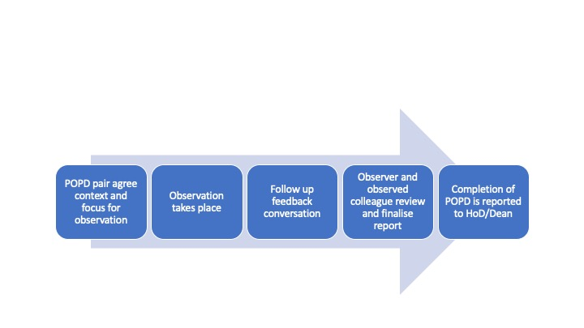
Figure A: POPD process

How will reports be used?
- Teaching observation reports are confidential to the observer and the observed colleague (see principle 7). However, the observed teacher may wish to draw upon a report for evidence to inform HEA fellowship applications and promotion cases.
- Reports can help individuals reflect on achievements and identify and prioritise areas for future CPD.

How will POPD be monitored and reported?
- Heads of Departments should champion the POPD policy and ensure that engagement is monitored via the recording of completion rates. Copies of observation reports should not be requested.
- Heads of departments should submit an end of year report on peer observation to their Dean/Director.
- Deans/Directors should ensure this annual report is reported to their relevant IADC/FADC.
- ADC should provide a copy of this report to Academic Board to demonstrate effective implementation and evaluation.

Definitions

CPD – Continuous professional development

Observer - the colleague who reviews the activity and provides constructive feedback. Typically, the observer will initiate a debrief conversation following the observation and will subsequently write a report. (See Appendix A for a sample form.) A colleague can act as observer for multiple peers.

Observed colleague - the colleague whose work is being reviewed.

Peer observation - process of reviewing teaching and learning support. Typically, the observer and observed colleague will agree an activity to be reviewed, identify areas for consideration in advance and meet following the activity to share findings.

Review and Update
This policy will be reviewed by CTESS regularly.

The term ‘pairing’ is used throughout the document because this is likely to be the default arrangement. However, colleagues may choose to work in trios or small groups to undertake observations.
Exemption from confidentiality will apply only where there is an overriding reason enshrined in law or University policy, e.g. if the observed practice raises concerns about staff misconduct or safeguarding.

