HEA Senior Fellow – planning template
Applications for Senior Fellow must evidence all five Areas of Activity as well as all the Core Knowledge and all the Professional Values (see below)
Portfolio section | Ideas | Evidence I could use
Reflective account of professional practice
Approx. 2000 words

Case study 1
Approx. 2000 words

Case study 2
Approx. 2000 words

Think about…
Which submission date will you aim for? February 24th or June 1st
Who will you approach to write your supporting statements? The Senior Fellow portfolio requires two supporting statements, one of which must be Fellow or above of the HEA. Your portfolio is only considered complete with the supporting statements. Templates for supporting statements are available on Moodle or direct from Laura Minogue laura.minogue@stmarys.ac.uk
HEA Fellowship information 2019-2020
UK Professional Standards Framework (UKPSF)
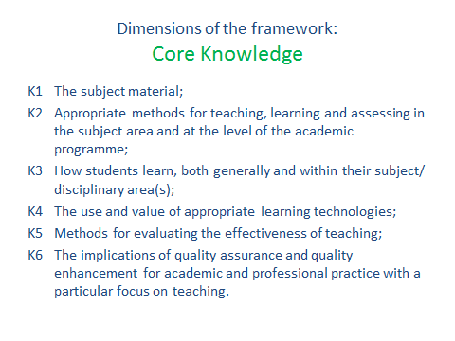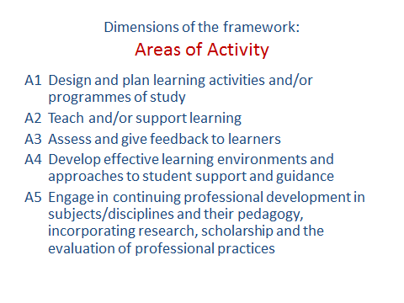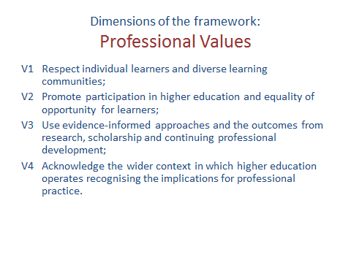
For all academic and learning support staff interested in submitting a portfolio this year for Associate, Fellow or Senior Fellow of the HEA, please see below for the submission dates for 2019-2020:
Monday 25th November
Monday 24th February
Monday 1st June
Please note that portfolios will only be accepted if they are complete i.e. contain all required written sections including evidence, supporting statements and teaching observation (for Fellow only). Portfolios should be emailed to Laura Minogue, Senior Lecturer in Academic Practice in CTESS, laura.minogue@stmarys.ac.uk by 5pm on the submission date.
The CPD route to Fellowship is accredited by Advance HE. Once submitted your portfolio will be reviewed by Senior Fellows of the HEA at St Mary’s. The aim is that somebody outside your department will review your portfolio. All portfolios are then considered at a panel convened by CTESS and attended by our External Examiner. You are strongly recommended to share a draft of your portfolio with Laura Minogue or another member of CTESS before submitting as this way we can ensure that your submission is fully developed.
A series of induction and progress workshops is available to support your progress. If you are thinking of starting your portfolio or have had a long break then you should attend one of the induction workshops. Please contact Laura Minogue if you have any questions. Room N46 / 020 8240 8202 / laura.minogue@stmarys.ac.uk

