New Programme Approvals
in SITS e:Vision

User Guide

May 2021
v1.0

Contents
Using the New Programme Proposal tool 4
Accessing the Curriculum Management portal in SITS e:Vision 4
General guidance and tips 4
Understanding the Curriculum Management portal homepage 6
1. Programmes and Modules 6
2. Messages 6
3. Search and Reports 7
4. Curriculum Approval Notifications 7
ONE PAGE GUIDE FOR PROPOSERS TO COMPLETING A PROGRAMME PROPOSAL 8
FULL PROGRAMME PROPOSAL GUIDE 9
1 PROPOSAL KICK-OFF 9
2 PROGRAMME DEVELOPMENT TEAM 10
3 COLLABORATIVE PROVISION 12
3.1 Arrangements for collaborative delivery 12
4 PROGRAMME PROPOSAL 13
4.1 Programme Overview tab 13
4.2 Award Type 15
4.3 Professional Accreditation 16
5 PROPOSED PROGRAMME STRUCTURE 17
5.1 Course structure 17
5.2 Add existing modules (i.e. currently approved) into programme structure 18
5.3 New Module details 19
5.4 MAV Details 22
6 PROGRAMME RESOURCING 25
7 MARKET ANALYSIS 27
8 STUDENT & EMPLOYER CONSULTATION 28
9 RECRUITMENT AND MARKETING 28
10 PROPOSAL SUBMISSION 29
11 PROGRAMME RESOURCING FEEDBACK 30
11.1 Proposal information 32
11.2 Supporting Documents 33
11.3 Decision 34
11.4 Submit 34
12 QS APPROVAL TO PROCEED 35
12.1 Set the Course Code 35
12.2 Decision 37
12.3 Submit 38
13 FACULTY EXECUTIVE APPROVAL 38
13.1 Decision 39
13.2 Submit 39
14 INITIAL PROPOSAL WORKSHOP 41
14.1 Submit 41
15 PROGRAMME ENHANCEMENT STRATEGIES 43
15.1 Submit 44
16 CTESS APPROVAL OF PROGRAMME ENHANCEMENT STRATEGIES 45
16.1 Decision 45
16.2 Submit 46
17 SUBMISSION TO FADC 47
18 FADC FEEDBACK ON PROPOSAL 48
18.1 Decision 48
18.2 Submit 49
19 FADC APPROVAL 50
19.1 Decision 51
19.2 Submit 51
20 ADVERTISE SUBJECT TO VALIDATION 52
20.1 Decision 53
20.2 Submit 53
21 ADVERTISE SUBJECT TO VALIDATION 54
22 PROGRAMME DEVELOPMENT 55
22.1 Submit 55
23 FADC SUBMISSION OF DRAFTS 56
23.1 Submit 56
24 FADC APPROVAL OF DRAFTS 56
24.1 Submit 56
25 QS APPROVAL POST FADC RESUBMISSION 57
25.1 Decision 57
25.2 Submit 58
26 APPROVAL EVENT DECISION 59
27 APPROVAL FOLLOW UP COMPLETED 59
28 ADC DECISION 60
29 ACADEMIC BOARD DECISION 60
30 PROGRAMME SPECIFICATION 61

Using the New Programme Proposal tool

Accessing the Curriculum Management portal in SITS e:Vision
- Go to https://evision.stmarys.ac.uk/ using your web browser
- Click Staff and Student Portal Log in
- Enter your St Mary’s username and password, then click Log in and you will be taken into e:Vision
- Click Curriculum Management at the top of the screen if necessary
- You will then see the New Programmes & Validations button. Click this to begin your programme proposal.

General guidance and tips

1. Always use the onscreen buttons to move forward or backwards through your proposals. The ‘Back’ button on your browser will not work:

2. As you progress through a proposal, more tabs become available at the top of the page that link you back to the previous stages of a proposal. Use these to move to different stages if you need to:
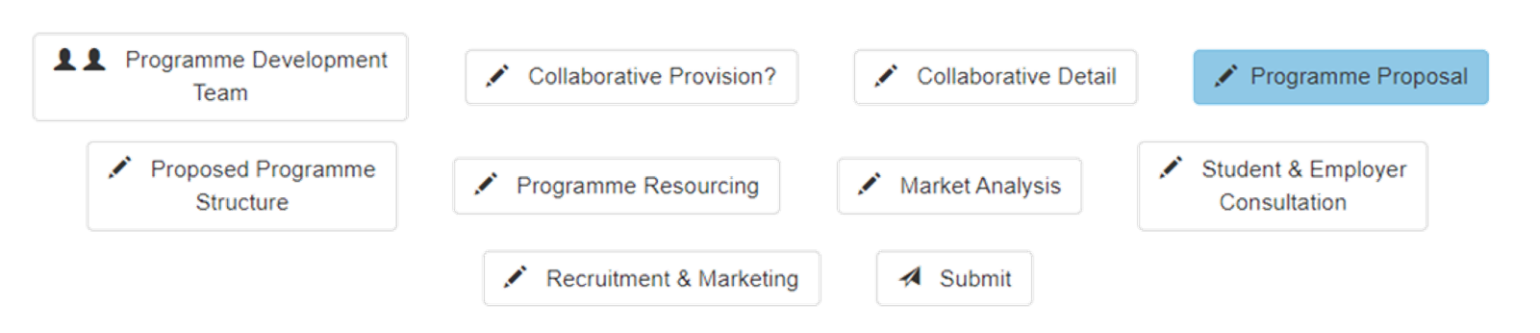

3. All fields with red shading must be completed, and questions with stars (*) must be answered:

4. Always click Store Changes when the button is available, or you may loose the information you have entered:

5. Use the text formatting options if you need to help present information more effectively. If you are pasting from Word or elsewhere, select your pasted text then choose ‘Big’ or ‘Small’ from the Formatting Styles list (where the word ‘Inserted’ appears – otherwise, your text will appear underlined when displayed (it reverts to the formatting for ‘inserted’ text).
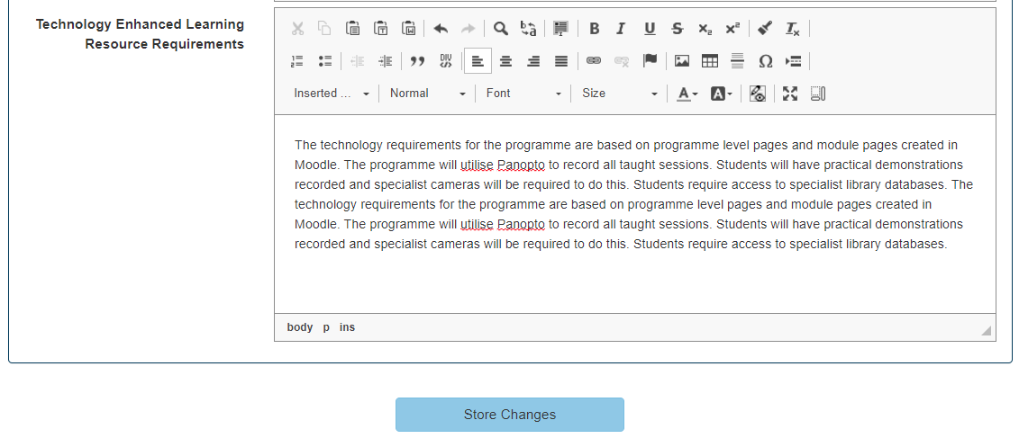

Understanding the Curriculum Management portal homepage

The Curriculum Management portal is structured around the following five sections. Not all are visible to all users.

1. Programmes and Modules
This contains the link to start a new programme approval via the New Programmes & Validations button
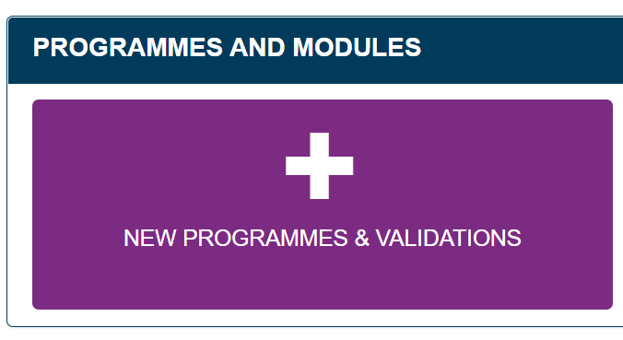

2. Messages
Curriculum Approval Proposal Tasks
The messages that appear here require action to be taken by you or your colleagues in the same user group. These include continuing to work on a proposal, provide feedback or give an approval decision. The message at the top of the screen is the most recent. When you click Open you are taken to relevant part of the process.
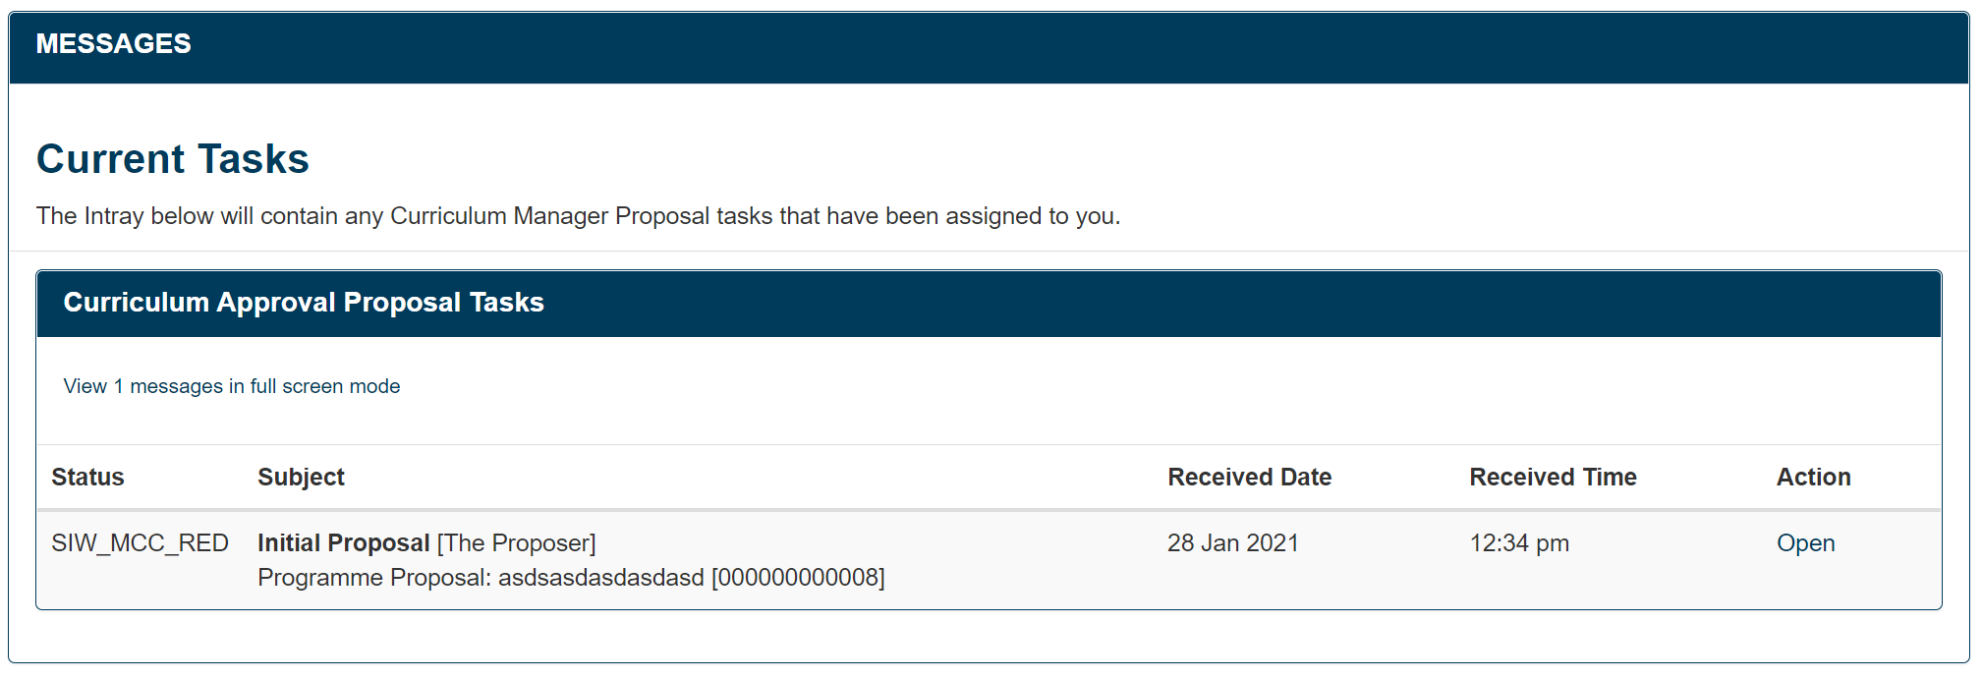

3. Search and Reports
Deployment
The deployment feature is used by the Q&S team to move an approved programme from the temporary planning area into the live environment. It is not used by other members of the Programme Development Team or any Approver.

Course Proposal Report
This gives access to information about all programmes that are currently being developed. Use the search boxes to narrow your search as required. Basic information about programmes meeting your search criteria are shown in the search results:

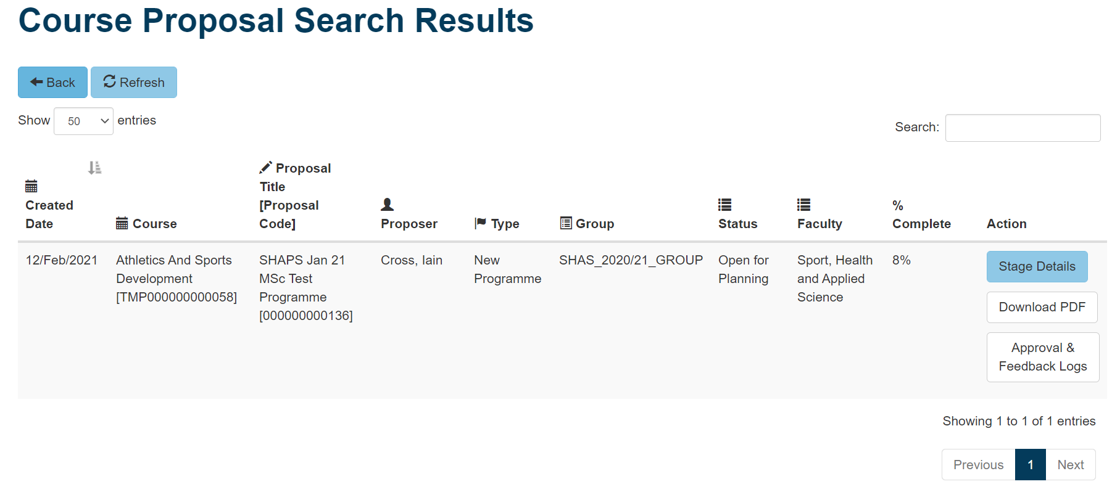
There are different options to view more information about the programme:
- To view information about the current status of a programme, and it’s stage in the approval process, click Stage Details.
- To view a copy of the proposal in its current state of development, click Download PDF
- To view a list of all the approvals given for a programme proposal, click Approval & Feedback Logs. This will also show basic information / comments provided by the approvers (if they have left any)

4. Curriculum Approval Notifications
Messages that appear here are only for notification – for example, when your proposal has been approved and progressed to the next stage of the development process. Click Open to view the details of the message.

ONE PAGE GUIDE FOR PROPOSERS TO COMPLETING A PROGRAMME PROPOSAL

Click underlined text to view full information for each section.
- Log in to e:Vision at
- Click CURRICULUM MANAGEMENT at the top of the screen
- Click the purple button New Programmes & Validations
- Enter a name for the new proposal, click Continue and select the programme type and Faculty/Department information. Click Continue (see: 1 PROPOSAL KICK-OFF)
- Add members of the PROGRAMME DEVELOPMENT TEAM (2); click Store then Next.
- Provide information if the programme is COLLABORATIVE PROVISION; choose Yes or No; if yes complete the further questions, click Store Changes then Next.
- Complete the information about the proposed programme in the PROGRAMME PROPOSAL tab; complete all fields, click Store Changes then Next and progress to the next tab.
  - Complete the Course Qualification Aim data, then Store Changes then Next.
  - Add any accreditations by clicking Add Record then completing the fields. Click Store Changes then Next.
- Under the PROPOSED PROGRAMME STRUCTURE tab, choose the course length, enter entry points (noting whether this is a St Mary’s or ‘NOT St Mary’s’ entry point), choose mode of attendance and whether there is a Foundation Year (i.e. year 0) for the programme. Click Update.
  - Click Add Module to add an existing module to the programme structure. In the search box, use the module code to locate the module you want; click Search, then click the Select tickbox adjacent to the relevant module(s). Choose Apply to all entry points? if appropriate. Click OK and repeat for each module to be added.
  - Add a new module by clicking on the New Modules tab then the New Module Proposal button. Answer all questions, click Store Changes then Next. Add the module availability data then click Next; if necessary click Add Record to add further module availability records, then Store Changes then Next.
  - Click Submit if all fields are completed, then Continue, then repeat to add new modules. Click Next when all modules have been added.
- Complete all of the information required on the PROGRAMME RESOURCING tab. Use the file upload to locate and store the completed finance template. Click Store Changes then Next.
- Complete all of the information required on the MARKET ANALYSIS tab. Use the file upload to locate and store the required documents. Click Store Changes then Next.
- Complete all of the information required on the RECRUITMENT AND MARKETING tab. Use the file upload to locate and store the required documents. Click Store Changes then Next.
- Check all sections are complete; any missing sections are shown with a red cross, and can be quickly located using the link under the Tab column. Correct the missing information then choose the Submit tab at the top of the screen and then click Submit underneath the checklist.
- The proposal is send to professional services colleagues for feedback. Check your Curriculum Management inbox for further notifications about the proposer.

FULL PROGRAMME PROPOSAL GUIDE

PROPOSAL KICK-OFF
F Proposer
Information | Required? | Data type | Brief guidance
Proposal title | Yes | Text | Provide a name for the proposal (as per the guidance provided on-screen)
- Click Continue
Type of programme | Yes | Drop-down | Select the programme template that matches the type of programme being proposed
Owning Faculty and Department | Yes | Drop-down | Enter the Faculty / Institute and Department (if required) with responsibility for the programme
- Click Continue

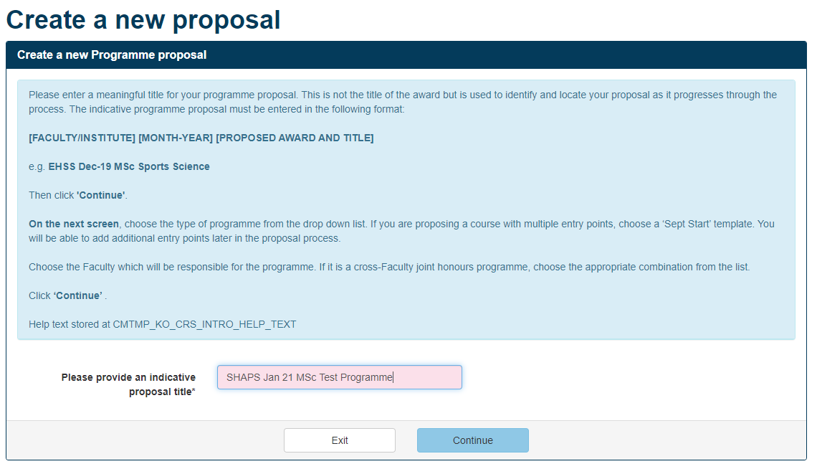

PROGRAMME DEVELOPMENT TEAM
F Proposer
Information | Required? | Data type | Brief guidance
Programme Development Team | Yes | Search look-up | Choose colleagues to add to the programme development team. Anyone added here will be able gain access to the proposal and receive notification messages about its development and approval
- Click Add to add members, then click Store to save changes THEN / OR
- Click Next

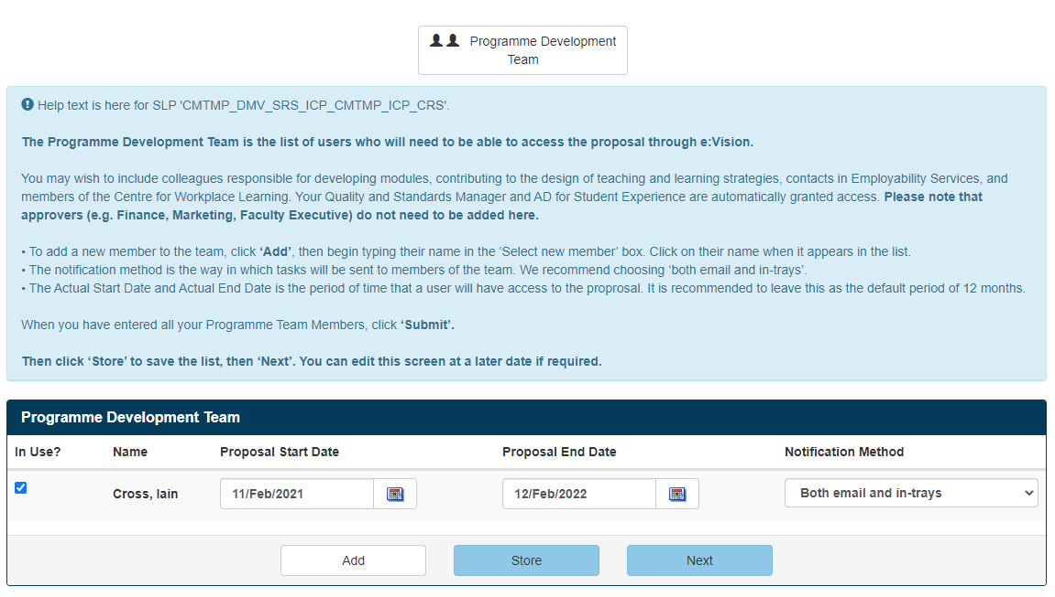

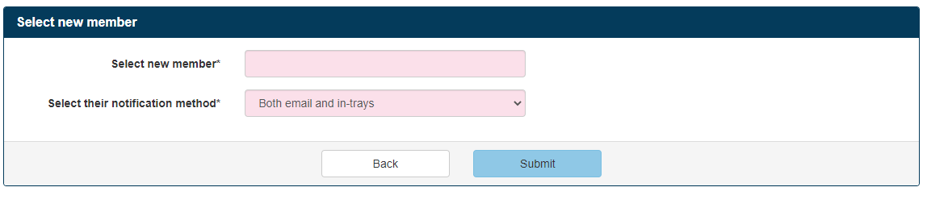

COLLABORATIVE PROVISION
F Proposer
Information | Required? | Data type | Brief guidance
Collaborative provision? | Yes | Yes / No | State whether proposal is for collaborative delivery or not.
- Click No then Next and progress to next screen OR
- Click Yes then Next

Arrangements for collaborative delivery
Owning Department | Only if collaborative | Drop-down | Choose department with responsibility for the collaboration
Partner institution | Only if collaborative | Text | Full name of the collaborative partner
Type | Only if collaborative | Drop-down | Choose type of collaboration
- Click Store Changes then Next

PROGRAMME PROPOSAL
F Proposer

Programme Overview tab
Information | Required? | Data type | Brief guidance
Programme Long Title | Yes | Text | Enter a name for the programme to help locate it in searching the approvals tool
Full name of proposed programme | Yes | Text | Enter the title of the programme (as will be given on the degree certificate)
Proposed start dates | Yes | Date Picker | Proposed start date: use first day of month e.g. ‘1 September 24’ for Sept. ’24.
Mode of study | Yes | Drop down | Choose main mode of study (e.g. full-time)
Mode of delivery | Yes | Drop down | Choose main mode of delivery (e.g. face to face)
Joint Honours? | Yes | Yes / No | Specify whether available as joint honours combination
Details of joint honours | Only if JH | Text | Specify details of JH combinations, and where applicable any limitations on accreditation for each combination
Programme Aims | Yes | Text | Enter programme aims
Programme Description | Yes | Text | Provide a short description of the programme that can be used in external marketing
Programme Learning Outcomes | Yes | Text | A numbered list of programme learning outcomes
- Click Store Changes then Next to progress to next tab (Award Type)

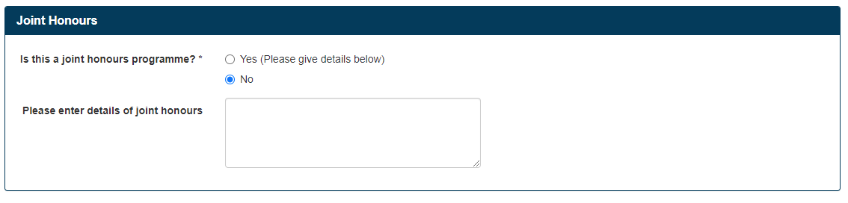
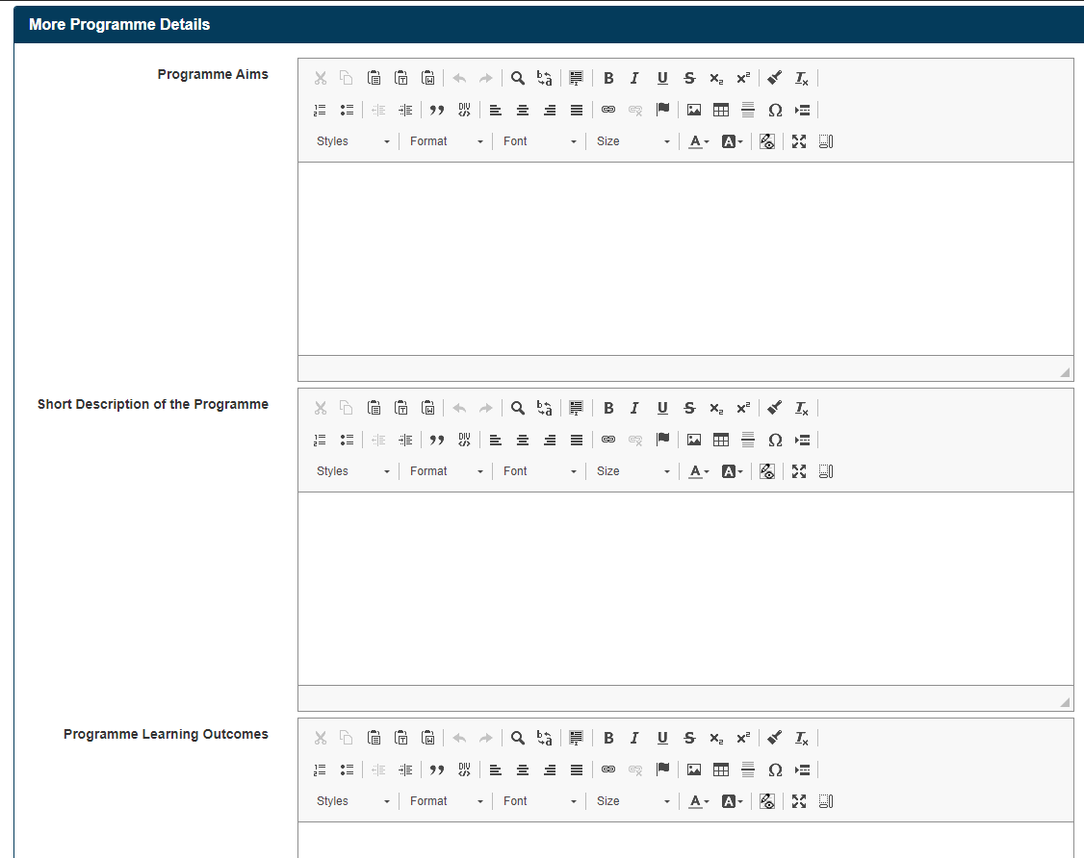

Award Type
Information | Required? | Data type | Brief guidance
Qualification Aim | Yes | Drop-down | Choose the qualification aim from the list. This should be full or highest level award that can be achieved (i.e. do not input step-off or interim awards)
Award | Yes | Drop-down | Choose the type of award (e.g. BSc, MSc)
Awarding Institution | Yes | Drop-down | Choose the awarding body (typically St Mary’s University, Twickenham)
- Click Store Changes then Next to progress to next tab (Accreditation)

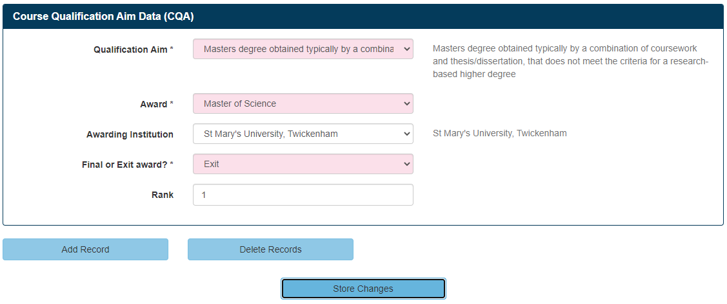

Professional Accreditation
Information | Required? | Data type | Brief guidance
- Click Next if no accreditation details to be added and move on to next stage
- Click Add record to add accreditation details
Professional body | Only if accredited | Drop-down | Name of the PSRB
Accreditation | No | Leave blank
URL link to accreditation | Only if accredited | Text | Provide a link to the PSRB’s accreditation webpages
Specific requirements | Only if accredited | Text | Describe the requirements for accreditation e.g. required modules, programme resources etc.
- Click Create then select In use? then click Store Changes
- Add additional accreditations by clicking Add Record
- Move on to next stage by clicking Store Changes then Next

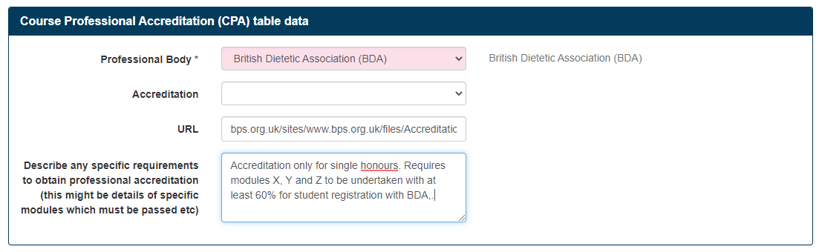

PROPOSED PROGRAMME STRUCTURE
F Proposer

Course structure
Information | Required? | Data type | Brief guidance
Course Length | Yes | Drop-down | Length in years of proposed programme
Entry points | Yes | Multiple choice | Add entry all points (e.g. September, January) and location of delivery (e.g. St Mary’s, NOT St Mary’s)
Mode of attendance | Yes | Drop-down | Select mode of attendance (typically ‘Full-Time’)
Foundation Year? | No | Tick box | Select if a Year 0 / foundation year is available for the proposed programme
- Click Update to update the programme structure that is created below

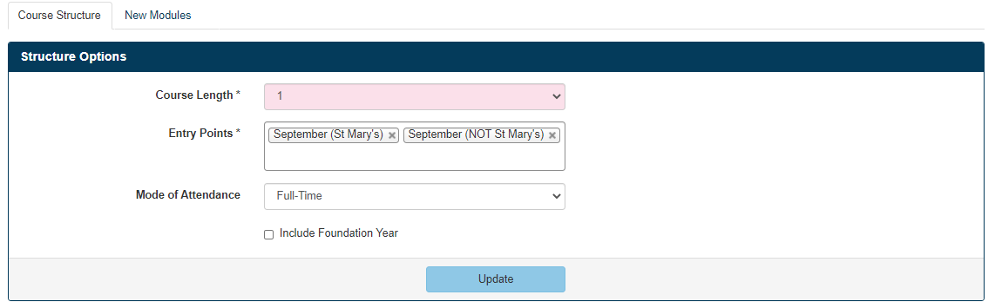

Add existing modules (i.e. currently approved) into programme structure
Information | Required? | Data type | Brief guidance
Module code(s) | Yes | MAV search | Search for the MAV for the module you wish to add by the module code
Apply to all entry points? | No | Tick-box | Use this option to add the selected module to all entry points on the programme
- Select the Year / Occurrence (entry point) that you are adding a module to (if a module is for all entry points it does not matter which you select)
- Click Add Module, and enter the Module (MOD) Code. Click Search and select the module from the results. Click Apply to all entry points if this is required. Click OK to add to the programme structure.

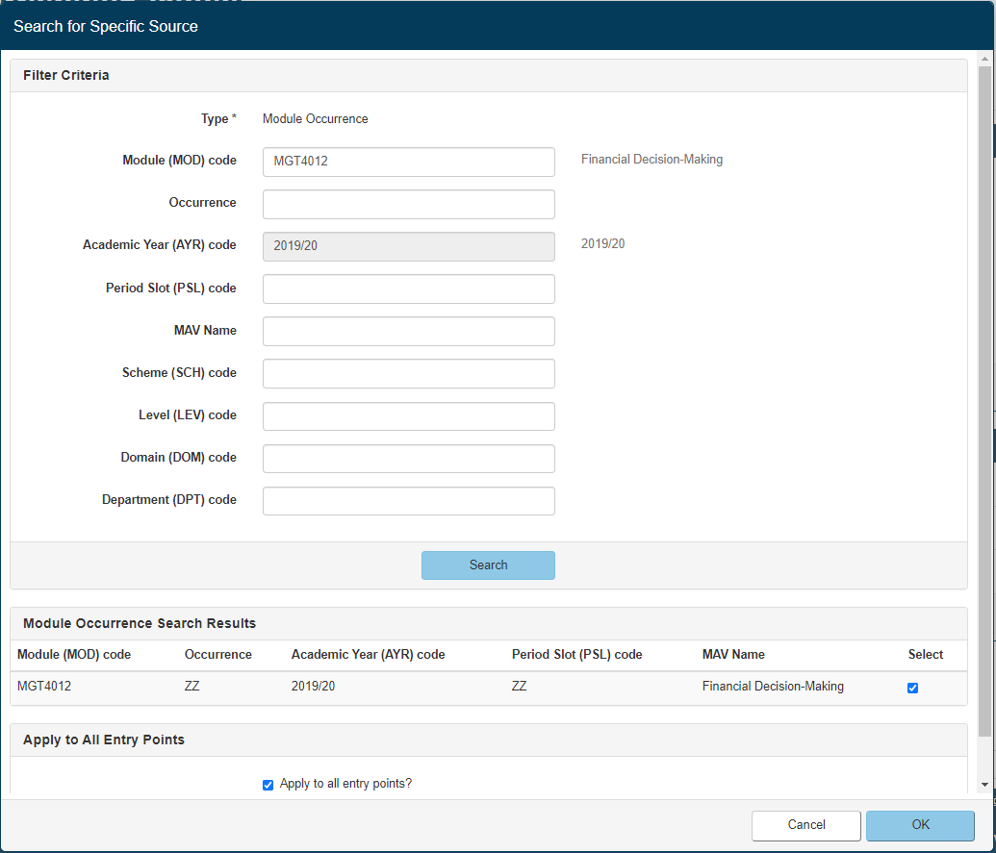

- Choose the selection status (either ‘Core’ or ‘Option’) for each occurrence of the module
- To remove a module click the Select tick box then Remove Selected
- Click Store Changes then Next to move on to next stage

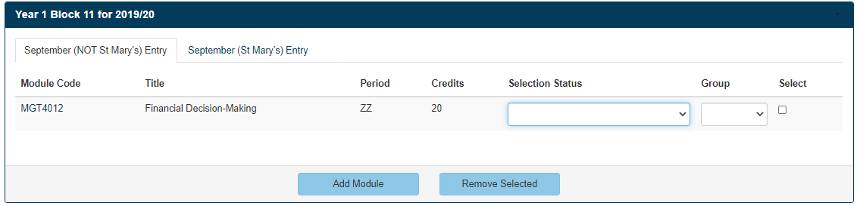

New Module details
Information | Required? | Data type | Brief guidance
Module title | Yes | Text | Add the module title (no module code required)
Owning Faculty / Institute | Yes | Drop-down | Change if necessary
Owning Department | No | Drop-down | Choose if required
Credit Weighting | Yes | Numeric | Enter number of credits
FHEQ Level | Yes | Drop-down | Enter the FHEQ level of the module
Use on more than one programme? | Yes | Yes / No | If the module is intended to be offered on other programmes choose ‘yes’
Name the programmes... | Only if for more than one prog. | Text | Provide the name of the programmes and state whether it will be core or option for each programme
- Click ‘New Modules’ then New Module Proposal. You now leave the main Programme Approval workflow to set up a new module

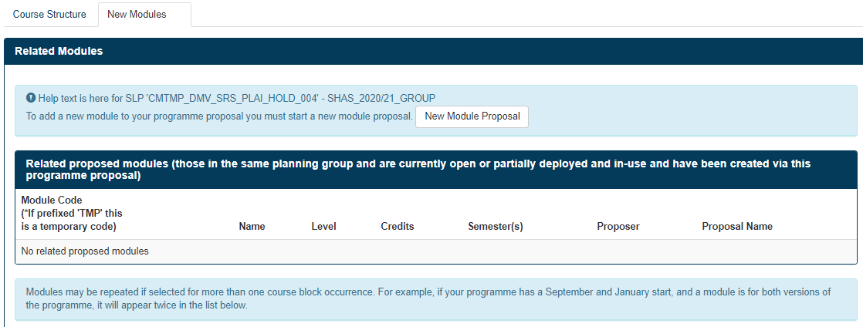
- Enter required information about the new module, then click Store Changes then Next to progress to the Module Availability data screen

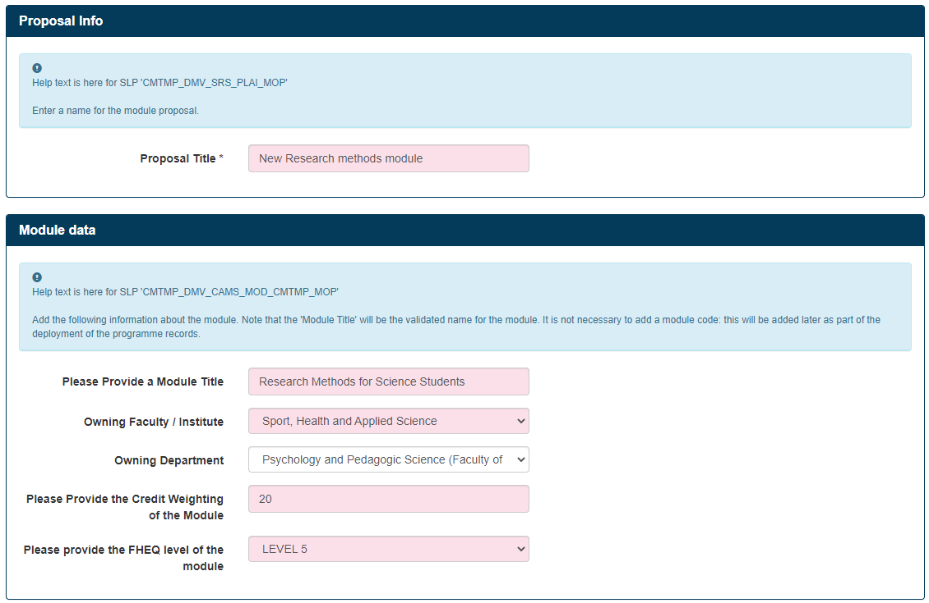
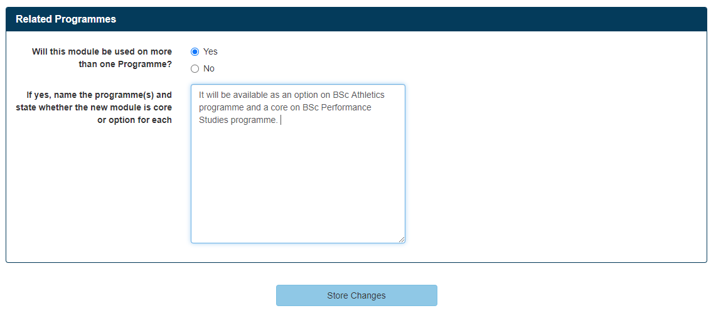

MAV Details
Information | Required? | Data type | Brief guidance
Occurrence | Yes | Drop-down | Choose the occurrence option for the module
Academic Year | Yes | Drop-down | Choose the first academic year the module will be delivered in
Period | Yes | Drop-down | Choose the semester of delivery
- Enter required information about the module availability, then click Create.
- Repeat the process as required if additional MAV records need to be set up (e.g. if the module will be delivered at multiple collaborative partners).
- Click Next to progress to the Submit stage

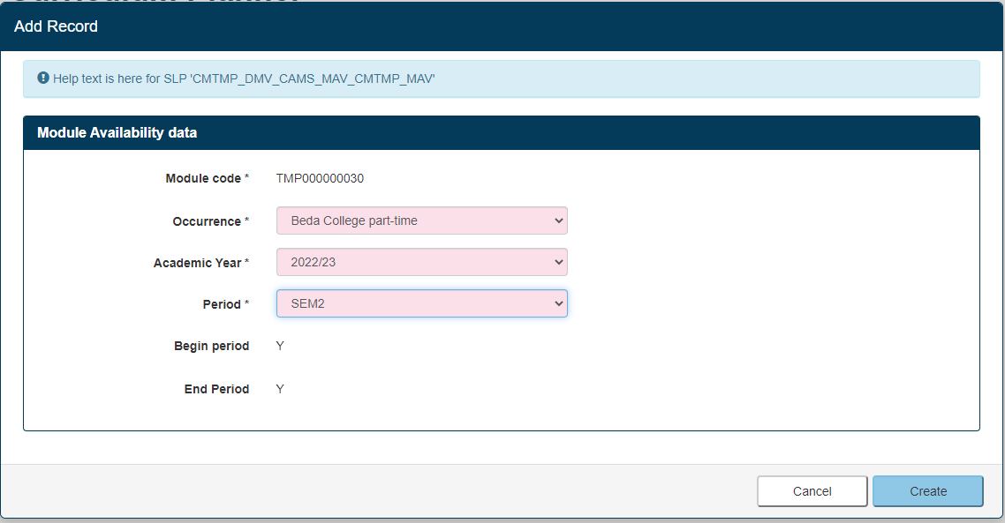

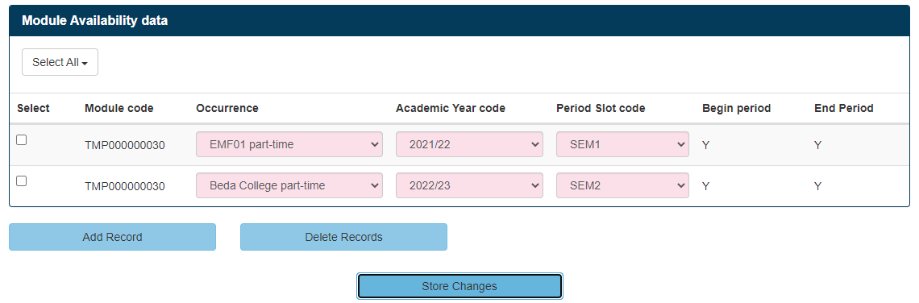
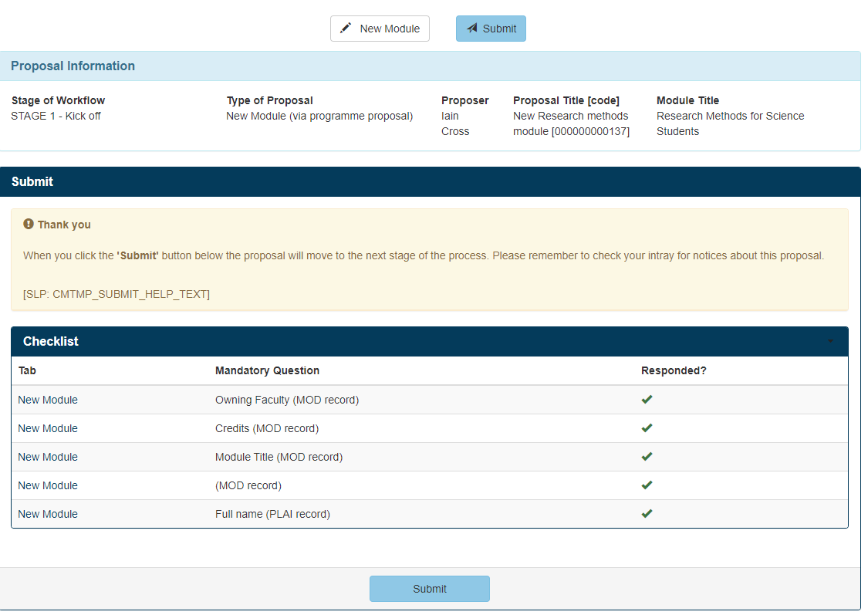

- Click Submit

TIP: You need to click the Submit button at the bottom of the screen

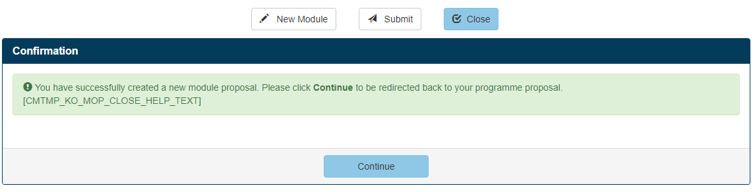
- Click Continue to return to your Programme Proposal
- The new module is now available under ‘Related proposed modules’ in the ‘New Modules’ tab
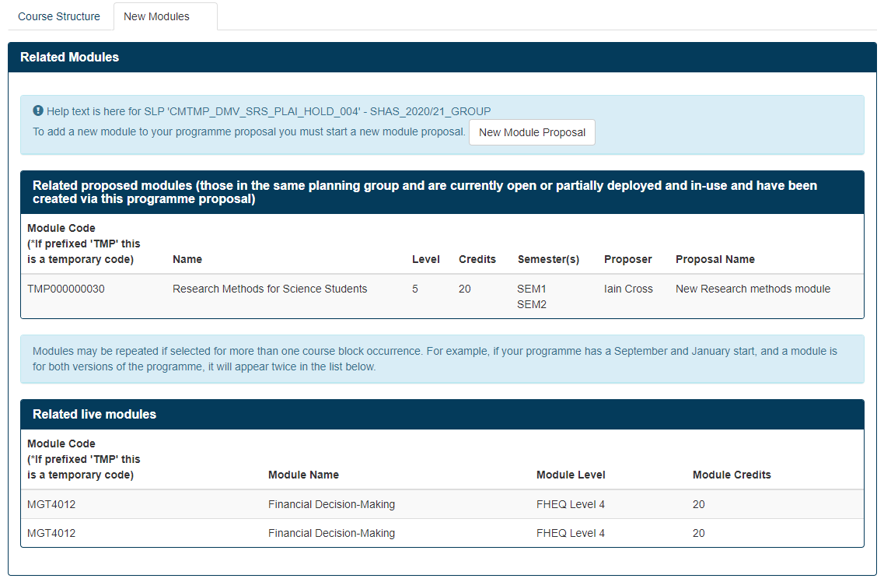

- Repeat the ‘New Module Proposal’ process as many times as required.
- Click Next to progress to the Programme Resourcing stage

PROGRAMME RESOURCING
F Proposer
Information | Required? | Data type | Brief guidance
Upload Finance Template | Yes | File upload | Upload the completed and agreed finance template
Commentary on programme costing | Yes | Text | Brief explanation of the finance template and any explanatory details e.g. projected growth, additional costs etc.
Staff resourcing requirements | Yes | Text | An explanation of how the programme will be staffed (academic, support and technical roles)
Library resources requirements | Yes | Text | A brief overview of the requirement for library resources (e.g. online resources, journals, books). To be completed in consultation with Library Services.
Estates & Timetabling | Yes | Text | Brief discussion of teaching spaces (including specialist spaces) required. To be completed in consultation with Estates and Timetabling teams
IT requirements | Yes | Text | Brief discussion of IT resources (including specialist equipment and / or software) required. To be completed in consultation with IT team
Additional requirements | No | Text | Any further requirements to enable programme to be delivered not captured elsewhere
Technology Enhanced Learning Resource requirements | Yes | Text | Brief discussion of TEL resources (including specialist equipment and / or software) required. To be completed in consultation with TEL team
- Click Browse My Computer to open a file picker window
- Choose the Programme Costing template you have completed, then click OK to upload it

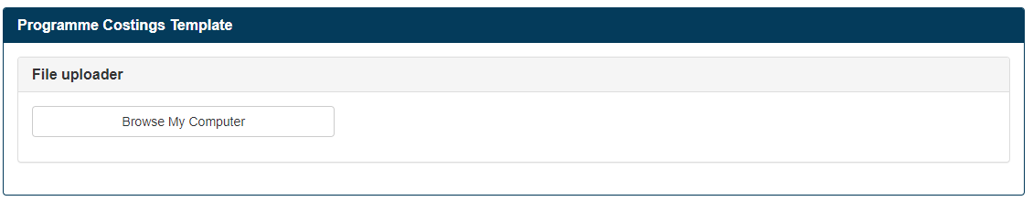
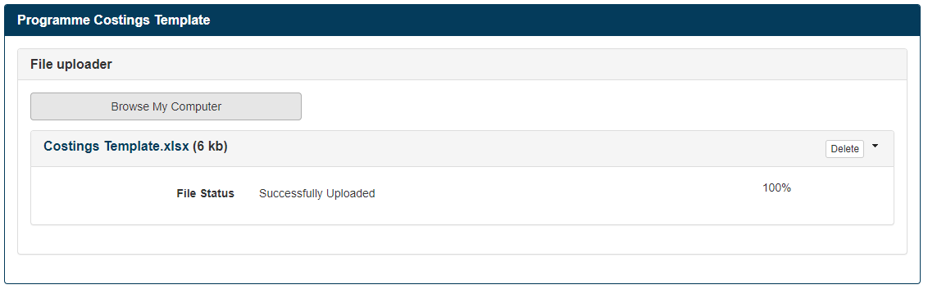

TIP: Click the file name to download and view the file, or if you need to upload a different file click Delete and re upload

- Complete each of the Details boxes below
- Use the formatting features (e.g. bullets, headings etc.) where required

- Click Store Changes when you have completed each of the boxes.
- Click Next to progress to the Market Analysis stage

MARKET ANALYSIS
F Proposer
Information | Required? | Data type | Brief guidance
Alignment with Faculty strategic plans | Yes | Text | Explain how the programme aligns to the Faculty / Institute strategic plans
Alignment to St Mary’s Vision 2025 | Yes | Text | Explain how the programme aligns to Vision 2025
Discussion of HEIDI+ data | Yes | Text | Provide an overview of the key features of the HEIDI+ plus data. This should be done in consultation with the Marketing Consultant
Upload Market Analysis Report | Yes | File upload | Upload the Market Analysis Report
Upload UCAS Trends Report | UG programmes only | File upload | Upload the UCAS Trends report
- Complete the text boxes using formatting as required
- Select the Upload Document Type using the drop down menu, then click Browse My Computer to find the file and upload

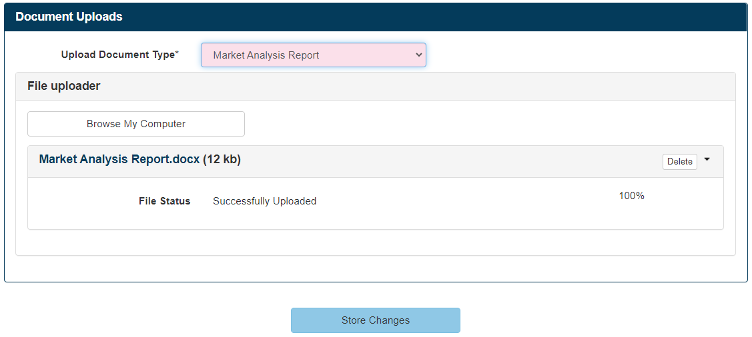

- Click Store Changes when you have completed each of the boxes.
- Click Next to progress to the Student & Employer Consultation stage

STUDENT & EMPLOYER CONSULTATION
F Proposer
Information | Required? | Data type | Brief guidance
Upload Student Feedback | Yes | File upload | A summary of discussions with students about the proposal should be uploaded, including the impact of student feedback on the programme design
Upload Employer Feedback | Yes | File upload | Evidence of feedback from employers about the programme proposal
Feedback from Employability Consultation | Yes | Text | A summary of discussion with the Careers Service about the programme design and approaches to maximise graduate employability
- Complete the text boxes using formatting as required
- Select the Upload Document Type using the drop down menu, then click Browse My Computer to find the file and upload
- Click Store Changes then Next to progress to the Recruitment & Marketing Stage

RECRUITMENT AND MARKETING
F Proposer
Information | Required? | Data type | Brief guidance
Proposed marketing strategy | Yes | Text | An outline of the intended marketing strategy for the programme
Target market | Yes | Text | An explanation of the target market for the programme
Proposed student intake (single & joint honours) | Yes | Text | An estimate of the recruitment target for the programme (or for both single and joint honours where appropriate). This should reflect the targets used in the financial modelling
Contribution to international recruitment | Yes | Text | A summary of how the programme contributes to international student recruitment
Proposed entry requirements (home and international) | Yes | Text | The proposed entry requirements for home and international students. Add detail as required for e.g. Foundation Year, joint honours.
- Complete the text boxes using formatting as required
- Click Store Changes then Next to progress to the submission stage

PROPOSAL SUBMISSION
F Proposer
- No information or data is added at this stage
- Review the checklist to ensure that all compulsory sections have been responded to:

ü: Stage is completed and all information is present
û: Details are missing; proposal cannot be submitted until complete

- Click the Tab column of the appropriate row to navigate to the page with missing data; click Store Changes after adding information into any stage

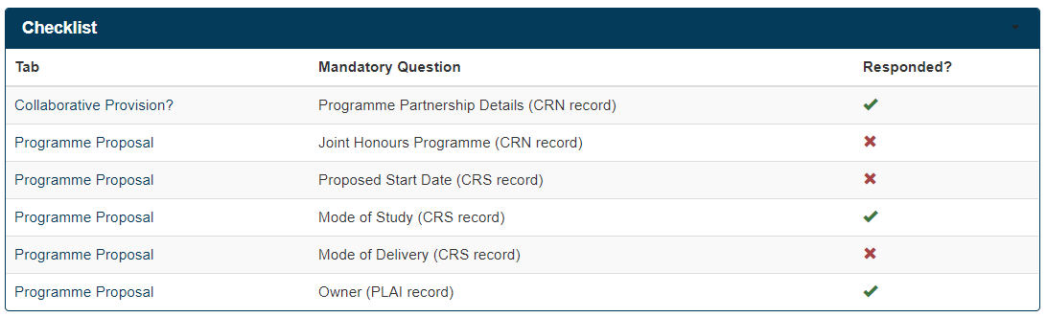

TIP: Use the tabs at the top of the screen to navigate through the proposal to complete missing information or view / edit current proposal details

Return to the Submit tab to review checklist and advance to the next stage

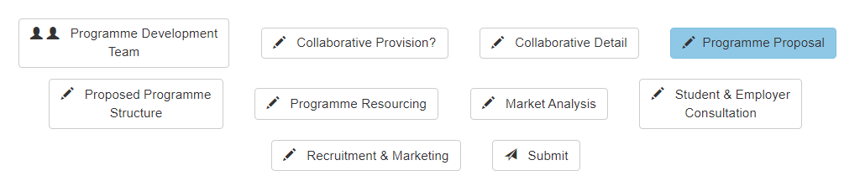

- Click Submit when you are happy your proposal is complete. Approvers will receive a notification that they need to view the proposal and contribute feedback. You and members of the Programme Development Team will receive a notification when feedback has been given. (NOTE: these notifications are in the Curriculum Management tool only; there are no emails sent at this stage – you may need to follow up with a reminder to encourage feedback to be given).
- Click Close at the bottom of the screen when you receive the confirmation of submission

PROGRAMME RESOURCING FEEDBACK
F Professional Services
- Click Open against the message in your Curriculum Approval Proposal Tasks window in e:Vision Curriculum Management

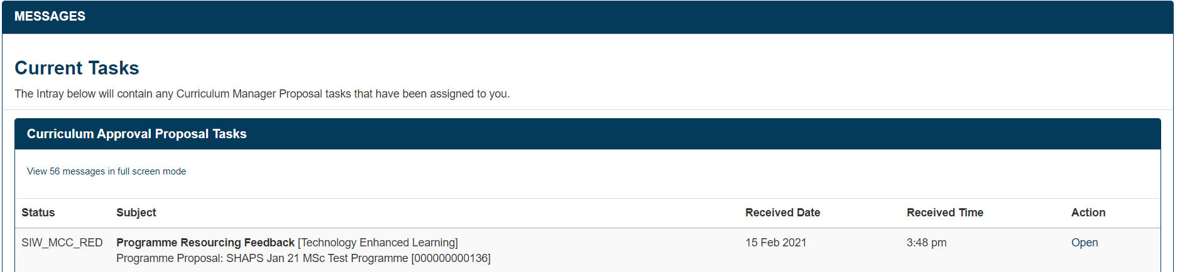

- Click the tab at the top of the screen to go direct to a specific section of the Programme Resourcing Feedback stage, or click Next to advance through the tabs.
- Review the contents of the proposal

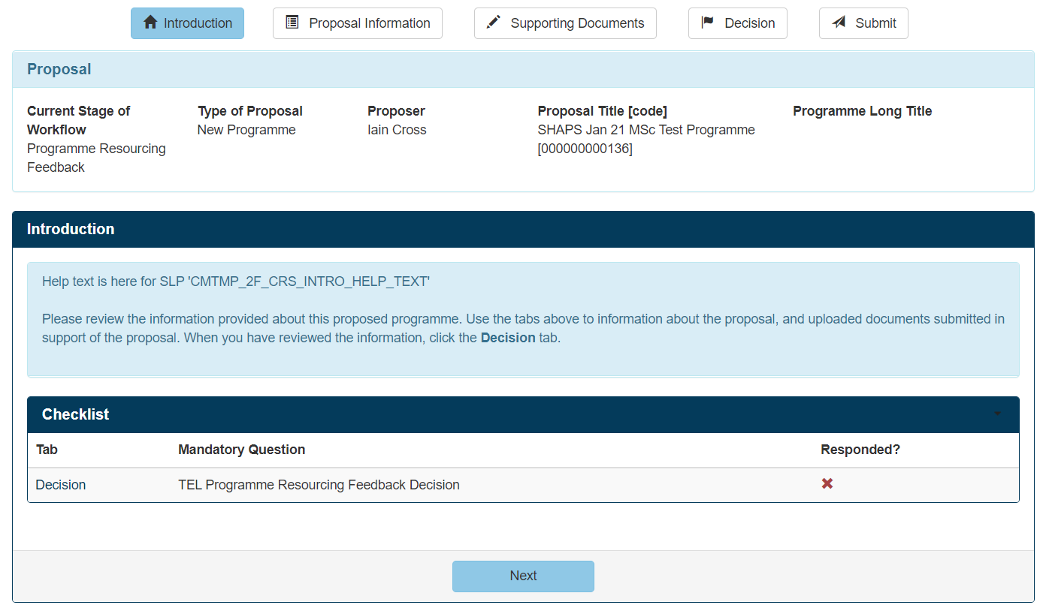

Proposal information
- Click Download PDF to create a local copy of the programme proposal
- Click the document link to view and / or save copies of the documents uploaded by the proposal team

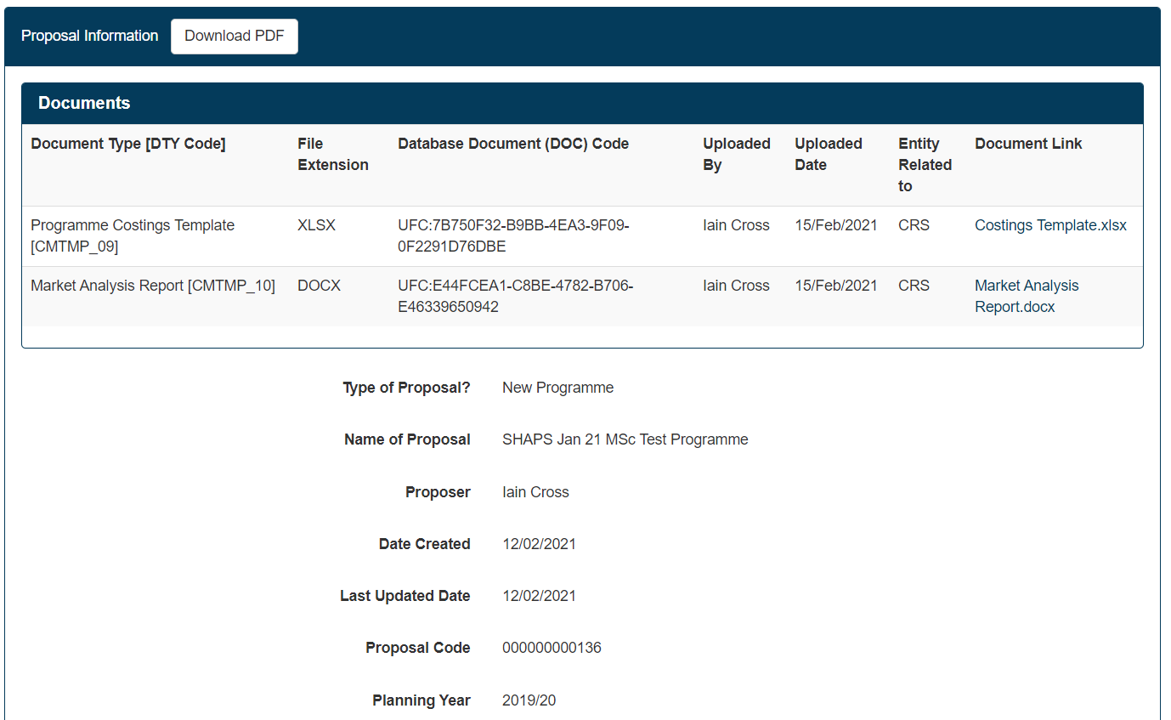

- Scroll down and click on the blue header to expand the information in each of the proposal sections
- Click Next or click the tab at the top of the page to move to the Supporting Documents section

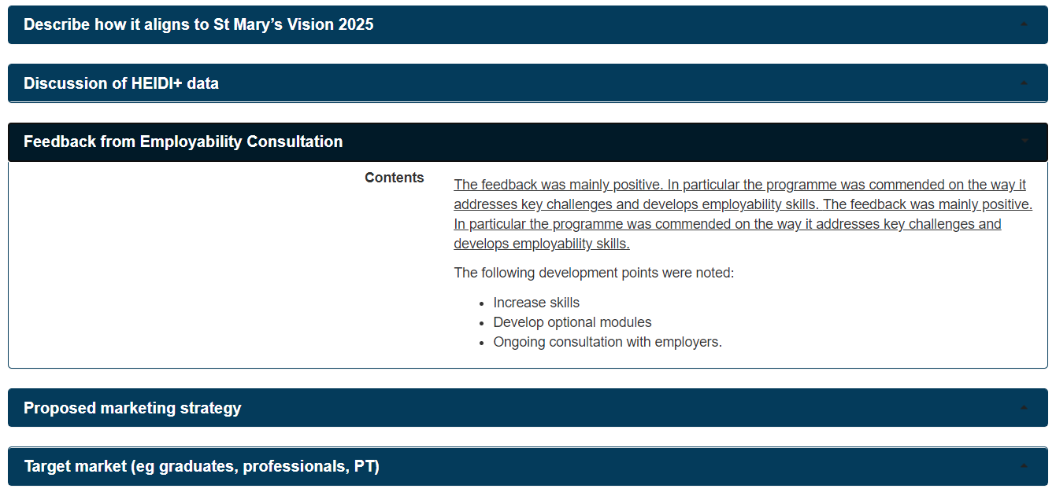

Supporting Documents
- View the information from the proposal team onto the ‘Feedback: [Service]’ (e.g. Feedback: TEL) tab

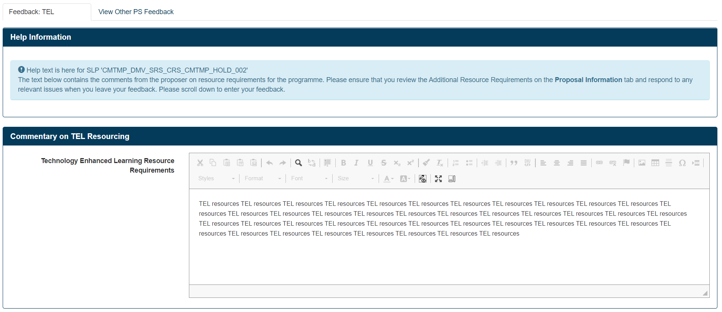
- Click View Other PS Feedback tab to view the responses left by other professional services teams. Feedback will only appear here if they have already submitted their response.

- Return to the Feedback… tab and leave your comments about the proposal. At this stage, these are likely to be a summary of off-line discussions with the programme development team following the Initial Proposal Workshop.
- Click Store Changes then Decision in the tabs at the top of the screen

Decision
- Enter a final decision as to whether your service / department supports the proposal
- It is possible that the approval has been redirected by the QS team e.g. from a Head of Service to a deputy if they are unable to provide feedback. If this is the case, please enter your name in the If you did not make the decision… box.
- Add any further details about your decision. A very brief summary of the feedback is useful here (especially if you are not approving) to track the proposal’s progress and resolve outstanding queries
- Click Store & Next Step to progress to the Submit stage

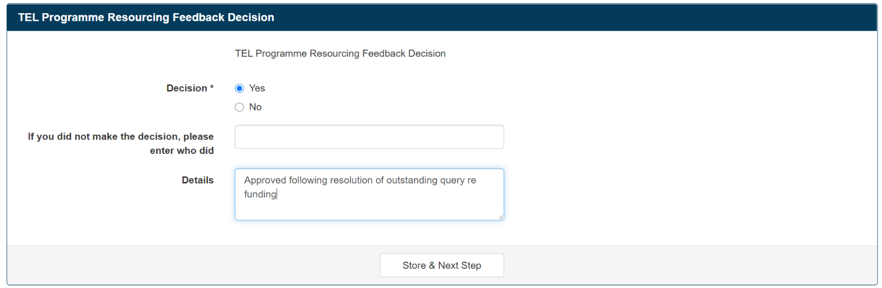

Submit
- Provided a decision has been entered, click Submit.
- Click on the Decision tab if you have not chosen Yes / No to approve, then Store & Next Step.

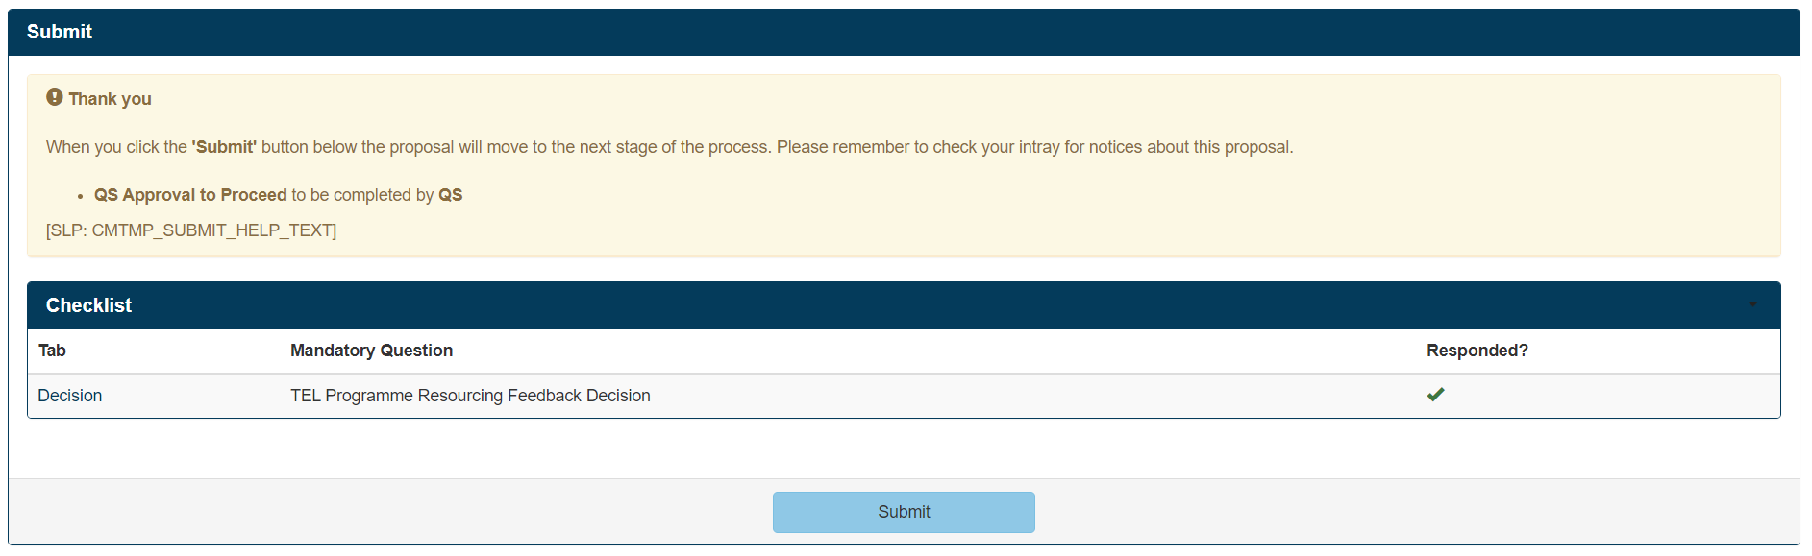
- Click Close to complete your feedback
- The Proposal response is sent to the QS Team
- The Programme Development team will receive a notification that you have responded

QS APPROVAL TO PROCEED
F Quality and Standards Manager
- View the information from the proposal team and Professional Services on the Proposal Information tab. The purpose of the stage is to check that it is appropriate for progression to the Faculty Executive, and that the professional services are supportive of the proposal being taken forward for development.
- View a summary of decisions on the Approvals & Feedback Logs tab

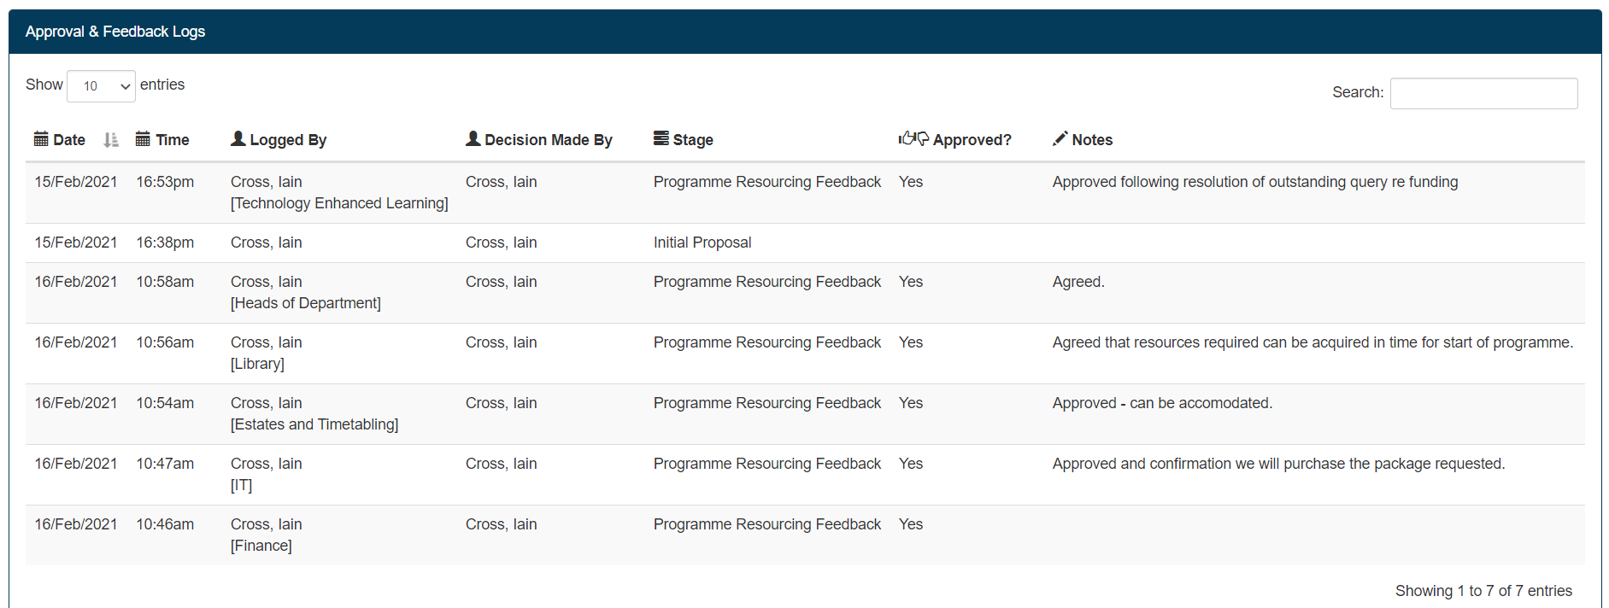

Set the Course Code
- Enter a Programme code, then click Submit. Use the Academic Model to define the programme code.

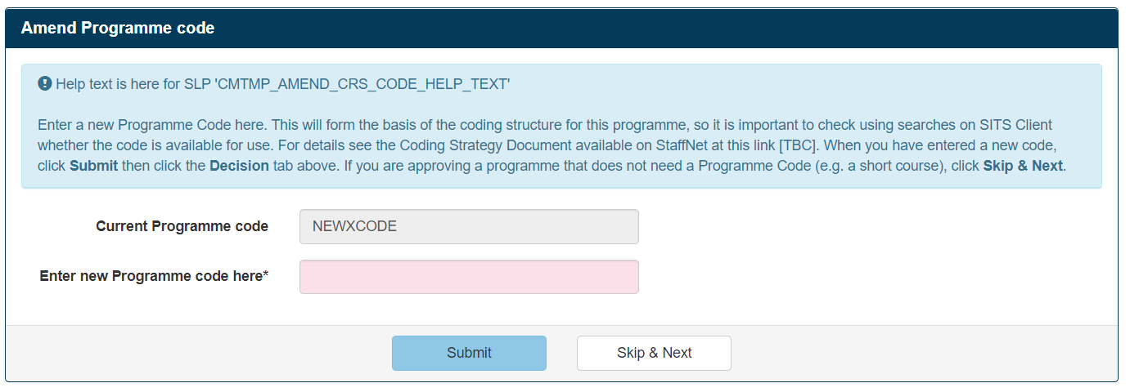

Decision
- Review the Proposal Information and Approval & Feedback Logs. Choose whether to:

Approve: proposal progresses to the next stage
Reject: proposal workflow is stopped (Use with caution!)
Rework: the proposal is reopened for modification based on the feedback given by Professional Services.

- Provide a brief explanation of the decision in the Details box to assist with the record of the approval process.
- Click Store & Next Step

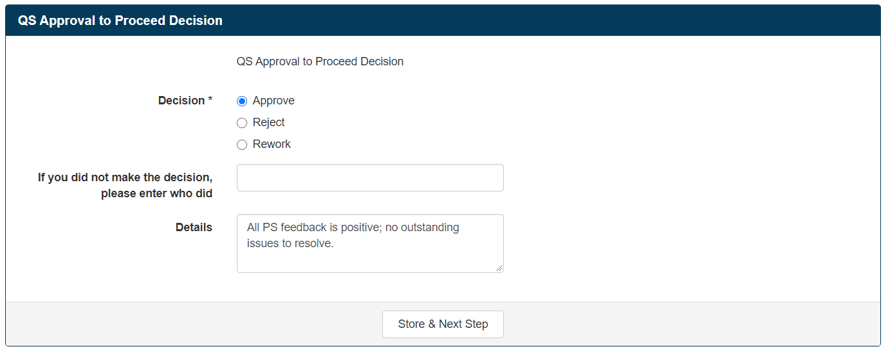

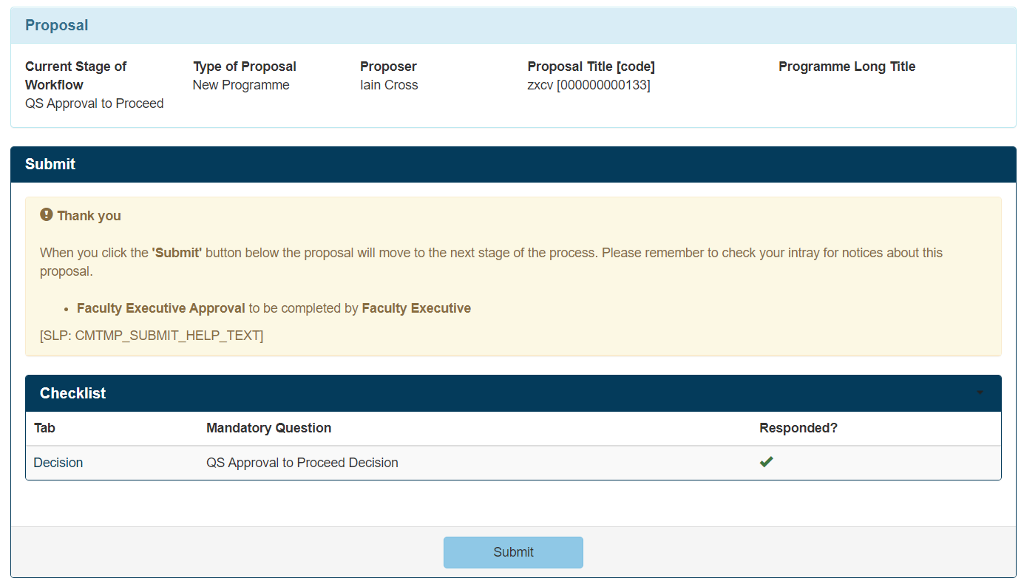

Submit
- Provided a decision has been entered, click Submit.
- Click on the Decision tab if you have not chosen from the approval choices, then Store & Next Step to progress the proposal to the Faculty Executive Approval stage.
- A notification is sent to the Programme Development team

FACULTY EXECUTIVE APPROVAL
F Faculty Executive
- View the information from the proposal team Proposal Information tab. The feedback from Professional Services colleagues has been previously reviewed and acted on by the Programme Development team in conjunction with the Quality and Standards Manager
- Enter your feedback on the Feedback tab then click Store Changes then Next.

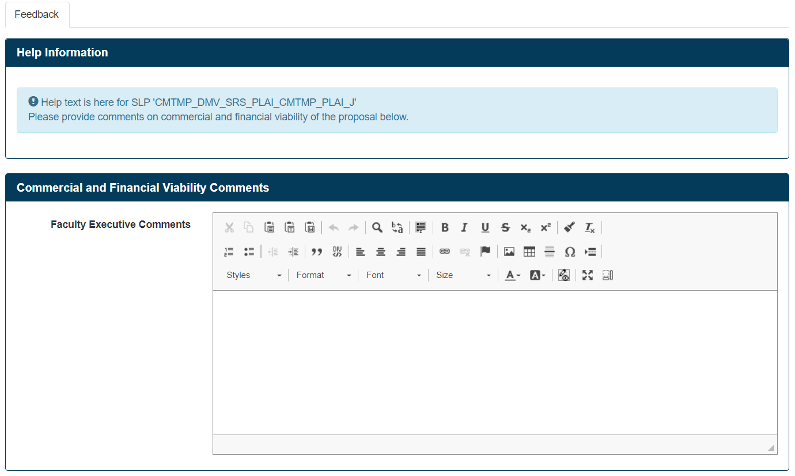

Decision
- On the Decision tab, choose whether to:

Approve: proposal progresses to the next stage
Reject: proposal workflow is stopped and the proposal/programme develop stops (Use with caution!)
Rework: the proposal is reopened for modification and progresses through the previous stages again

- Provide a brief explanation of the decision in the Details box to assist with the record of the approval process.
- Click Store & Next Step

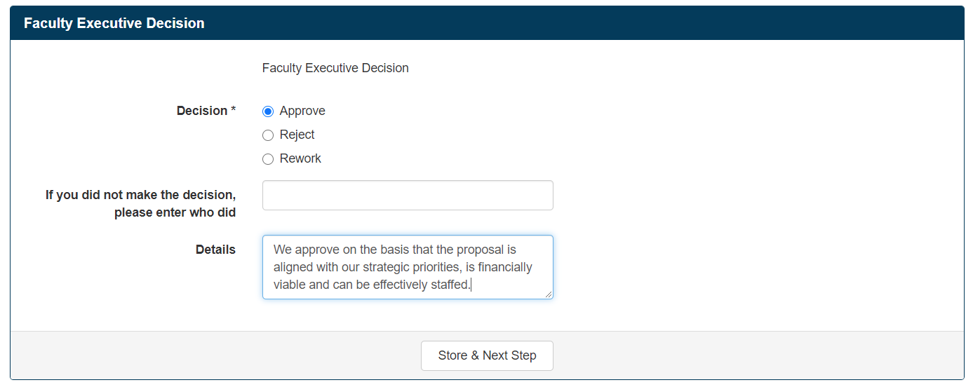

Submit
- Provided a decision has been entered, click Submit.
- Click on the Decision tab if you have not chosen from the approval choices, then Store & Next Step to progress the proposal to the Initial Proposal Workshop stage.
- A notification is sent to the Programme Development team

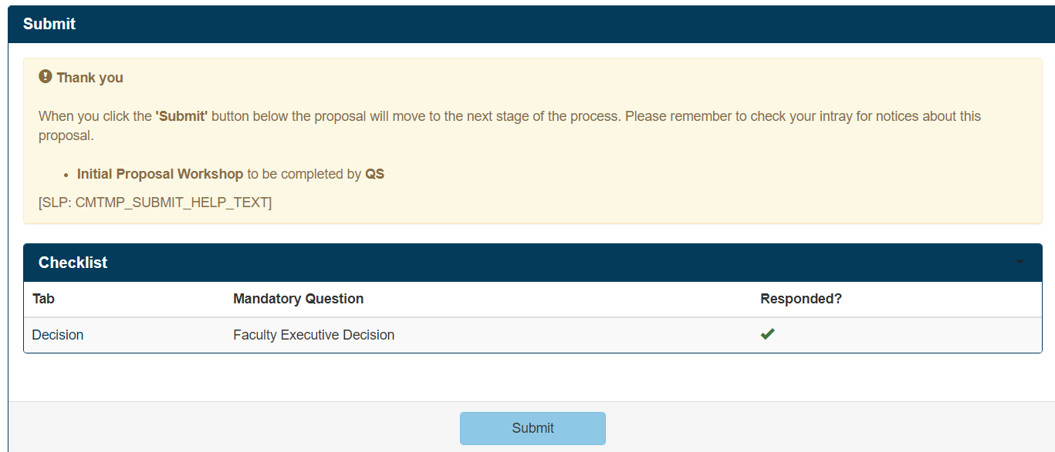

INITIAL PROPOSAL WORKSHOP
F Quality and Standards Manager
- Complete the information on the Proposal Workshop tab to store information about the Initial Proposal Workshop. This stage is only to record the details of the workshop held previously. It should have happened prior to professional services being asked to approve the proposal.
- Click Browse My Computer to upload a copy of the Proposal Workshop Outcomes document
- Click Store & Next to move to the Submit stage

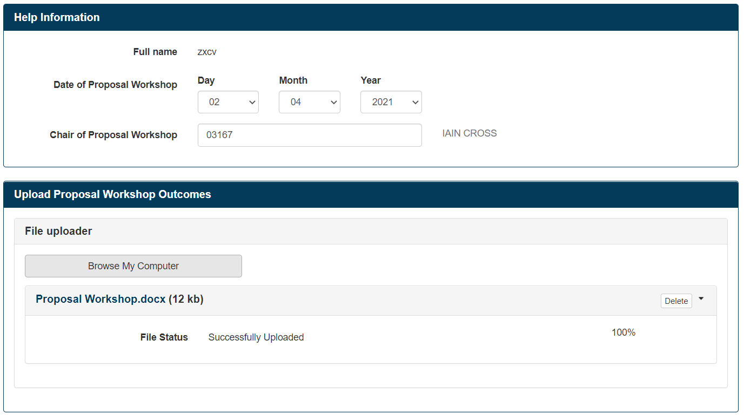

Submit
- Click Submit
- The proposal moves on to the Programme Enhancement Strategies stage and a notification is sent to the Programme Development team

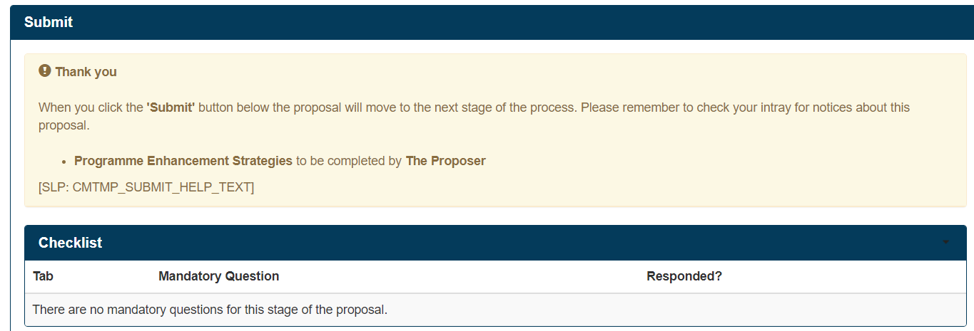

PROGRAMME ENHANCEMENT STRATEGIES
F Proposer
- Review the information on the Proposal Information tab; a PDF of the programme proposal can be downloaded from the Download PDF button at the top of the screen
- Review the Approval & Feedback Logs, showing the notes provided by different stakeholders. Their full feedback is included on the Proposal Information tab and PDF document
- Add information about your programme strategies following the Programme Design Intensive
- Click Store Changes then Next

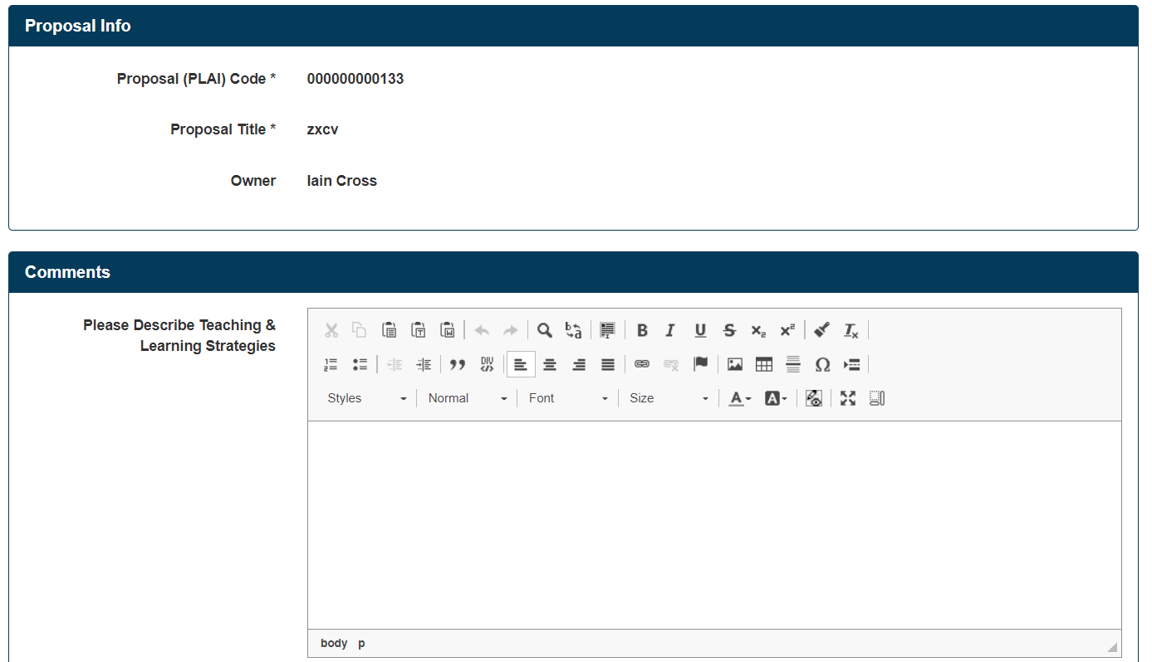

Submit
- Click Submit if all sections are complete; use the link in the checklist to return to any missing information
- The proposal moves on to the CTESS Approval of Programme Enhancement Strategies stage and a notification is sent to the Programme Development team

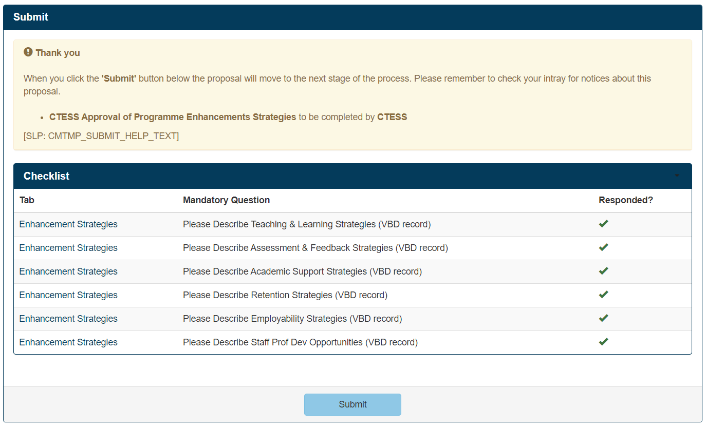

CTESS APPROVAL OF PROGRAMME ENHANCEMENT STRATEGIES
F Associate Dean / Dean of Learning and Teaching
- Review the information on the Proposal Information tab; a PDF of the programme proposal can be downloaded from the Download PDF button at the top of the screen
- The strategies designed by the programme development team are on the Proposal Information Tab
- Review the strategies then on the Feedback tab provide your commentary. Use the text formatting features if you wish.
- Click Store Changes to progress to the Decision tab.

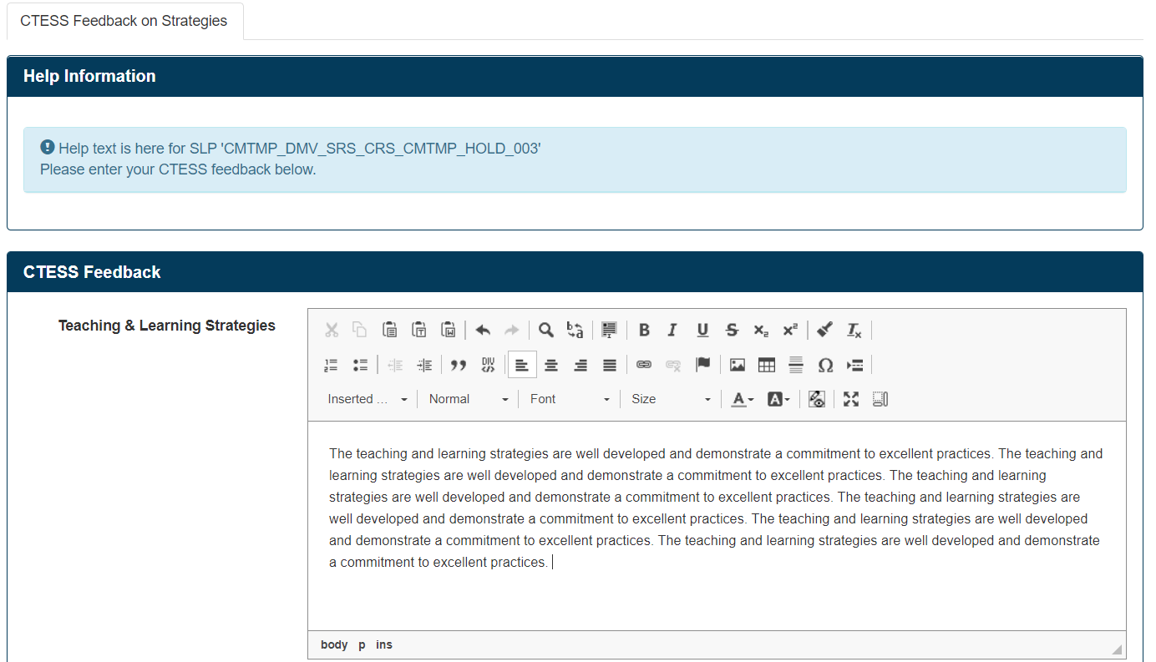

Decision
- On the Decision tab, choose whether to:

Approve: proposal progresses to the next stage
Reject: proposal workflow is stopped and the proposal/programme develop stops (Use with caution!)
Rework: the proposal is reopened at the Programme Enhancement Strategies stage for modifications

- Provide a brief explanation of the decision in the Details box to assist with the record of the approval process.
- Click Store & Next Step

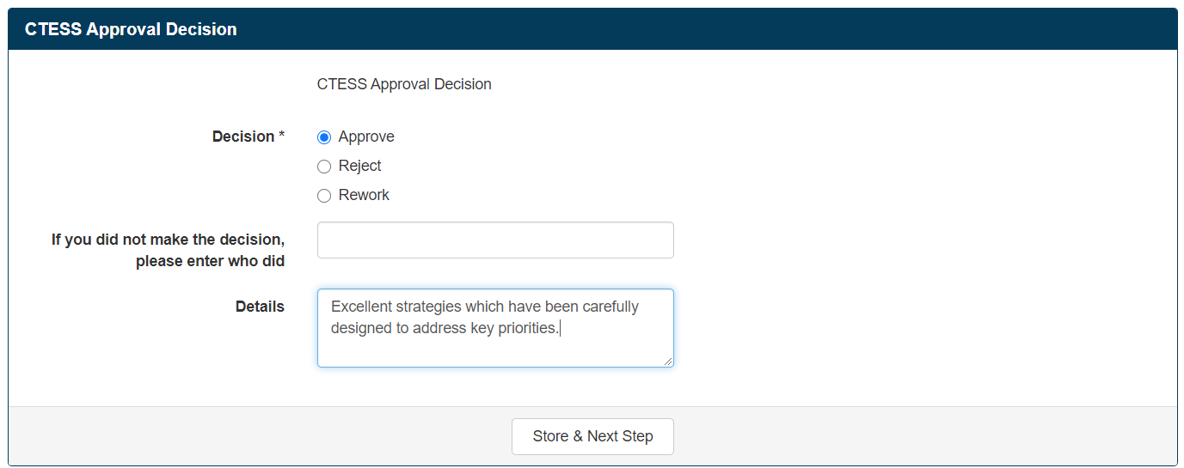

Submit
- Click Submit
- The proposal moves on to the Submission to FADC stage and a notification is sent to the Programme Development team

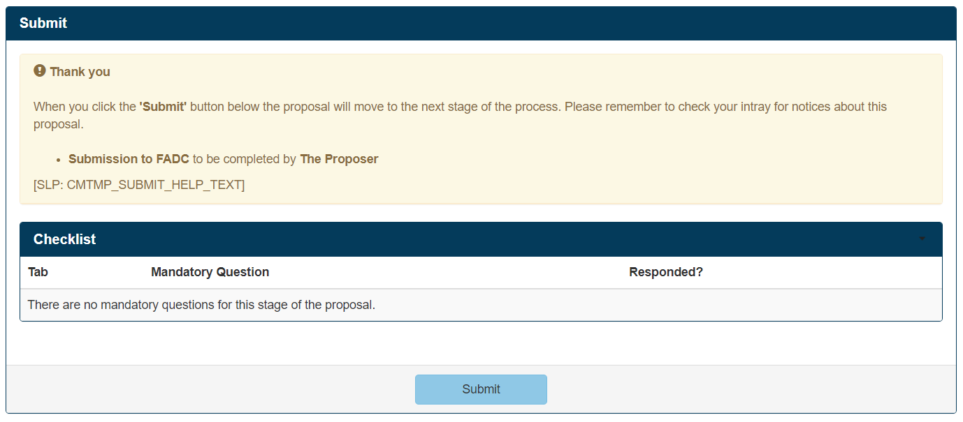

SUBMISSION TO FADC
F Proposer
- Review the information on the Proposal Information tab; a PDF of the programme proposal can be downloaded from the Download PDF button at the top of the screen
- The proposal is now complete
- Click on the Submit tab
- The proposal is now sent to the Faculty / Institute ADC. You will be notified when the QSM has entered the FADC Feedback on the proposal

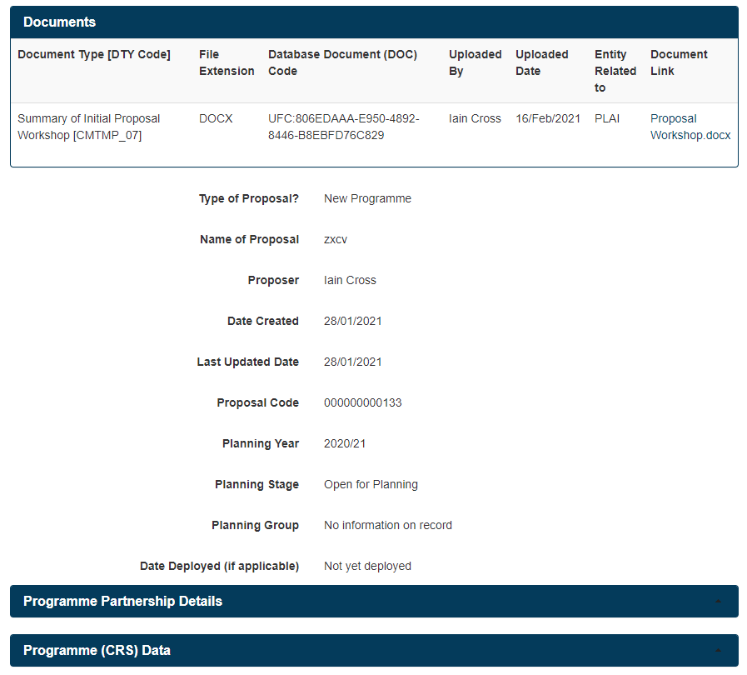

FADC FEEDBACK ON PROPOSAL
F Quality and Standards Manager
- Review the information on the Proposal Information tab; a PDF of the programme proposal can be downloaded from the Download PDF button at the top of the screen
- The purpose of this stage is to store the feedback from the FADC meeting on each of the teaching strategies. Enter the feedback from the FADC in the FADC Feedback tab

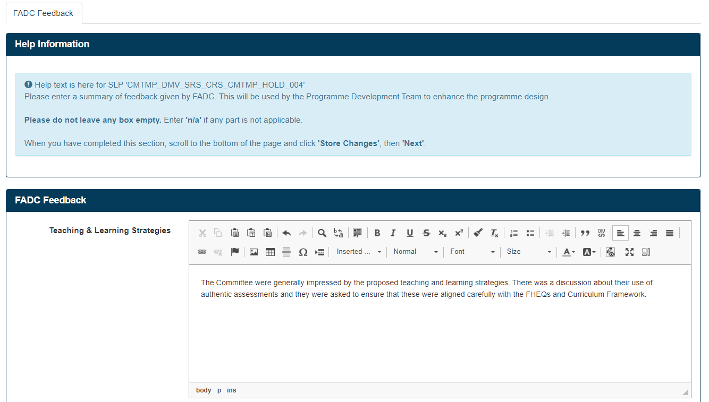

Decision
- On this stage, the Decision tab simply allows the feedback you have submitted to be recorded and for the process to move on to the FADC Decision stage. You should not be selecting reject/rework at this stage.
- Provide a brief summary of the feedback in the Details box to assist with the record of the approval process.
- Click Store & Next Step
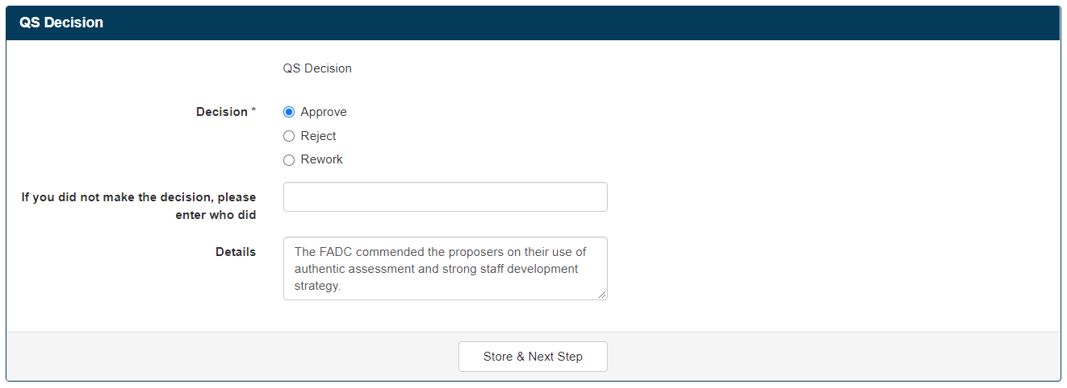

Submit
- Click Submit
- The proposal moves on to the FADC Approval stage and a notification is sent to the Programme Development team

FADC APPROVAL
F Quality and Standards Manager (on behalf of F/IADC Chair)
- Review the information on the Proposal Information tab; a PDF of the programme proposal can be downloaded from the Download PDF button at the top of the screen
- A log of all approvals is available from the Approval &Feedback Logs

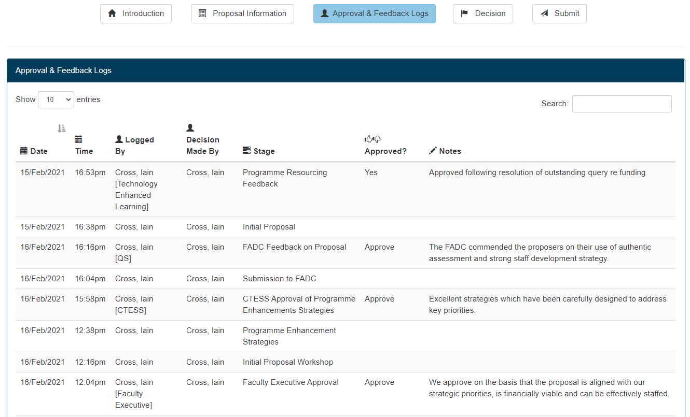

Decision
- On the Decision tab, choose whether to:

Approve: proposal progresses to the next stage
Reject: proposal workflow is stopped and the proposal/programme develop stops (Use with caution!)
Rework: the proposal is reopened at the proposal stage for modifications

- Enter the name of the I/FADC Chair in the If you did not make the decision… field
- Provide a brief explanation of the decision in the Details box to assist with the record of the approval process.
- Click Store & Next Step

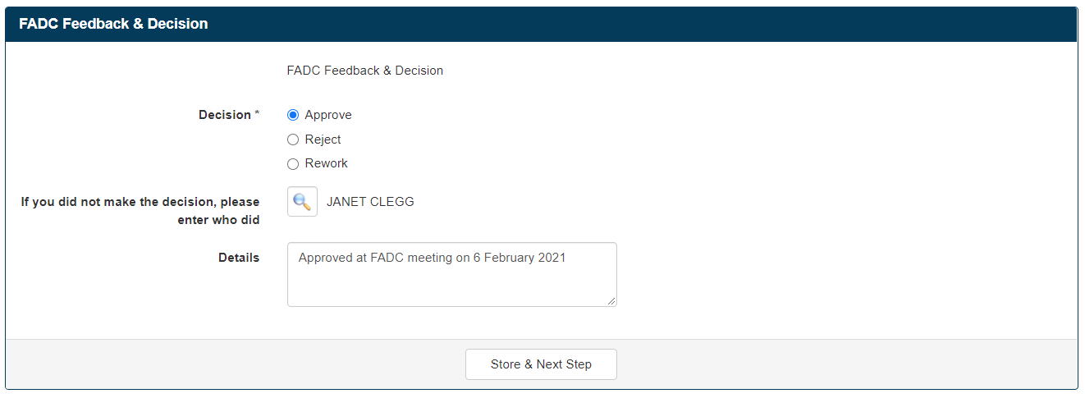

Submit
- Click Submit if all sections are complete; use the link in the checklist to return to any missing information
- The proposal moves on to three simultaneous sections:
i) Preparation for Applications (Admissions Team)
ii) Advertise Subject to Validation (Pre-deployment Team)
iii) Programme Development (Proposal team / QS)

ADVERTISE SUBJECT TO VALIDATION
F Pre-deployment Team
Information | Required? | Data type | Brief guidance
MAS Course Code | Yes | Text | Enter MAS code according to the Academic Model
Full Name | Yes | Text | Full name of the programme
Title | No | Text
Entry Block | Yes | Text | Entry block
Entry occurrence | Yes | Text | Entry occurrence
Mode of attendance | Yes | Drop down | Mode of attendance
Admissions Entry System | Yes | Drop down | Entry system
UCAS Course Code | No | Text | Enter for programmes with UCAS entry
Scheme Code | Yes | Auto-completed
Print in Reports? | Yes | Auto-completed
- Review the information on the Proposal Information tab; a PDF of the programme proposal can be downloaded from the Download PDF button at the top of the screen
- Information on the Programme Dev Team can be used to address any queries you have abou the programme set up
- Add the MCR details on the Programme Data tab. Click Add Record at the bottom of the screen to create a new MCR for the programme, then click Create then Next. Repeat as necessary.

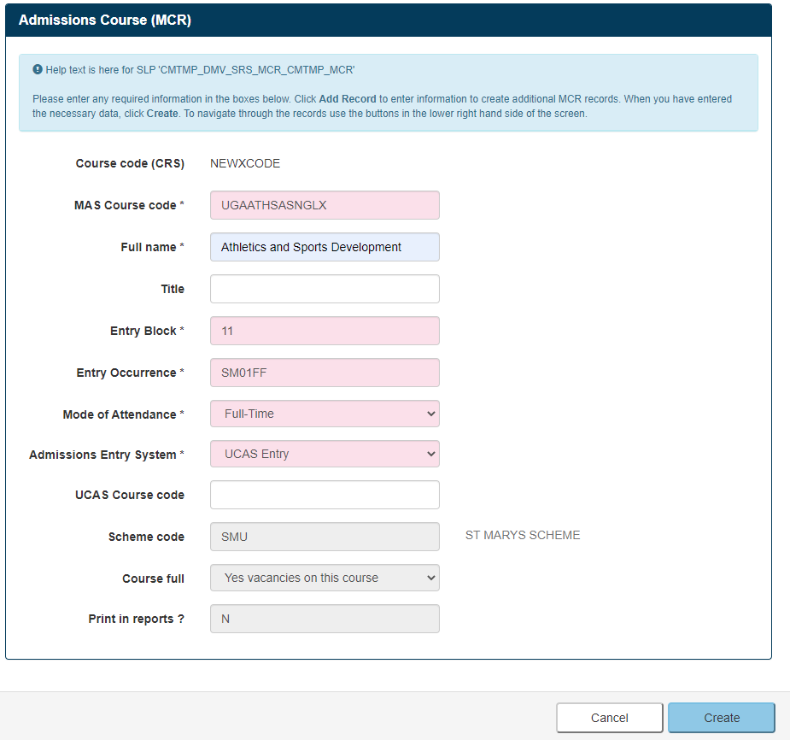

Decision
- Choose ‘Yes’ as the decision when the MCR codes are set up
- Then click Store & Next Step

Submit
- Click Submit to confirm the MCR code(s)

ADVERTISE SUBJECT TO VALIDATION
F Admissions
This stage should only be completed once the previous stage has been submitted. If there are no MCR details, do not submit this stage; wait until there is information to confirm in the MCR details tab.

- Review the information on the Proposal Information tab; a PDF of the programme proposal can be downloaded from the Download PDF button at the top of the screen
- Information on the Programme Dev Team can be used to address any queries you have abou the programme set up
- Review the MCR details on the Programme Data tab, edit if required. Click Store Changes if edits are made, then Next.
- There is no need to enter any comments on the Feedback tab
- Click Submit.

At this point, most of the development of the programme takes place. The tool is next used when the programme approval documents have been prepared and are ready for submission to the Faculty / Institute ADC.

PROGRAMME DEVELOPMENT
F Proposer / Programme Development Team / Quality & Standards Manager
- This stage only requires the upload of the programme approval documents. Any one of the above groups can do this. When completed the stage is no longer visible to the other two groups.
- Use the file picker to upload i) Programme Approval Document, ii) Student Programme Handbook
and iii) Module outlines
- Click Next

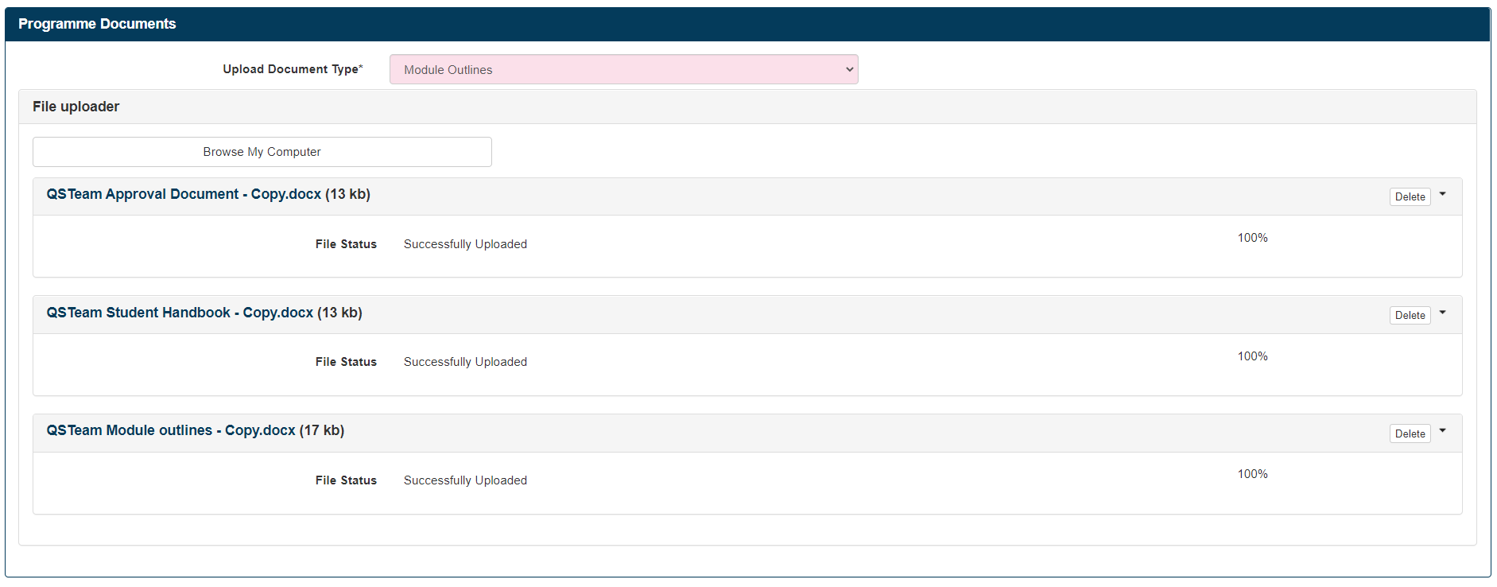

Submit
- Click Submit to progress the proposal to the FADC Submission of Drafts stage.

FADC SUBMISSION OF DRAFTS
F Proposer
- In this step, the Proposer finalises the version of the documentation that they wish to be considered at the Faculty / Institute ADC. It should happen after the programme development phase is completed. Click the document name to download and view a copy of it.
- The Proposal Information tab contains all of the information about the proposed programme.
- The documents uploaded in Step 22 (PROGRAMME DEVELOPMENT) are shown in the Programme Documents section.
- If there have been updates made to the document, click Delete next to the relevant document and re-upload the updated version using the file picker.

Submit
- Click Submit to progress the proposal to the post-FADC stage.

FADC APPROVAL OF DRAFTS
F I/FADC Representative
- In this step, the I/FADC representative reports the decision of the Committee:

Approve: proposal progresses to the next stage
Reject: proposal workflow is stopped and the proposal/programme develop stops (Use with caution!)
Rework: the proposal is reopened at the proposal stage for modifications

- Enter the name of the I/FADC Chair in the If you did not make the decision… field
- Provide a brief explanation of the decision in the Details box to assist with the record of the approval process e.g. when the documents were approved. If changes need to be made (i.e. it is approved subject to…’), revised documents can be entered in the next stage.
- Click Store & Next Step

Submit
- Click Submit to progress the proposal to the post-FADC resubmission stage.

QS APPROVAL POST FADC RESUBMISSION
F Proposer
- In this step, the QS Team ensure that any changes required to the document after the FADC approval are made, and finalises the version of the documentation that will be taken forward to the Panel event. Click the document name to download and view a copy of it.
- The Proposal Information tab contains all of the information about the proposed programme.
- The documents uploaded in Step 22 (PROGRAMME DEVELOPMENT) are shown in the Programme Documents section, except for the programme approval document (see below)
- If there have been updates made to the documents, click Delete next to the relevant document and re-upload the updated version using the file picker.
- You must upload a new version of the programme approval document (it is typical that there will be minor updates and revisions to this document – this is a trigger to check that this has been done)
- Click Next.

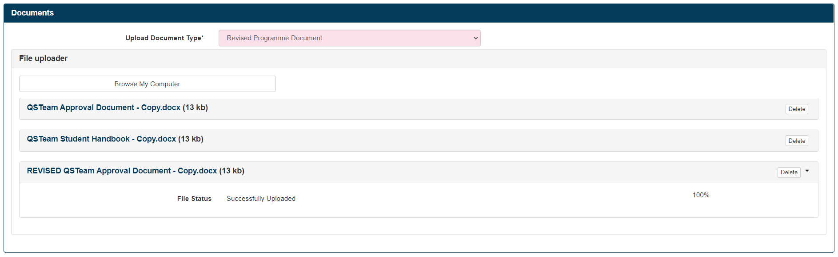

Decision
- On the Decision tab, there are number of trigger decisions. You should be able to choose ‘Approve’ to all of them. It is not advisable to chose ‘reject’ or ‘rework’ at this stage, but you should delay approving until you are certain that the task has been completed. You need to be certain at this point that all the documentation required for the Panel Event has been received in its finalised, I/FADC form.

Approve: proposal progresses to the next stage
Reject: proposal workflow is stopped and the proposal/programme develop stops (Use with caution!)
Rework: the proposal is reopened at the proposal stage for modifications (avoid at this stage)

- If you are completing this stage on behalf of another QSM, enter the name of the QSM in the If you did not make the decision… field
- Click Store & Next Step

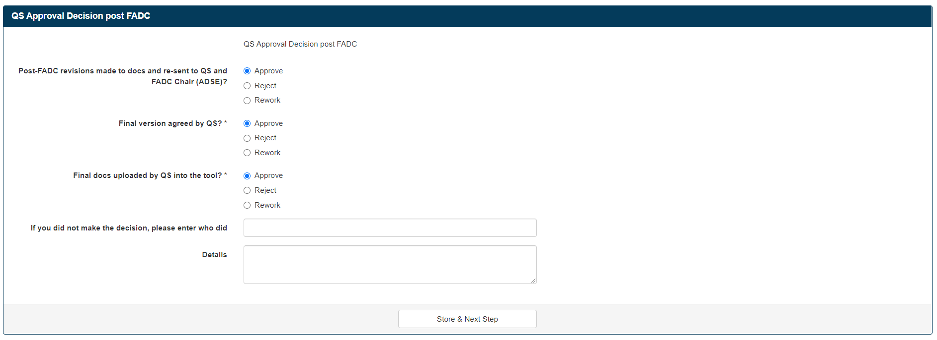

Submit
- Click Submit to progress the proposal to the Approval Panel stage.

At this point the programme approval event happens. The tool is next used to enter the outcomes of the Approval Panel event.

APPROVAL EVENT DECISION
F Approval Panel Representative
- In this step, the outcome of the Approval Panel is recorded.
- Use the Details field to briefly summarise the outcome of the Panel and justify the decision
- Click Store & Next Step – in the next stage revised documents can be uploaded to the tool, so it most likely that the decision at this stage is APPROVE unless the Panel does not approve the programme, and a thorough reworking is required (REWORK). A panel outcome of Approved with conditions should be noted as APPROVE at this stage. A panel outcome of not approved would be a REWORK to facilitate the team to reshape and present the programme again.

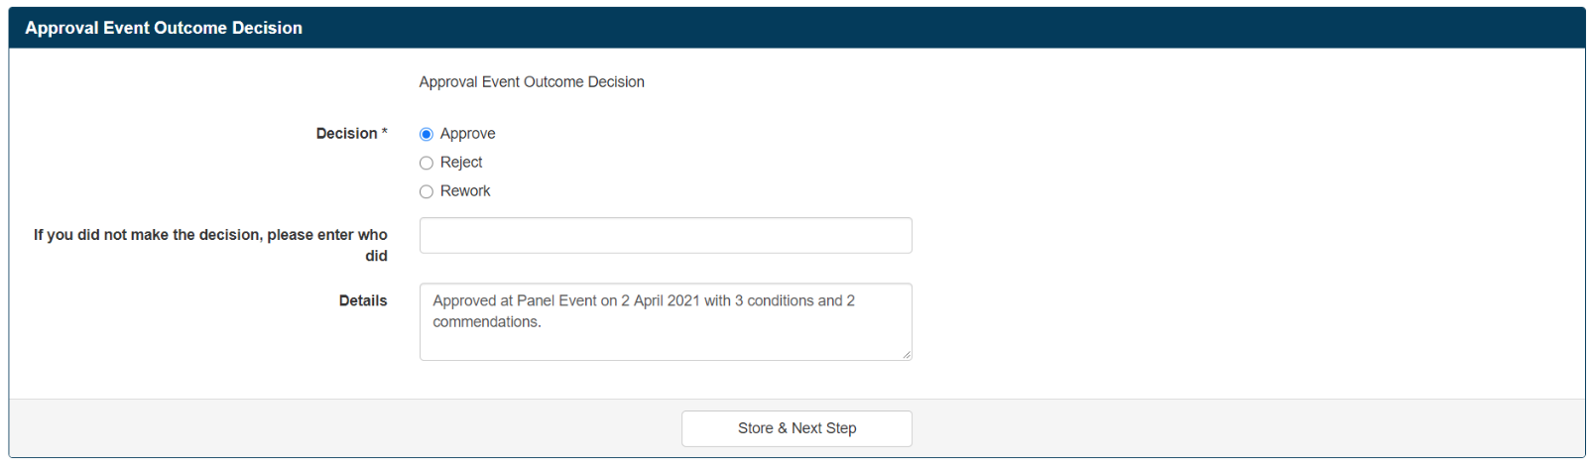

APPROVAL FOLLOW UP COMPLETED
F Approval Panel Representative
- Check that the programme team have submitted the final post-Event documents before commencing this step.
- In this step, final approved documents are uploaded to the tool. The documents submitted in Stage 25 (QS APPROVAL POST FADC RESUBMISSION) are visible in the tool and can be replaced by deleting and re-uploading the updated version through the file picker.
- It is helpful at this stage to add the Panel Event feedback / Approval Event Report to the Programme Approval Document
- Currently these are not mapped correctly to the documents generated by the Panel Event. Please use the following mapping until this is updated:

CM Tool Document Name | Document to upload
Revised Programme Document | Panel Feedback report
Programme Approval Document | Post-event Programme Approval document with module outlines appended
Student Programme Handbook | Student Programme Handbook

- Click Next and choose Approve on the Decision tab. After Submit the document moves to the ADC Decision stage

ADC DECISION
F Academic Development Committee Representative
- The proposal information and programme documents can be downloaded from the Proposal Information tab
- Add the ADC decision in the Decision tab, noting the date of the meeting at which the approval was made. Click Store & Next Step then Submit.

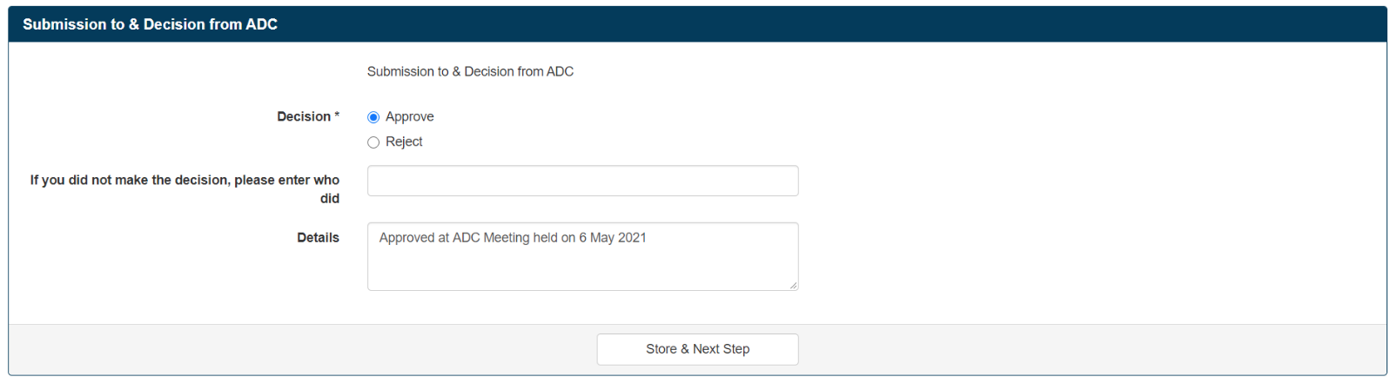

ACADEMIC BOARD DECISION
F Academic Board Representative
- The proposal information and programme documents can be downloaded from the Proposal Information tab
- Add the Academic Board decision in the Decision tab, noting the date of the meeting at which the approval was made. Click Store & Next Step then Submit.

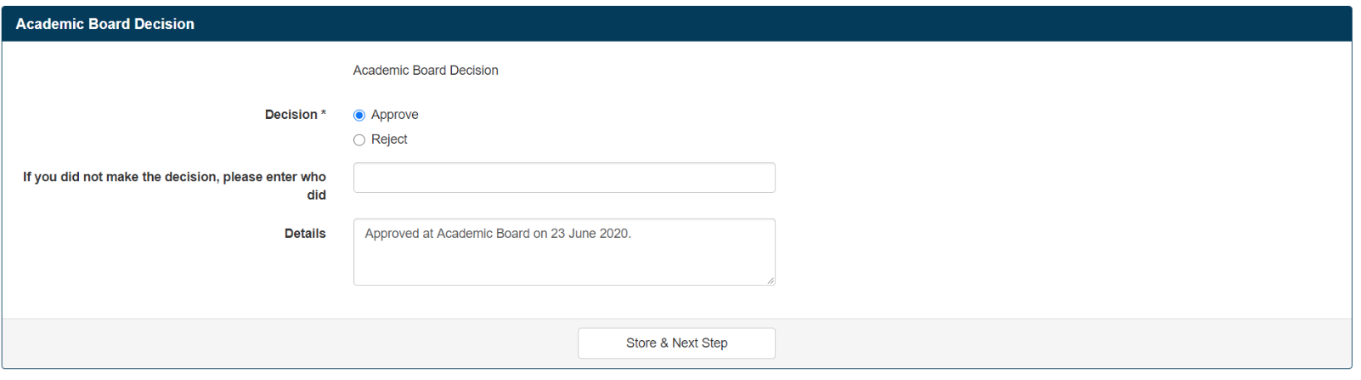

PROGRAMME SPECIFICATION
F Quality Standards Manager
- In this section you are able to make any final corrections or updates to the programme information.
- You will need to add at least one HECoS Code under Programme Name and Department on Part 1.
- Click Store Changes then Next, then Submit.

The programme proposal process is now complete and the
programme is ready for deployment

