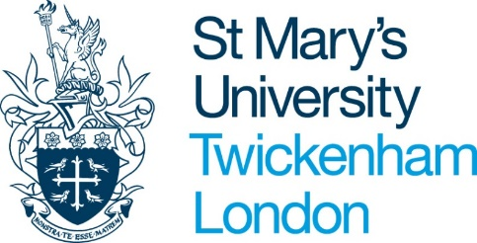
Student Consultation Questionnaire

- What attracted you to the programme in the first place?
- In what areas do you feel that your academic abilities have grown during your degree?
- Where the programme is interdisciplinary, what areas of good practice have you found, and what might help to synergise your learning?
- What particular types of learning and teaching do you most enjoy, eg lectures, seminars, tutorials?
- What types of learning activities do you feel you benefit from?
- Do you find Moodle supports you learning through self-directed reading/activities/activities etc?
- What kinds of learning materials do you find most accessible and useful to the study of your discipline?
- Do you feel there is/has been a sufficient breath of assessment during your studies?
- Are there any types of assessment you particularly thrive on or find difficult?
- How has formative and summative assessment feedback helped you to improve academically?
- Have your methods of assessment always been clear to understand?
- How has learning, teaching and assessment practice supported development of your research skills and academic integrity?
- What methods of revision for assessment have been particularly effective?
- How have supplementary materials such as handbooks, assessment briefs and assessment criteria supported your study and are there any areas for improvement?
- What academic extra-curricular activities have you valued or think would be useful?

