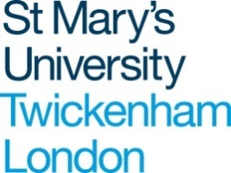

The St Henry Walpole Award for Teaching and Learning 2023

We invite you to complete the following form and return it via e-mail to adf@stmarys.ac.uk by 5pm on Tuesday 30th May 2023. The form should be typed throughout.

If you are shortlisted, you will be invited to a 10-minute panel presentation on Thursday 29th June in the afternoon – venue to be confirmed.

Criteria

Applications will be evaluated against the following criteria:

- Distinctiveness/innovation. How unique is the initiative at St Mary’s? How will the initiative enhance teaching and learning at St Mary’s? What will be the measures of successful enhancement?

- Effectiveness. How effective has the initiative been? What evidence is there to support this? (e.g. student feedback, module evaluation data, other survey data, attainment data)

- Alignment with scholarship. How has scholarship influenced the development and/or implementation of the initiative?

- Alignment with University and sector priorities. How does the initiative align with current institutional priorities e.g. retention, the BAME attainment gap, inclusive and research-informed teaching, the UK Professional Standards Framework and current developments in the Higher Education sector?

- Potential for institutional impact. How will the initiative influence practice in other disciplines/programme areas/institutions?

Details of applicant(s)

Applicant (name & job title)

Department

Additional applicants (if group entry)
Please give name and job title for each person

Title of project

Please describe the work you wish to submit for the prize aligning it against the criteria.
Please note you must complete all boxes. You have a maximum of 1000 words:

Distinctiveness/Innovation:

Effectiveness:

Alignment with scholarship:

Alignment with university and sector priorities:

Potential for institutional impact:

