

**The use of Defibrillators at St Mary’s University – Health and Safety Guidance**

# Scope of Guidance

This guidance relates to the emergency response procedure for the use of Portable Automated External Defibrillators (AEDs) and the arrangements for training and maintenance of the AED equipment.

# Introduction

AED is a lightweight portable machine that can give the heart a controlled electrical shock during a cardiac arrest. An AED detects the electrical activity of the heart and gives automated instructions to the operator on what to do, the AED will only operate under certain circumstances to prevent incorrect use. [The British Heart Foundation](http://www.bhf.org.uk/#%26panel1-2) says that for every minute that passes without defibrillation chances of survival decrease by about 10 percent. Research shows that giving a controlled shock within five minutes of collapse provides the best possible chance of survival for the casualty.

The University arrangements for emergency response to a cardiac arrest, e.g. the location of AED machines, and the provision of training, aim to ensure that a defibrillator and trained operator(s) reach the casualty without delay.

# Provision and Location of AEDs

AEDs are provided in a number of key areas across campus with mobile units held on all Security Service vehicles. All Security Service personnel are qualified first aiders and have received additional training in the use of AEDs.

First aid signage is displayed across campus and has the emergency contact details for requesting an AED “responder”.

# Training in the use of AEDs

The type of AED chosen by the University is suitable for any person to use and will not deliver a shock to a casualty unless it is appropriate to do so. The equipment is automated and will instruct the user, giving “step by step” guidance. Whilst some University first aiders have received training in the use of AEDs, this is not a pre-requisite. Training opportunities are available to all University staff (see below):

# 

# Defibrillator and First Aid Training

Training in the use of AEDs is available to both University First Aiders and non-first aid trained members of staff. Whilst training in the use of the AED is not considered necessary due to the simplicity of the AED device, training is offered to promote familiarity and confidence when using the AED.

AED and First Aid training is organised by the University Health and Safety Service (H&SS) and sessions are run on campus by qualified in-house instructors.

# AED Access

AED’s will be kept in carry cases, and stored in secure wall mounted cabinets located in prominent positions.

The AED, in its carry case, is easily removed from the cabinet by pulling the door open. An alarm is activated when the door is opened to alert local staff that someone is accessing the cabinet.

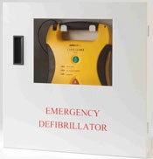

# Access Out of Hours

Buildings where AEDs are located are accessible to all during normal working hours. Some buildings are open for extended hours and some are accessible by University swipe card. Where access to a building and an AED cabinet is not possible you should contact Security Service who operate a 24/7 cover to respond with a mobile unit.

# Emergency Response Procedure

Suspected Cardiac Arrest

Person on the scene/First

Aider calls the Emergency Services **(999)** and Security **(4060 internal or 02082404060** for an AED

Responder

First Aid given until AED

responder arrives

AED Responder attends

and applies AED whilst waiting for the Ambulance

Health and Safety Office

informed

First Aid Treatment Form

Completed

**First Aid Response**

If a cardiac arrest is suspected an ambulance should be summoned immediately. If available another person should make the emergency calls whilst the first aider initiates basic life support and first aid. If an AED is available and suitable for use on the casualty/emergency case its use should be considered.

* Contact the emergency services by dialing 9-999 (*Security must be contacted to direct the emergency services to the incident location)*.
* Contact the Security gatehouse immediately to locate the closest AED responder or request that they respond with a mobile unit by dialing internal emergency number **888** or **0800 526966** if using an outside line or mobile phone

# AED “Responder”

When called to respond to a cardiac arrest emergency, the AED “responder” should attend the location without delay collecting or requesting the AED unit from the nearest location.

The AED “responder” should attend to the casualty as trained, using other persons present to call for help, await and direct the emergency services and keep the area clear. First Aiders at the location should carry out basic life support and CPR.

# Reporting AED Incidents

At the earliest opportunity the incident should be reported to the University Health and Safety Service. The AED “responder” and First Aider who have dealt with the incident should complete a First Aid Treatment Form. These forms are available from the Health and Safety webpage.

# AED Maintenance

A nominated member of staff should check the AED on a regular basis. This duty should usually be assigned to an AED qualified First Aider in the building where the AED is located. The checks are to ensure that the AED is stored in the correct location and has not been misplaced, the equipment is ready for use and batteries are charged, accessories are in place, expiry dates are checked and stock is replenished.

AED checklists is available in this document appendix A and must be completed monthly and sent to the H&S team.

When an AED unit is unavailable at its designated location, e.g., when taken away for service or repair, the nominated person from the location should place signage on the AED cabinet. The signage should direct responders to contact Security Services to respond with a mobile AED unit when dealing with a suspected cardiac arrest.

AED battery packs and pads have a specified shelf life. The length of which is dependent upon the make and model. Schools and Departments must ensure that the manufacturer’s instructions regarding the replacement of batteries and pads is strictly adhered to and that replacements are acquired and installed before the relevant expiry date.

Links to suppliers of batteries etc. follow;

Cardiac Science G3 Batteries/Pad website Link

<http://www.direct365.co.uk/supplies/powerheart-g3-spare-battery>

Defibtech Batteries/Pad website Link

<http://www.direct365.co.uk/supplies/standard-battery-pack-for-lifline-aed-auto>

ZOLL AED Plus Batteries/Pad website link

<http://www.direct365.co.uk/supplies/zoll-aed-plus-fully-automatic-defibrillator?___SID=U>

# 

# Document management table

|  |  |  |  |  |
| --- | --- | --- | --- | --- |
| **Version** | **Owner** | **Revised by** | **Summary of revision** | **Date of revision** |
| V1 | UH&SS | Terry Docherty | New draft | May 2014 |
| V2 | H&S | Terry Docherty | Amended Appendix A and extended guidance on maintenance by Schools | March 2016 |
| V3 | H&S | Graham Smith | Refreshed and added device / location detail Appendix 3 plus communicated out | August 2021 |
| V4 | H&S | Graham Smith | Details how to test internal batter charge on Lifepak 1000 | December 2021 |
| V5 | H&S | Graham Smith | Added details for Paediatic pads | August 2022 |



**APPENDIX A**

**AED CHECKLIST – MONTHLY CHECKS**

To be completed every month or after an AED incident and returned to University Health and Safety Office.

**Please delete where appropriate Yes/No.**

|  |  |
| --- | --- |
| **MONTHLY CHECKS** | **COMMENTS/ACTION** |
| **Check Internal battery is fully charged and in date Yes/No**  (for Lifepak 1000 remove battery and check – see Appendix 4) |  |
| **Check AED is on standby mode –Yes/No** |  |
| **Run manually initiated self-test Yes/No** |  |
| **Check Adult pads are sealed and in date Yes/No** | **DATE -** |
| **Check Paediatric pads are sealed and in date Yes/No** | **DATE -** |
| **Is the AED unit damaged e.g. cracks, loose parts etc. Yes/No** |  |
| **Is AED storage box damaged Yes/No** |  |
| **Are the AED operating Instructions present Yes/No** |  |
| **Wipes/Towel/Scissors/Razor available and in good condition Yes/No** |  |

|  |  |
| --- | --- |
| **Date:** |  |
| **Department/School** |  |
| **Name:** |  |
| **Signature:** |  |

Appendix 3

**Location of Devices and Departments Responsible for Inspecting**

|  |  |  |  |
| --- | --- | --- | --- |
| **Location** | **Device** | **Battery Rechargeable** | **Department** |
| **Security Lodge** | **Lifepak 1000** | **N** | **Security Team** |
| **Refectory** | **Lifepak CR2** | **N** | **Food Service Team** |
| **Security Car** | **Lifepak 1000** | **N** | **Security Team** |
| **Sports Hall** | **Lifepak 1000** | **N** | **Sports Team** |
| **Teddington Lock**  **Code C159X** | **Lifepak 1000** | **N** | **Grounds and Gardens Team** |

Note: Defibrillators used in sports research are managed by the appropriate team to be available if the protocol for that activity requires one – These are checked and managed by the SAHPS department.



All our defibrillators are now listed on the national network for emergency use

Appendix 4

**LifePak 1000 Battery check**

1. Remove battery from the compartment using the switch on the battery on the side of the unit.
2. Press grey round button under battery symbol on battery pack

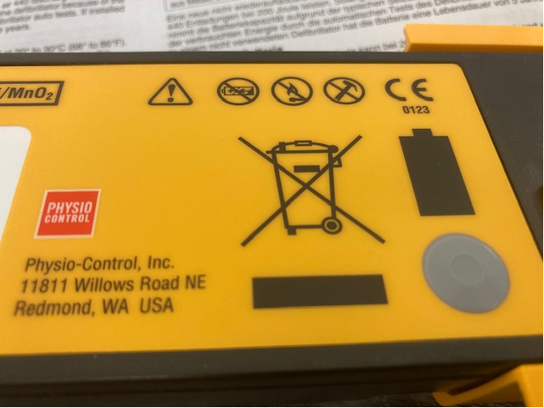

1. Within the battery symbol lights will appear. One to four lights will appear.

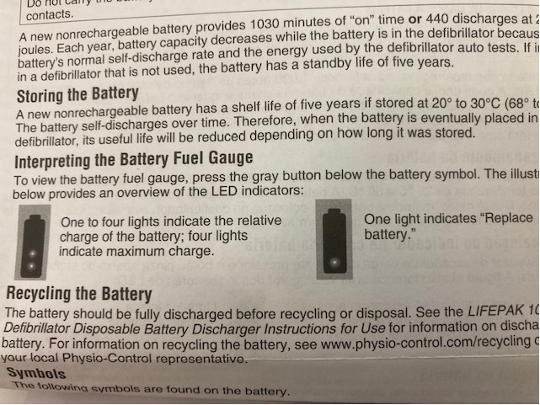

If two or less appear please record on the check sheet so a new battery can be ordered before the charge is fully depleted.