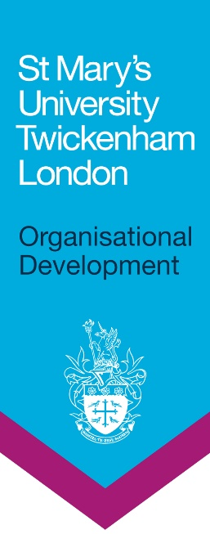

**2023 Aurora Leadership Development Programme for Women**

**What is Aurora?**

Aurora is the Advance HE’s leadership development programme for women. It aims to enable a wider range of women in academic and professional roles to think of themselves as future leaders, to develop the skills they will need and to help their institutions to maximise the use of the skills they acquire.

Whilst most leadership programmes are aimed at leaders and managers already in role, Aurora is designed to enable a wide range of women, in academic and professional roles in higher education, to engage with leadership development at an earlier stage in their careers. Aurora was designed to help address the issue of the reducing numbers of women in senior posts in higher education as outlined in the Leadership Foundation’s Stimulus Paper ‘Women and Higher Education: Absences and Aspiration’ by Professor Louise Morley (January 2013).

**What does Aurora cover?**

Aurora addresses core areas associated with leadership success:

* Understanding organisations and the sector
* Developing leadership behaviours, skills and knowledge
* Identifying and overcoming barriers and obstacles
* Growing confidence and a leadership identity
* Building networks, coalitions and support processes

Aurora will address these areas by using a combination of development days; self-directed learning that follows the interests, needs and time constraints of participants; action learning sets are organised and delivered locally and St Mary’s will provide in-house mentoring.

**Can I join the Aurora Programme if I am Non-binary?**

Yes, non-binary colleagues are welcome to apply for and take part in the Aurora Programme.

Please be aware that the programme has been developed as a positive action programme designed to address the underrepresentation of women in HE leadership. As such, many of the conversations throughout are focused on the lived experience of being a woman in HE, which may or may not be relevant to the experience of a non-binary person.

**What is the commitment?**

Aurora consists of seven interlinked days – five development days and two action learning set days. Aurora will take place online in 2023.

**Dates for 2023**

|  |  |
| --- | --- |
| Title | Date |
| Pre-programme briefing with applicants and managers | 10 January 2023 |
| Introduction and Guest Speaker | 18 January 2023 |
| Identity, Impact and Voice | 25 January 2023 |
| Core Leadership Skills | 1 March 2023 |
| Action Learning Set 1 | 30 March 2023 |
| Politics and Influence | 3 May 2023 |
| Adaptive Leadership Skills | 24 May 2023 |
| Action Learning Set 2 | 21 June 2023 |

Each participant must attend each of the development days – it is essential that you can commit to all of these.

**Eligibility criteria**

Aurora is open to academic and professional services women who meet the following criteria:

* You and your Institute/Faculty/Professional Service can commit and release the you for all of the dates for the programme.
* A need for leadership development has been identified on your most recent appraisal.
* You fall into one or more of the following categories:
  + Show visible capacity and ability for progression into a leadership role in the next 5 years.
  + Are new to a leadership role and would benefit from joining the programme and learning from lived experiences.
  + Supports the university’s ambition to diversify its talent pipeline into leadership roles.

Your eligibility will be assessed through the application form before being put forward to the Staff Development Panel for consideration.

**Selection criteria**

Participants on Aurora will experience education, mentoring and project work providing them with a learning experience with more enduring impact. Aurora provides a positive experience of leadership and encourages participants to recognise their talent and capabilities and ‘step-up’ to promoted posts.

St Mary’s University have a limited number of places. In addition to the eligibility criteria specified above, when selecting individuals for the programme we will take into consideration the following:

* Does the applicant show a clear commitment to demonstrating the university values?
* Has the applicant received formal leadership or management development previously?
* Will attendance on the programme contribute to the local Department plan and/or the University Vision?
* Is there a clear link between the programme content and the applicant’s personal leadership and development goals?
* Does the applicant show a clear commitment to taking an active part in furthering the ‘Aurora’ community of women leaders in the future?

You must clearly explain how you meet the selection criteria in your supporting statement.

**How to apply for the programme?**

Please complete the Expression of Interest Form in collaboration with your Line Manager, accessible from Organisational Development website pages (Leadership and Management Development section).

This should reach Organisational Development at [organisationaldevelopment@stmarys.ac.uk](mailto:organisationaldevelopment@stmarys.ac.uk) **no later than Friday 18th November 2022.**

We will confirm places by Friday 16th December 2022.

**Further information**

Please contact [organisationaldevelopment@stmarys.ac.uk](mailto:organisationaldevelopment@stmarys.ac.uk) if you have any questions.