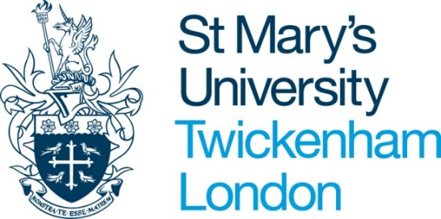

PROBATION REPORT FOR ACADEMIC STAFF

[This form can be completed and signed electronically. Please type directly into the boxes as indicated. The boxes will expand as required.]

Name (Printed)

Job Title

Faculty

Start date in post

Date of meeting
Probation Report  (please select by placing ‘x’ in box) | 1 ☐  2 ☐  3 ☐
 | Please use the separate Final Probationary Report form for the final probation meeting

Guidance Notes

The guidance notes are important and Line Managers should aim to follow them at all times.

- The probation period for academic staff is 12 months.
- Meetings should be arranged at 3, 6, 9 and 12 months into the probation period. Please use the Final Probation form for the 12 month review
- At the meeting the Line Manager should explain the standards of work required, acknowledging successes, but also explaining any areas where the employee has not met the standards required, if relevant.
- If performance is deemed to be unsatisfactory during the probation period the employee should be given an ‘Probation Personal Improvement Plan’ setting out the performance problem, the improvement that is required, the timescale for achieving this improvement, a review date and any support that will be given to assist the employee.
- Additional review meetings should be arranged if performance is deemed to be unsatisfactory during the probation period.
- All probation report forms and Probation PIPs will form the supporting documentation if an employee is dismissed during probation for unsatisfactory performance.
- The form should be completed by the Line Manager during the probation meeting.
- The Line Manager and employee should sign and date the bottom section of the form.
- The Line Manager and employee should keep a copy of the form and the original should be sent to the HR Department.

- PROBATION OBJECTIVES
Probation objectives clarify expectations for the member of staff on probation. In order to set objectives it will be useful to have a copy of the job description, the line manager’s objectives and University/Faculty/Institute objectives.

What should be achieved? | Has it been achieved and how (indicators of success and timescales)? (Line manager comments)
Objective 1:

Met/Not met
Objective 2:

Met/Not met
Objective 3:

Met/Not met
Objective 4:

Met/Not met
Objective 5:

Met/Not met
Development Objective(s)

Met/Not met

Employee comments on probation objectives:

- BEHAVIORS AND RELATIONSHIPS

Has the employee built good working relationships and exhibited appropriate behaviours?
Yes ☐ No ☐

- Comment on progress/performance

- ARE THERE ANY PROBATIONARY AREAS FOR IMPROVEMENT? Yes ☐No ☐

If yes, this should take the form of a ‘Probation Personal Improvement Plan’ setting out the performance problem, the improvement that is required, the timescale for achieving this improvement, a review date and any support that will be given to assist the employee. The PIP should be issued to the employee, a copy of this should be forwarded to the HR Department along with the completed probation report.

- TRAINING AND DEVELOPMENT

- Essential modules completed:
- Discovering St Mary’s Induction Event
(Discovering St Mary’s is a half day induction for all staff. Please contact organisationaldevelopment@stmarys.ac.uk for upcoming dates if your new starter had not yet completed this)
- Data Protection Briefing
- Dignity at Work
- Equality and Diversity
- Fire Safety
- Information Security Essentials
- Safeguarding Essentials
- Understanding Health and Safety
- Unconscious Bias

Yes ☐ No ☐

- Identify co-tutoring/mentoring arrangements that have been put in place:

- Identify any Learning and Teaching initiatives:

- Identify any training courses attended and benefits accrued:

- Areas for further development and learning:

Signed

Line Manager
Name

Employee

Please return the completed form (and Probation PIP if applicable) to the Human Resources Department or email to HR Services (hrhelpdesk@stmarys.ac.uk).

