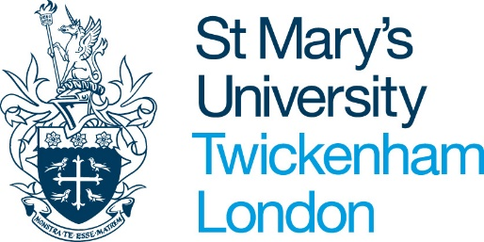

External Work Declaration Pro Forma 2019-20

Please complete this pro forma if you are intending to undertake work outside St Mary’s. You may accept other work as long as it does not interfere with the professional commitments of your contract with St Mary’s, does not conflict with the interests of St Mary’s, and the work has been approved in advance by your line manager and Senior Staff.

Please complete this form and have it signed by your line manager, before returning to your HR Partner.

If any objections are raised to the work you have declared, that will be communicated to you and you may be invited to explain the nature of the work more fully.

It is presumed that this form will be filled in after discussion with your line manager. If your line manager for any reason objects to your doing the work as defined, and you feel the objection is not justified, then you may write a letter to HR directly, giving full details of the work, as below, stating that your line manager would not sign this form, and requesting a meeting with a representative from HR or senior management, together with your line manager, in which the matter can be addressed and settled.

Name:
(BLOCK CAPITALS)
School:

Give the name and address of the company or organisation who will employ you.
What is the nature of the work?
When is the work to be done? (Please state how many hours and over what period of time.)
Has it been agreed with your line manager?
Yes
No

Please continue on a separate sheet if necessary.

Signature:
Date:

Request approved by line manager:

Line Manager Name:
Signature:
Date:

The line manager should now return the form to the relevant HR Partner.

For HR use: Employee notified on _ _ / _ _ / _ _

