

**PeopleNet Guidance**

**Headcount Online Approval Process**

# **Introduction**

If you have line management responsibilities you will be allocated the ‘Recruitment Manager’ functionality on your PeopleManager profile by the HR team. The following functionality will be available for Recruitment Managers:

* Creating a headcount control business case
* Starting the advertisement process
* Adding screening questions
* Viewing recruitment campaigns
* Viewing applications
* Conducting shortlisting
* Scheduling candidates for interview
* Making an offer
* Running management information reports

# **Accessing ‘Recruitment Manager’**

Go to your [People Manager account.](https://ce0230li.webitrent.com/ce0230li_web/core/dist/#/login?page=roles)

Select Recruitment Manager role from the drop-down list and then login

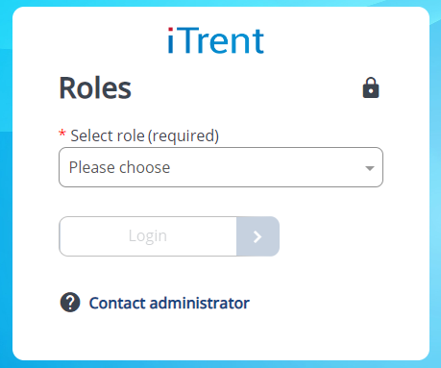

If the Recruitment Manager profile does not appear on your drop down then the profile has not been attached to your account. Please contact [hrhelpdesk@stmarys.ac.uk](mailto:hrhelpdesk@stmarys.ac.uk) to request that the profile is added to your account.

## **Headcount control process**

The Headcount control process is an online business case which works by utilising a series of workflows which sits in the background of PeopleNet. The purpose of the business case is to request not only recruitment activity but it is also used for the following purposes:

* Extending a fixed term contract
* Moving a temp to permanent employment
* Requesting a casual
* Increase in FTE
* Agency staff (including contractors)
* Recruiting casual staff

What you request will determine the workflow and the number of approvers needed. You can see the workflows in the table below:

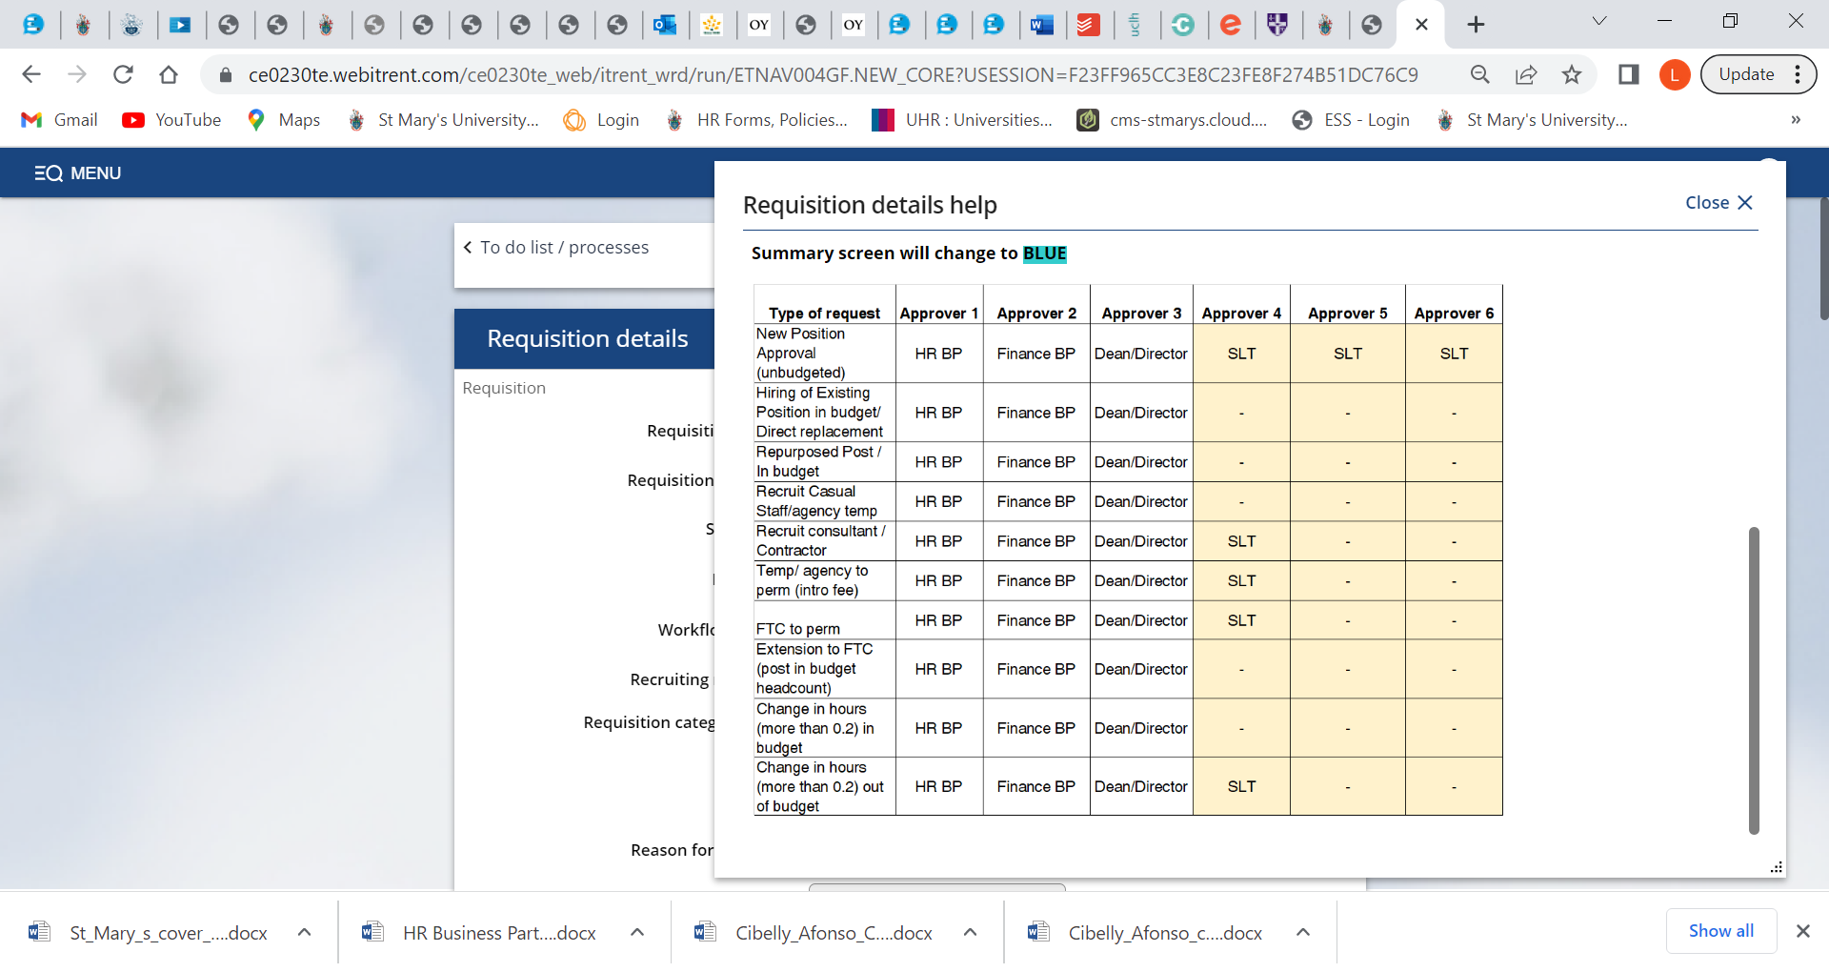

* 1. **Creating a new business case**

To create a new business case

* Log into your Recruitment Manager profile
* Select the Recruitment Summary tab

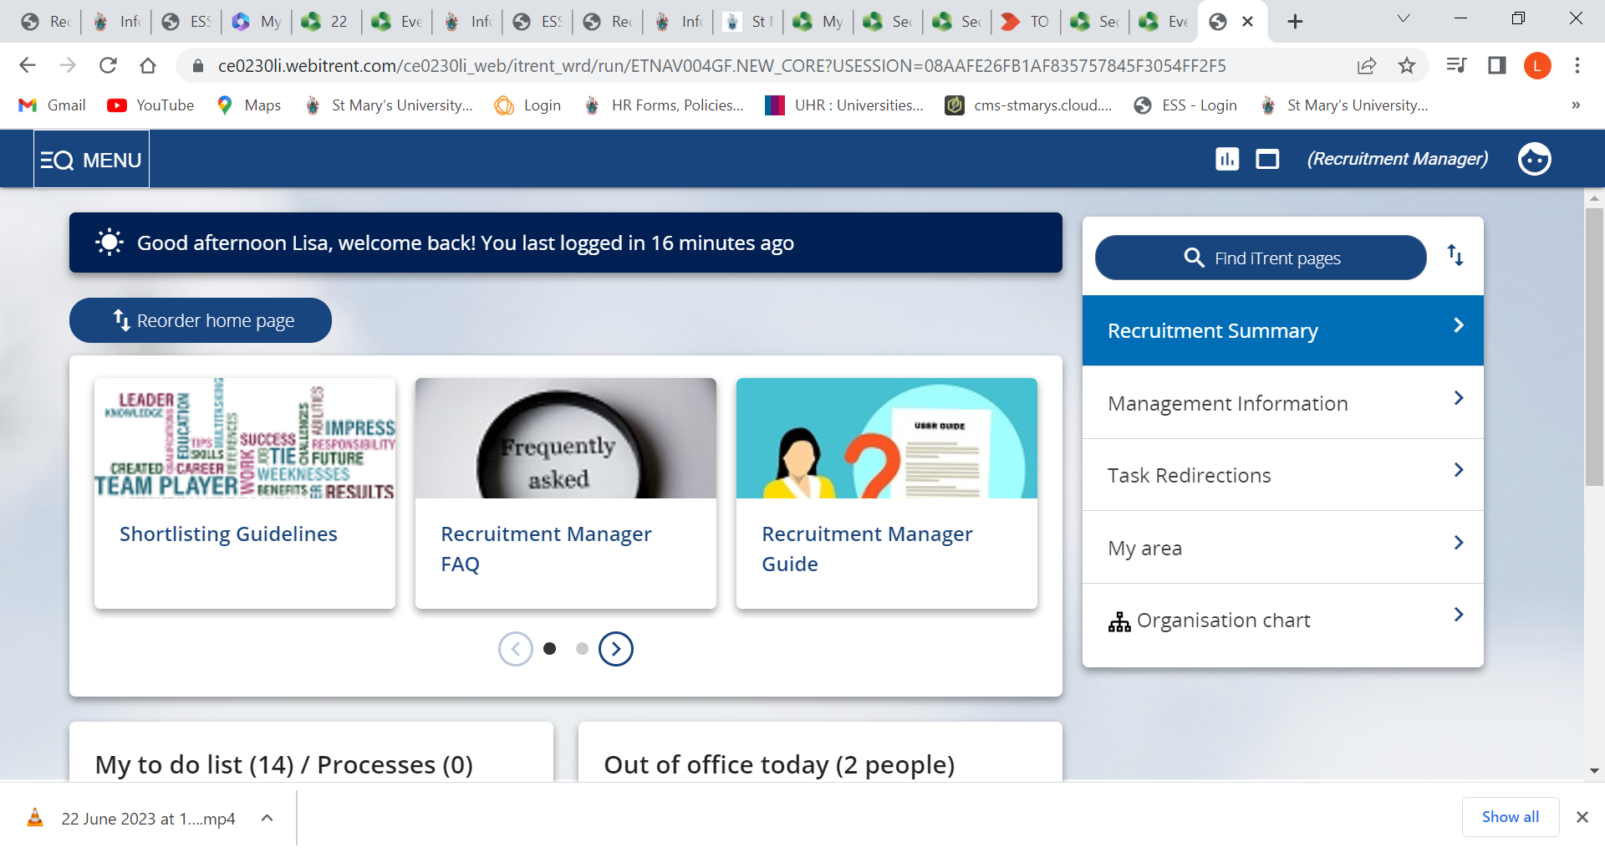

Select the

Recruitment Summary tab

The below screen should now appear, scroll to the bottom and click on the ‘**Step 1. Create new business case’** link at the bottom of the Recruitment Summary screen.

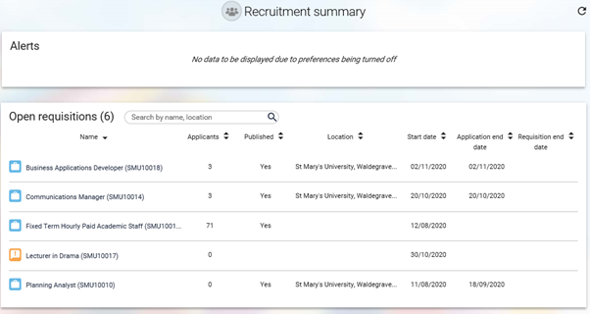

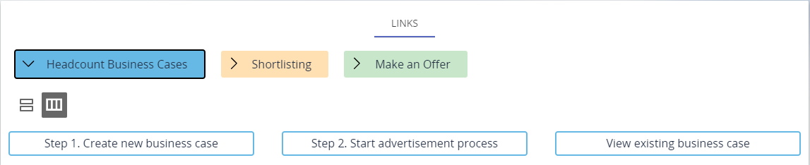

Select Step 1

A ‘Requisitions’ page will now appear. To complete your Headcount Control business case please fill in the form. Details on how to complete the business case are noted below.

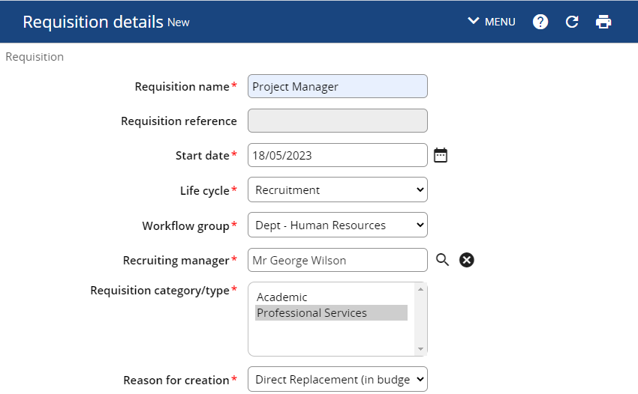

Select the role type

Select your department from the workflow group

Enter the current date (Today)

Click on the magnifying glass to select the recruiting manager (yourself)

Enter the name of the role here

Select the reason for the headcount business case

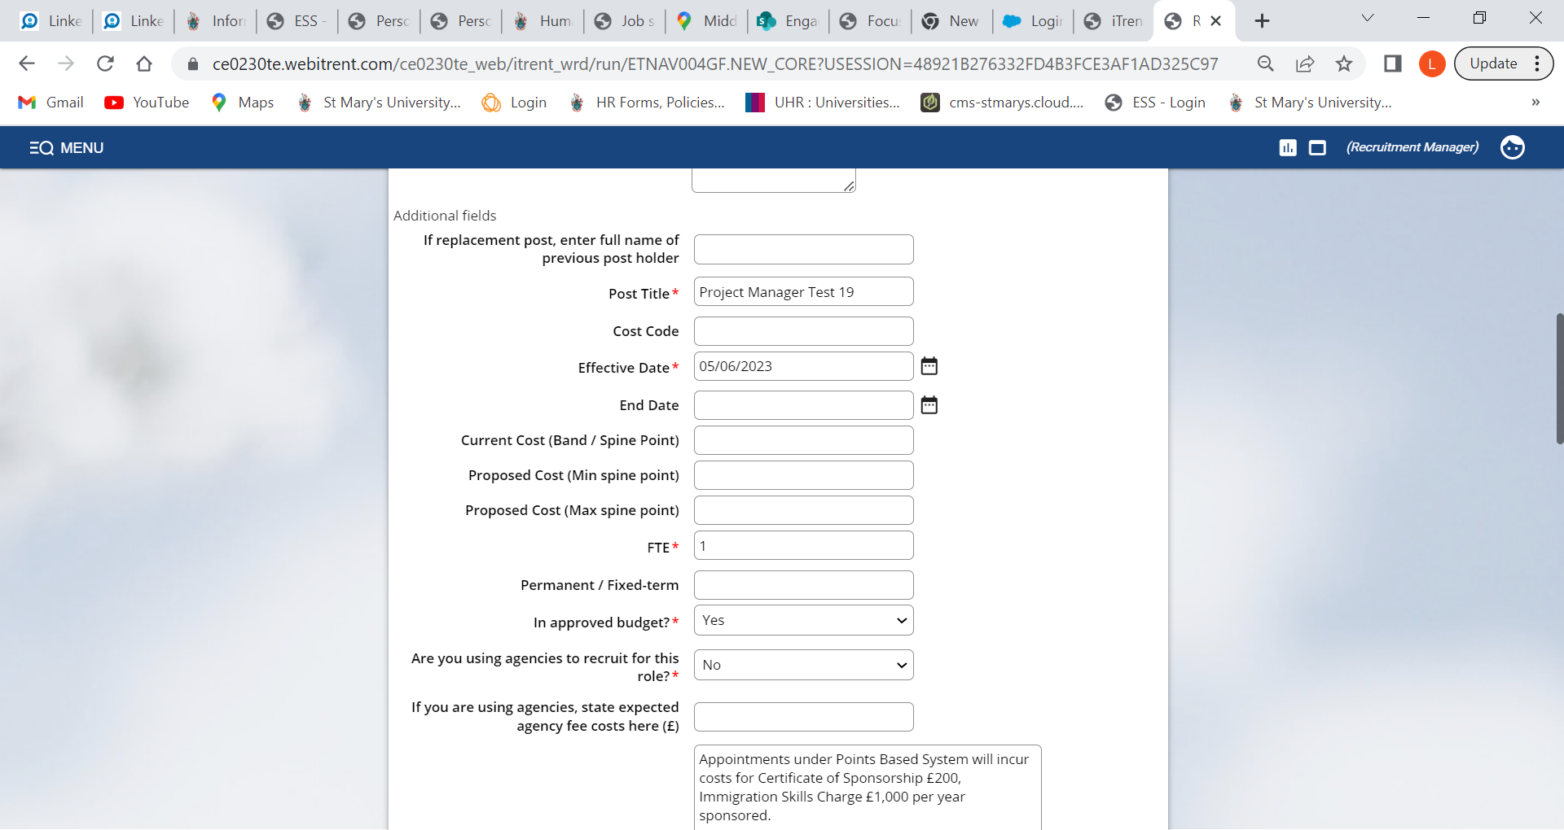

Please also fill in this box if you are recruiting for maternity cover or backfilling a secondment.

If you know you want to recruit through a recruitment agency please state yes and state expected costs in the box below. Please note recruitment agencies carry an extra cost which the department will have to fund.

If unsure, please consult your Finance Business Partner

Full time equivalent

Please enter min and max costs

Date you would like the role/change to start

Enter the post title again

Enter date you want role/change to end. Leave blank if permanent or not applicable.

When filling out the Headcount control business case you will need to justify your reasoning/rationale for your request. Please use the following boxes to outline your business case.

|  |  |
| --- | --- |
|  | Considerations |
| Additional Cost | * Appointments under Points Based System will incur costs for Certificate of Sponsorship £200, Immigration Skills Charge £1,000 per year sponsored. * Maternity cover will attract an extra cost. For more information please contact your Finance business partner. * Any other additional costs. |
| Business case | Please use this space to put forward your business case and the reasons for your request. You may wish to also consider the following:   * What are you trying to achieve through this request? * How does it link back to Vision 2030 and the strategic aims of the university? * What is a good outcome? * Why do we need this role? * What alternatives have you considered? * Workload of the team * Skills/ knowledge gaps * Gather data to support your request * Highlight the benefits |
| Financial implications | * If in approved budget, provide details. If not in approved budget how will savings/income generation be achieved to fund post. Include costing information. |
| University impact | * What improvements will be made to the team and wider University operation/student experience? * Is this post critical in meeting our regulatory/legal obligations, and if so how? |
| Any other considerations | * Is this a ‘difficult to fill post’ with a scarce skill set? * Is there a known equality impact across team and band? * Any other additional supporting evidence? |

Once you have completed the requisition form, click the green **Save** button at the bottom of the form. A notification will appear at the top of the page to confirm changes have been saved.



If you are recruiting then please attach the job description at this stage. You can do this by scrolling to the top of the form and attaching via the paperclip icon.

Your requisition will now be visible on the Recruitment Summary screen with an **ORANGE** icon indicating the progress of the requisition:

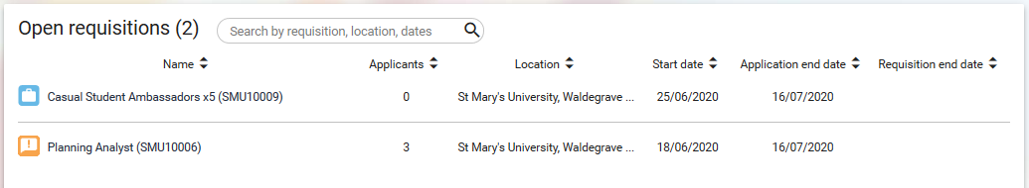

Pending approval from approvers

Once the business case has been approved by the required approvers (see table on page 3), you will be notified by email and the icon on the Recruitment Summary screen will change to BLUE:

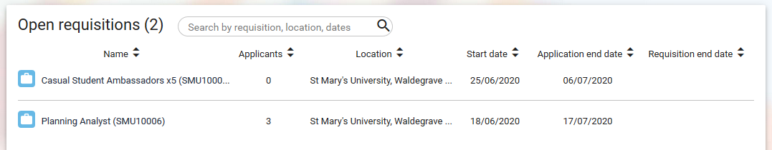

Authorised by required approvers

* If you are not intending to recruit then the process ends here. The email notification that you will have received stating that your request has been approved will contain detailed instructions on how to proceed with the next steps.
* If you now need to recruit – carry on reading the recruitment process guidance document.