Manager Briefing

COVID-19 and mental health
We all know the pandemic has been challenging, and it will come as no surprise that the Office for National Statistics (ONS) has found an increase in feelings of anxiety, and a decrease in life satisfaction, happiness and feeling worthwhile.
We don't yet know what the impact of the COVID-19 pandemic will be on long term mental health, but research suggests we can expect a noticeable increase in stress, anxiety, and related mental health problems in the workplace.
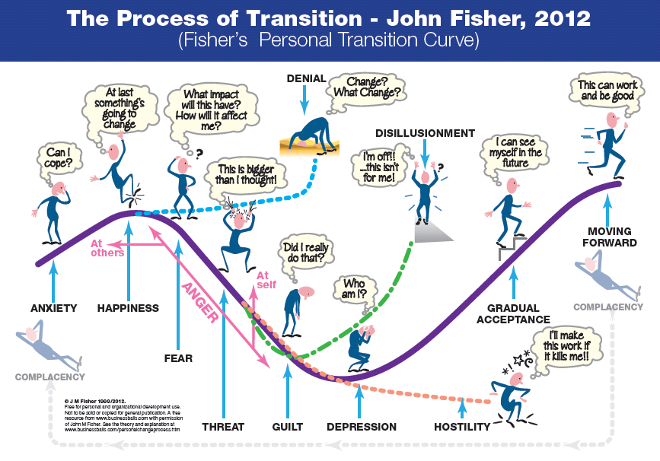
Our ability to process emotions about changes during the pandemic has been inhibited:
When major changes occur, there is a transition period. People may go through a range of emotions, including anxiety, fear, hostility and depression, before they accept the change and start to look at moving forward. However, the constant changes over the past year have left little time for people to process their emotions.
Figure 1: The Process of Transition - John Fisher
Mental Health problems have increased: Mind found that 60% adults and 68% young people said their mental health worsened during lockdown. According to the ONS “Around one in five (21%) adults aged 16 years and over in Great Britain experienced some form of depression (indicated by moderate to severe depressive symptoms) in early 2021 (27 January to 7 March), an increase from 19% in November 2020.”
Business Impact: In 2019/20 stress, depression or anxiety accounted for 51% of all work-related ill health cases and 55% of all working days lost due to work-related ill health.
COVID-19 is not the main driver: Analysis by the HSE indicates that while COVID-19 may be a contributory factor in work-related stress, depression, and anxiety, it “does not appear to be the main driver overall of these increases in work-related ill-health and injury”. This is consistent with the definition of stress as “the adverse reaction people have to excessive pressures or other types of demand placed on them”. COVID-19 creates additional pressure, but this does not inevitably lead to stress if this pressure is well managed.

Managing work-related stress
Pressure is a normal part of life. Stress happens when the pressure we are under starts to exceed our capacity to cope. COVID-19 and the changes that have taken place over the past 18 months have created huge pressures in our personal and professional lives. As a line manager you can help mitigate the impact of pressure and help your staff avoid stress, burnout and illnesses resulting from work related stress.
Your behaviour matters: Manager competency managing stress has been found to influence the risk factors associated with stress at work. This includes being respectful/responsible; managing and communicating work; managing difficult situations; and managing individuals effectively. The Health & Safety Executive have a free Stress management competency indicator tool which can help you reflect and assess your behaviour.
Help people process change: It is normal for people to have a range of reactions to change, and many of these may be challenging and lead to resistance. For many staff their ability to process change effectively will be inhibited by the period of constant change and additional pressure we have been under. Remember that you can validate people’s emotions without agreeing with them, and taking time to listen and understand people’s concerns will help you support them to change where they need to.
Consider Hybrid and Flexible Working: Many staff will be considering how they want to work going forward, and it will be important to balance the needs of individuals against the needs of students and your service area. You must have a valid business reason for turning down a flexible working request, and considering what your area needs ahead of time will help you manage flexible working requests smoothly. For more information see the Future of Work guidance here.
Being back in the office: Many people will be excited about returning to the office, while others will be anxious. Some people may have been on campus throughout, but have not had as many colleagues and students around them for some time. For everyone it is a big change that will take time to adjust to. Check in with how your staff are feeling, and consider ways to support them, such as phasing back into working on campus, or taking more frequent breaks during the day. Especially consider the impact of disabilities that might be impacted by a busy office environment, or changes to their routine. See UCU report Disabled workers returning to work for more information.

Mind, The mental health emergency
ONS, Coronavirus and depression in adults, Great Britain: January to March 2021
HSE, Work-related stress, anxiety or depression statistics in Great Britain, 2020
HSE, Potential impact of COVID-19 on HSE’s main statistical data sources in 2019/20
HSE, Work-related stress and how to tackle it
Toderi S, Sarchielli G. Psychometric Properties of a 36-Item Version of the “Stress Management Competency Indicator Tool”. International Journal of Environmental Research and Public Health. 2016; 13(11):1086. https://doi.org/10.3390/ijerph13111086

