PeopleNet Guidance
Recruitment Manager Guide

CONTENTS

Introduction 2
Accessing ‘Recruitment Manager’ 2
1. Headcount control process 2
2. Recruitment: Getting your role advertised and live 7
3. Viewing and downloading Applications 12
4. Shortlisting Process 13
5. Processing your applicants to the interview stage 18
6. Making an offer 20
Data Protection 22
Helpful Contacts 22

Introduction

If you have line management responsibilities you will be allocated the ‘Recruitment Manager’ functionality on your PeopleManager profile by the HR team. The following functionality will be available for Recruitment Managers:

- Creating a headcount control business case
- Starting the advertisement process
- Adding screening questions
- Viewing recruitment campaigns
- Viewing applications
- Conducting shortlisting
- Scheduling candidates for interview
- Making an offer
- Running management information reports

Accessing ‘Recruitment Manager’

Go to your People Manager account.

Select Recruitment Manager role from the drop-down list and then login
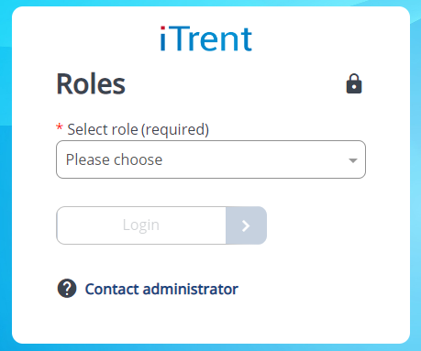

If the Recruitment Manager profile does not appear on your drop down then the profile has not been attached to your account. Please contact hrhelpdesk@stmarys.ac.uk to request that the profile is added to your account.

Headcount control process

The Headcount control process is an online business case which works by utilising a series of workflows which sits in the background of PeopleNet. The purpose of the business case is to request not only recruitment activity but it is also used for the following purposes:
- Extending a fixed term contract
- Moving a temp to permanent employment
- Requesting a casual
- Increase in FTE
- Agency staff (including contractors)
- Recruiting casual staff
What you request will determine the workflow and the number of approvers needed. You can see the workflows in the table below:

  - Creating a new business case
To create a new business case

- Log into your Recruitment Manager profile
- Select the Recruitment Summary tab

Select the
Recruitment Summary tab

The below screen should now appear, scroll to the bottom and click on the ‘Step 1. Create new business case’ link at the bottom of the Recruitment Summary screen.

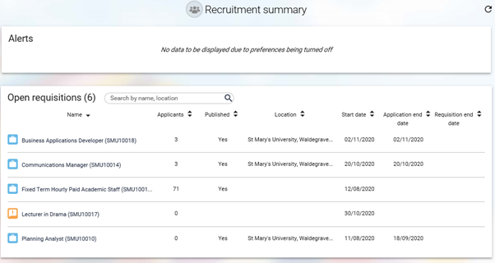
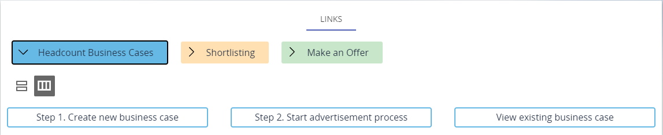

Select Step 1

A ‘Requisitions’ page will now appear. To complete your Headcount Control business case please fill in the form. Details on how to complete the business case are noted below.
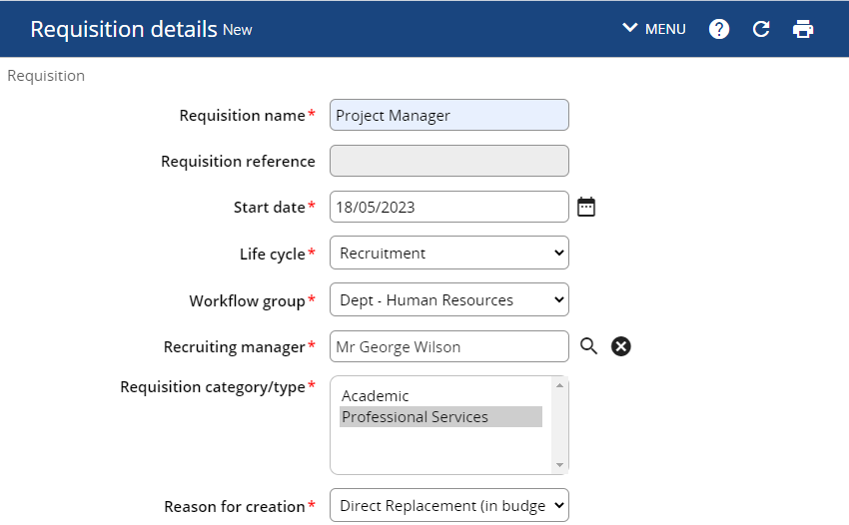
Select the role type

Select your department from the workflow group

Enter the current date (Today)

Click on the magnifying glass to select the recruiting manager (yourself)

Enter the name of the role here

Select the reason for the headcount business case

Please also fill in this box if you are recruiting for maternity cover or backfilling a secondment.

If you know you want to recruit through a recruitment agency please state yes and state expected costs in the box below. Please note recruitment agencies carry an extra cost which the department will have to fund.

If unsure, please consult your Finance Business Partner

Full time equivalent

Please enter min and max costs

Date you would like the role/change to start

Enter the post title again

Enter date you want role/change to end. Leave blank if permanent or not applicable.

When filling out the Headcount control business case you will need to justify your reasoning/rationale for your request. Please use the following boxes to outline your business case.
 | Considerations
Additional Cost | - Appointments under Points Based System will incur costs for Certificate of Sponsorship £200, Immigration Skills Charge £1,000 per year sponsored.  - Maternity cover will attract an extra cost. For more information please contact your Finance business partner.  - Any other additional costs.
Business case | Please use this space to put forward your business case and the reasons for your request. You may wish to also consider the following:  - What are you trying to achieve through this request?  - How does it link back to Vision 2030 and the strategic aims of the university?  - What is a good outcome?  - Why do we need this role?  - What alternatives have you considered?  - Workload of the team  - Skills/ knowledge gaps  - Gather data to support your request  - Highlight the benefits
Financial implications | - If in approved budget, provide details. If not in approved budget how will savings/income generation be achieved to fund post. Include costing information.
University impact | - What improvements will be made to the team and wider University operation/student experience?  - Is this post critical in meeting our regulatory/legal obligations, and if so how?
Any other considerations | - Is this a ‘difficult to fill post’ with a scarce skill set?  - Is there a known equality impact across team and band?  - Any other additional supporting evidence?

Once you have completed the requisition form, click the green Save button at the bottom of the form. A notification will appear at the top of the page to confirm changes have been saved.

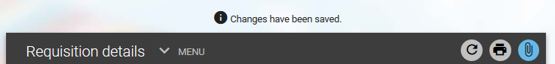

If you are recruiting then please attach the job description at this stage. You can do this by scrolling to the top of the form and attaching via the paperclip icon.
Your requisition will now be visible on the Recruitment Summary screen with an ORANGE icon indicating the progress of the requisition:

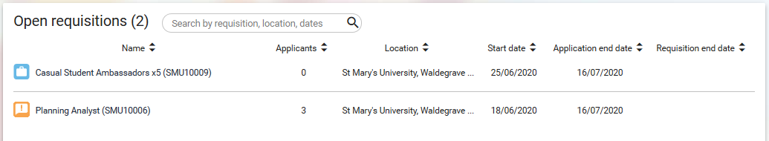
Pending approval from approvers

Once the business case has been approved by the required approvers (see table on page 3), you will be notified by email and the icon on the Recruitment Summary screen will change to BLUE:

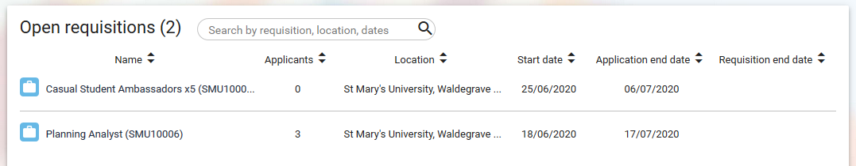
Authorised by required approvers

- If you are not intending to recruit then the process ends here. The email notification that you will have received stating that your request has been approved will contain detailed instructions on how to proceed with the next steps.

- If you now need to recruit – carry on reading!

Recruitment: Getting your role advertised and live

Once your business case has been approved you can start the process to advertise the role. To upload your job advert text, add shortlisting criteria and add screening questions, click on the ‘Step 2 Start advertisement process’ link at the bottom of the Recruitment Summary screen.

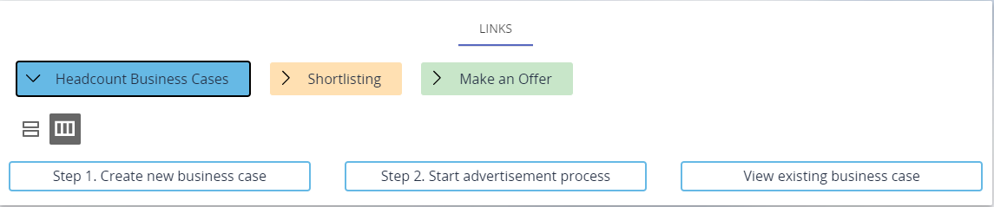

The page will refresh and display as shown below.

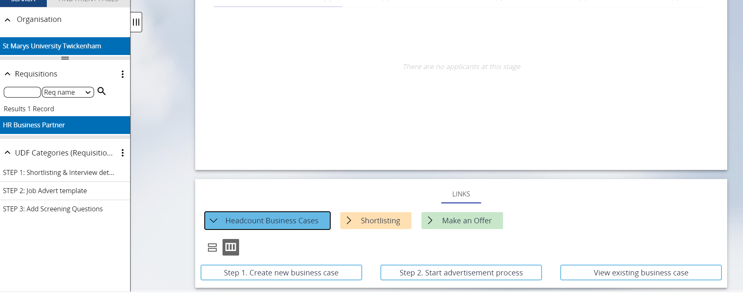
Please note the new steps on the left-hand side.

Click on ‘STEP 1: Shortlisting & Interview details’ to start adding shortlisting criteria for this role and click SAVE. This is the information that HR will use to set up the interview and create an application form (if required) for your role.

- Shortlisting criteria and creating application form questions

Shortlisting criteria are the set of factors that you will use to decide who to hire. These factors will be listed on the job description under the ‘Person Specification’ and will be the Essential and Desirable skills, experience, qualifications that the candidate will need to demonstrate in order to be selected for interview. There are 5 boxes that look like the below:

- The smaller box is the shortlist criteria, this is where you will put the skill, experience or qualification that is essential for the role.
- The second larger box is the ‘description for shortlist criteria’. This is where you will ask the candidate to demonstrate the criteria. This will appear on the candidate’s application form as below:

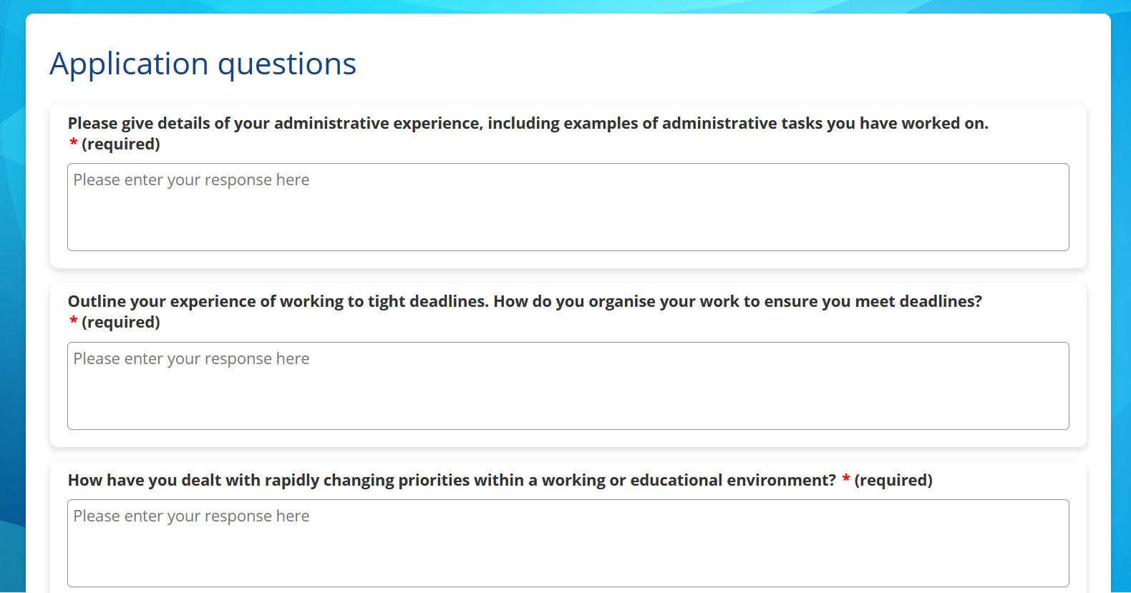

- The maximum number of characters for each answer is 9999 but if you wish to reduce that then please include this request in the box.
- An application form allows you to cover the relevant criteria quickly and is easy to score, but a CV may uncover details about the candidate which you would never have thought to ask.
- If you don’t want to have application form questions and you want a CV and Statement only application then do not fill out the ‘description for shortlist’ box.

Once you’ve completed this form and pressed save you can move onto step 2.

Click on ‘STEP 2: Job Advert template’ to start completing the job advert for this role and click SAVE.

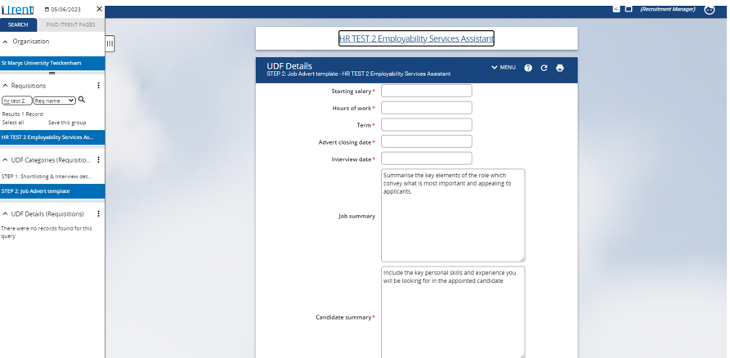
Click on ‘STEP 2: Job Advert template’ to load the page

- Click on Step 3 ‘Add Screening Questions’
Screening questions are optional but they may help you to filter out those candidates who do not have the absolute essential criteria that you need for the role. For example, if the role is for a driving instructor, one of your screening questions may ask if the candidate holds a driving licence. If they say no, then they will not be able to continue with the process. Screening questions are asked at the beginning of the process and must be an essential part of the job description. They must be fair and proportionate. You can also ask candidates if they hold the right to work in the UK.

You can have a maximum of 3 questions. Once you’ve submitted your questions then click save.

You’ve now completed the first part of the recruitment process – the HR recruitment team will process your campaign for you and make it live. If you have any queries at this stage please email hrhelpdesk@stmarys.ac.uk.

  - Viewing your existing business case
If, at any point after you have pressed save, you would like to review your existing business case return to the Recruitment Summary screen by clicking on the navigation button at the top of the Requisition Summary screen

To view the basic details of your requisition/recruitment campaign e.g. reference number, closing date etc. select the name of the requisition on the Recruitment Summary screen:

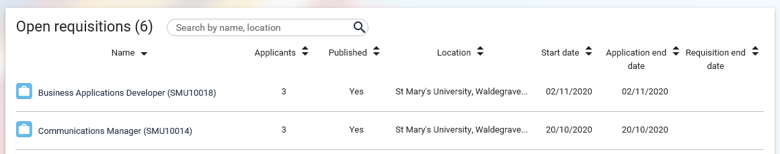

Alternatively, you can perform a search via the left-hand panel search field and then select the requisition you want to view details for:

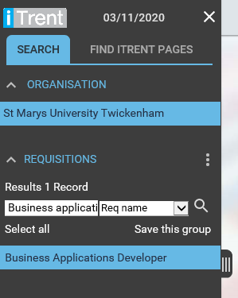

Scroll down to your available links and select View Existing Requisition Details under Headcount Business Cases:

Details of the requisition will display on this page (refer to section 1.2 for more information on this).

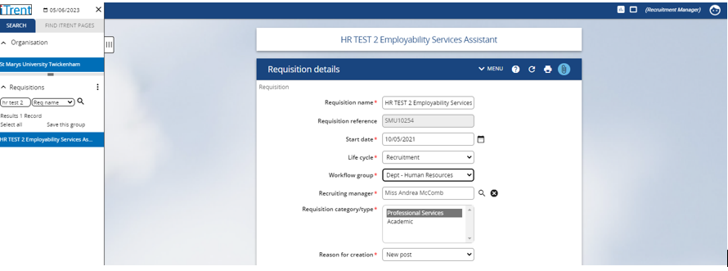

*If you need to make any changes to the information on this page, please contact the Recruitment team via HRhelpdesk@stmarys.ac.uk

Viewing and downloading Applications

You can view completed applications before the deadline. There are two ways in which you can view and download applications (the second way is shown in section 4). You can download an applicant’s application form and any other documents which they have attached with their application from the Requisition Summary screen. To do this, select the ALL DOCS button next to the applicant’s name and the application or attachment you want to download:

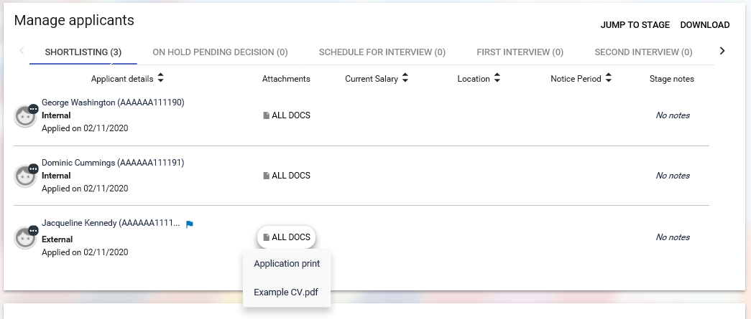
The selected attachment will open a PDF document which can be viewed for shortlisting purposes.

The PDF document can also be printed or saved to an external folder.

If you save applications outside of the recruitment system you must ensure this is not in a shared area and/or password protect the document(s).
You will need to ensure that all applications stored outside of the recruitment system are deleted once the recruitment campaign is finished. Failure to do this could result in a breach of our Data Protection Policy regarding the storage and retention of applicant’s information.

If you want to download all documents across all stages of the requisition or attachments for a single stage (e.g. Shortlisting), select the DOWNLOAD button and the stage required:

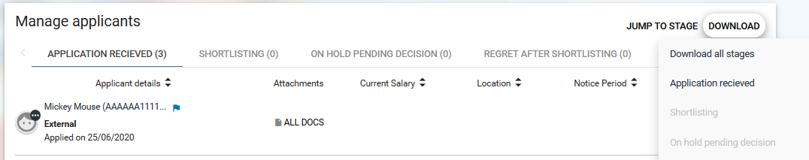

Shortlisting Process

Applications can be viewed once the advert has closed, however you should shortlist applications as per the guidance within the Recruitment & Selection policy.

  - Review Requisition Campaign Summary
You will be notified by email when the advert for your vacancy has closed and candidates are ready to be shortlisted. To start shortlisting, click on the Shortlisting folder at the bottom of the Requisition Summary and select Review Requisition Campaign Summary.

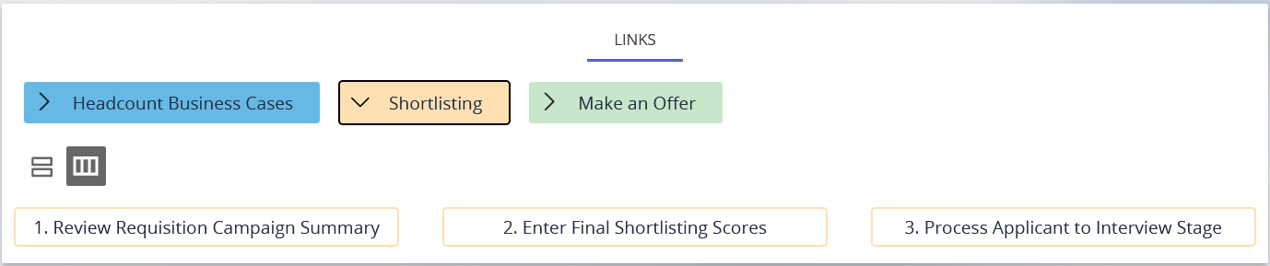

The Requisition Campaign Summary provides you with a summary of the details for a selected requisition:
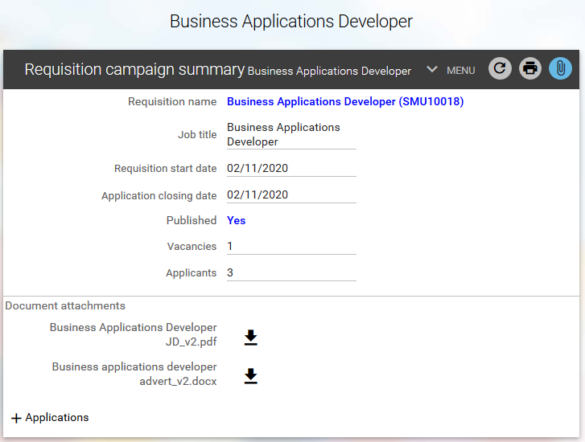
The name is a hyperlink which when clicked will open a new view and display the relevant Requisition details page.

This field displays the total number of vacancies for the selected requisition.

This field displays the total number of applicants for the selected requisition.

This is the advert closing date

This field will display Yes if the job has been published to web recruitment.

The page makes use of plus + and minus - icons which when clicked will expand or collapse the display of additional information.

To view a list of applicants who have submitted an online application, select the + plus icon next to Applications.

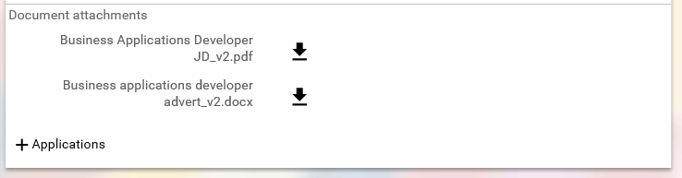
You can now click on the + icon next to the Shortlisting stage to view the applicant details (applications and any attached documents):
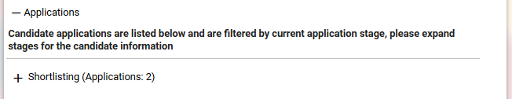

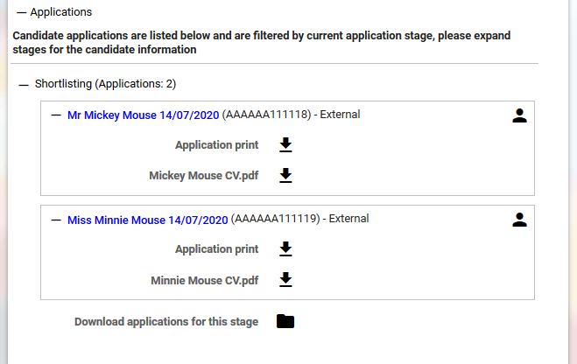
Click to view/download individual applications and documents

Shows total number of applications received

To view an individual application form, click on the button this will open a PDF document which can be viewed for shortlisting purposes.

The PDF document can also be printed or saved to an external folder.

  - Download All Applications in Bulk
Click on Download applications for this stage on the Requisition Campaign Summary page to download all candidate application forms and attached documents:

You will be prompted with a confirmation screen asking if you want to continue with the bulk download process:

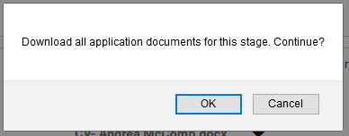

A message will appear to confirm the bulk application download is being compiled as a background process:

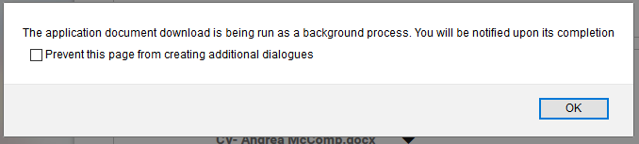

You will receive an email to confirm the bulk application download process has finished and a message will also appear at the top of your Recruitment Manager screen:

An alarm icon will also appear at the top left-hand corner of your screen to notify you when the bulk application download process has completed:

Click on the alarm icon at the top of the page to go to your to-do/processes section of iTrent where you can download the applications. You can also access your to-do list from the Recruitment Manager homepage (refer to the People Manager guide for more information on this)

Select the Processes tab on your to-do list to view the completed process and click on the arrow next to the process to go to the downloads page:

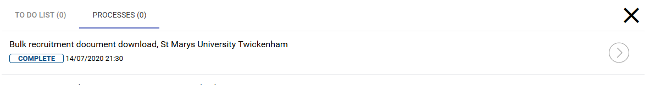

You will be able to download your document by selecting the ‘select all’ check box and then clicking on download button:

The applications will be available to open/save as PDF documents stored in a compressed folder in your own ‘Downloads’ folder on your laptop or PC:

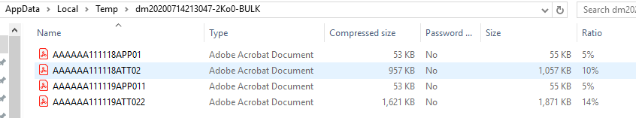

  - Scoring
Shortlisting can be conducted after the advert closing date. Please note however – panel members must enter their scores/comments before the Recruiting Manager.

Record final scores for applicants

To begin shortlisting, navigate to the additional links under the Requisition Summary screen. To record scores on the recruitment system, select the Shortlisting folder from the available links under the requisition summary screen and click on 2. Enter Final Shortlisting Scores.

Clicking on this link will take you to the shortlisting details page displayed below. All applicants will display on the left-hand panel, select an applicant’s name for the shortlisting page to load for the chosen applicant.

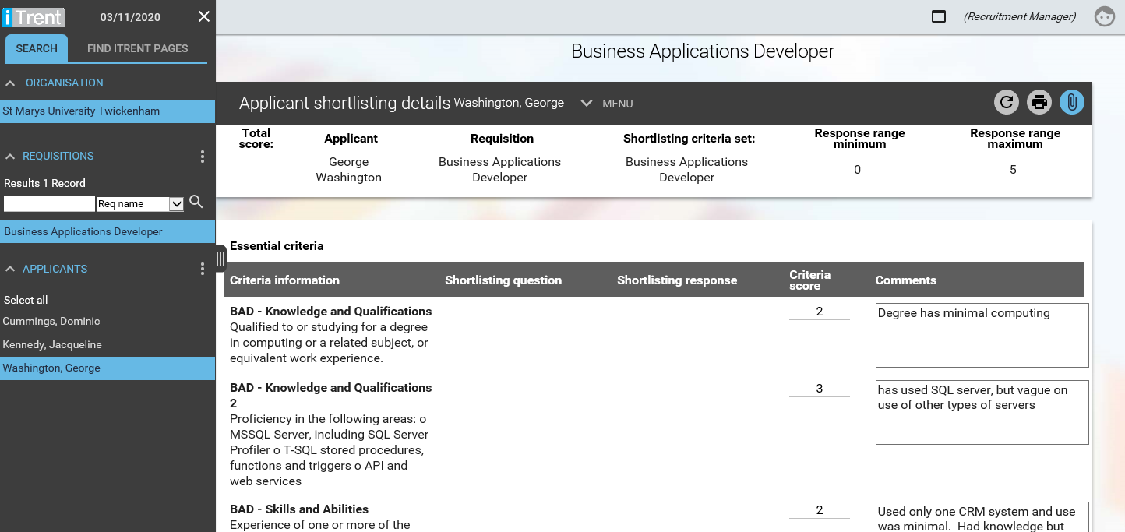
Click on the applicant’s name to display shortlisting details

Enter the final score/comments

Expand the + icon to view panel member scores/comments

You must complete the above for each applicant by selecting the applicants name from the list on the left-hand pane and entering the total scores against each shortlisting criteria.

Once you have entered the final scores against the applicant, click SAVE. A notification message will appear at the top of the screen to confirm the changes have been saved:

The recruiting manager must record the final scores for each applicant on the recruitment system before candidates can be invited for interview.

Processing your applicants to the interview stage

Once the Recruiting Manager has completed shortlisting on Recruitment Manager, the next step is to move the shortlisted candidates to the next stage on the recruitment system. This will allow HR to create and send the invite to interview emails.

To start this process, you will need to move shortlisted candidates to the Schedule for Interview stage of the recruitment campaign:

Select the Shortlisting folder from the available folders under the Requisition Summary screen and click on 3. Process applicants to interview stage.

You will be prompted to confirm the effective date (today):

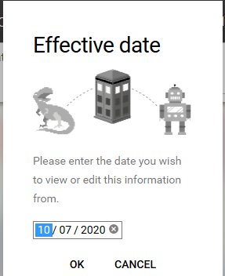

The Requisition Processing page will load and is used to process the applicants forward through the recruitment system:

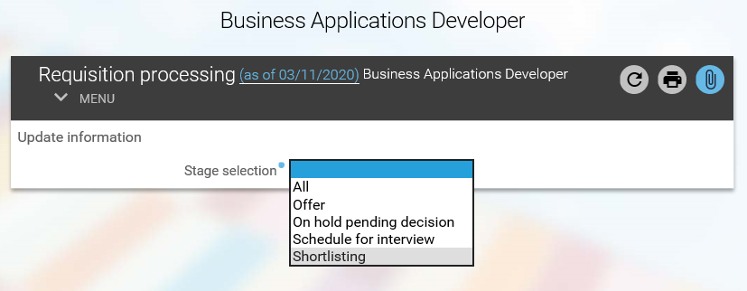
Select Shortlisting here

For the Stage Selection field, you must select the Shortlisting stage from the drop-down menu to start the process. Selecting the Shortlisting stage will load all applicants at the shortlisting stage of the recruitment campaign for the selected requisition:

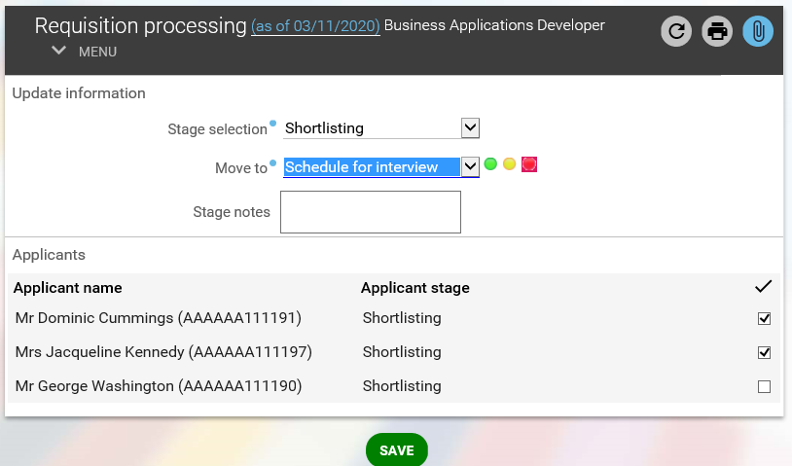
This is the stage that all shortlisted candidates will be moved to once you save this page

Tick the box next to each shortlisted candidate to select them to be invited for interview
Selecting this stage will display a list of all applicants at the shortlisting stage of the recruitment campaign

To schedule candidates for interview you must select the Schedule for interview stage from the drop-down menu for the field ‘Move to’.

Select the shortlisted applicants you want to progress to schedule for interview stage of the recruitment campaign and click SAVE. A notification message will appear at the top of the screen to confirm the changes have been saved and an email will be sent to HR to invite the selected candidates for interview.

Candidates will be invited to book an interview slot via the online recruitment portal and the recruiting manager will be notified every time a candidate has booked/deleted an interview slot.

Making an offer

Once the interview process has been completed the recruiting manager must process the appointed candidate on the recruitment system.

To do this, select the Make an Offer folder from the available links in the requisition summary screen.
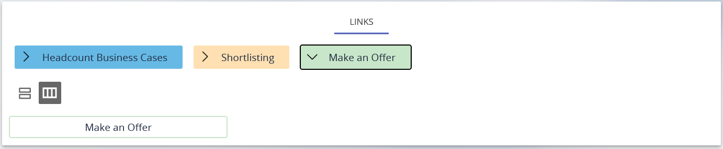
Select the Make an Offer button to load a list of candidates on the left-hand panel:
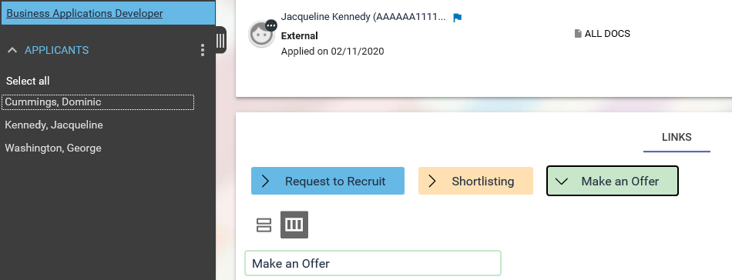

Select the name of the appointed candidate and confirm the effective date (today):

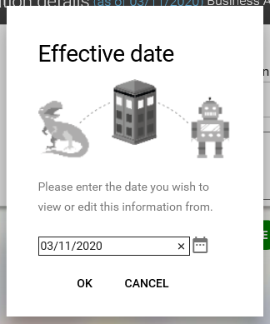

The Application details page will load showing the appointed candidates (in this example we are appointing George Washington) stage details.

To make an offer, you must change the stage to Offer stage on this page, this will now reload the page with additional details of the offer.
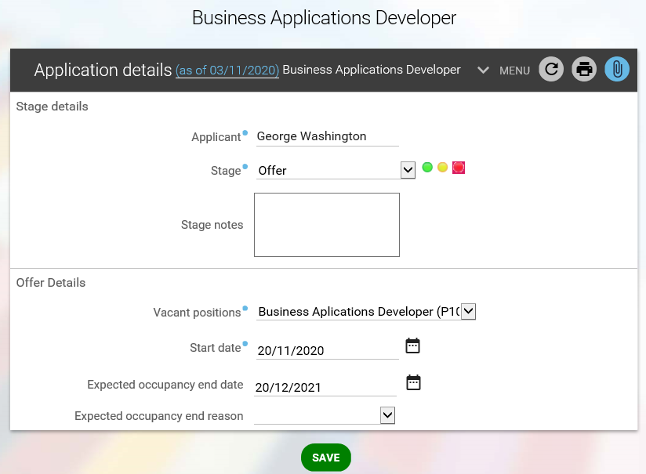
Change stage to OFFER

Select the recruiting vacancy

Enter the anticipated start date for the new member of staff
Select the vacancy for this requisition from the drop-down menu for Vacant positions and enter the Start date of the employee (this can be an anticipated start date or the start date discussed with the candidate during interview). You can also choose to enter an expected occupancy end date and add notes (for the attention of HR) against this appointment in the box provided. Once complete, click SAVE.

A notification message will appear at the top of the screen to confirm the changes have been saved and an email will be sent to HR to start the offer and appointment process for your new starter:

You must email a completed Appointment form to HRhelpdesk@stmarys.ac.uk as soon as you have completed this process on Recruitment Manager. The Appointment form template can be found here: https://www.stmarys.ac.uk/hr/docs/recruitment/appointment-sheet.docx

Once the offer has been made on Recruitment Manager, and on receipt of the Appointment form, HR will pick up from the system that you have offered the post and will issue a formal conditional offer and commence pre-employment checks.

HR will contact you once all the pre-employment checks are completed. You can then arrange a definite start date with the successful candidate

Please note that the start date of your new member of staff will be confirmed once HR have completed all pre-employment checks and a start date has been agreed with the new starter.

Data Protection

As Recruitment Manager contains detailed position information including salary scales it is important that you use it responsibly to ensure that the security of this information is maintained at all time.

Therefore, when you have finished using Recruitment Manager, please always ensure that you logout.

It is also important that you never let anyone else know your username and password as this information would allow people to access information on you and your staff through Recruitment Manager, exposing a risk of identity fraud.

Helpful Contacts

If you have any questions, queries or issues when using the recruitment system or about the recruitment process please contact:
HRhelpdesk@stmarys.ac.uk

