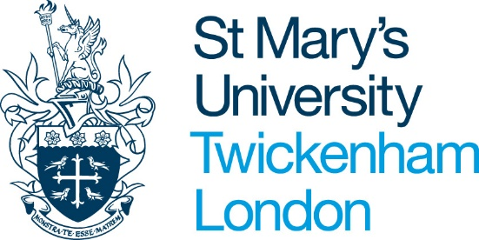

Job Title:
Department:
Reports To:
Responsible for:
Grade:
Pay Spine:
Salary:
Hours:
Term:
Overview
As the University builds on its proud heritage, we are looking for exceptional people to help shape our future. We provide a high-quality professional environment, inspired by our distinctive ethos and Catholic mission and values. Our values of excellence, generosity of spirit, inclusiveness and respect inspire us to create an academic community in which everybody is welcomed and which puts the student at the centre of all our endeavours.
With over 6,000 students the University makes significant contributions to its local community and the wider society, empowering its staff and students to have a positive impact on the world. The University’s academic structure is focused around three Faculties, each comprising two to three Schools. Our academic portfolio embraces the Social Science, Allied Health and Sport, Teacher Education, and Theology and the Liberal and Creative Arts.
St Mary’s is committed to providing our students with a transformational experience. The University’s Vision 2030 outlines our approach and guides our supporting strategies, operating plans, and team and individual targets for achieving this. This includes extending our impact through growth to ensure future sustainability. We are focused on delivering outstanding teaching and pastoral support to our student population, as well as expanding and internationalising our academic portfolio of programmes. As we continue to expand our reach, our shared goals and values underpin a flourishing network of trusted partners, both at home and overseas, enabling us to promote our global profile and reach diverse communities.
School/Service Information:
Introduce your School/Service here

Job Purpose:
Outline the purpose of the role here

Main Duties and Responsibilities:
Use the following key words as headings or to help you capture all of the duties and responsibilities required of the role (links to HERA Job Evaluation criteria):

Communications
Teamwork and Motivation
Service Delivery
Decision Making
Planning and Organising
Initiative and Problem Solving
Analysis and Research
Teaching and Learning
Management
Team Management

PERSON SPECIFICATION
 |  | Assessed by
Selection Criteria | Essential (E) Desirable (D) | Application | Interview | Skills Test
Knowledge and Qualifications
Skills and Abilities
Personal Attributes

University Policies and Procedures
All staff are expected to undertake their work in an inclusive, fair, safe and respectful manner, particular consideration should be given to the University values.

St Mary’s University reserves the right to change and amend this Job description/Person Specification in accordance with the changing requirements of the organisation.

Written by:
Approved:

