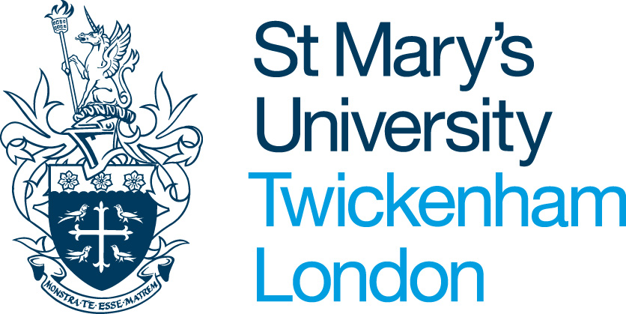

ANNUAL SEASON TICKET LOAN APPLICATION

Full Name:

Department / Faculty

Phone number:

Type of Ticket:

Commencement Date:

Cost:

Operating Company:

Photo Card Number:

NOTES
- St Mary’s University will make interest free loans available to employees solely for the purchase of annual season tickets for travel by rail (second class fare), bus or other approved transport. Evidence of purchase of ticket may be requested.
- No employee of St Mary’s University will be allowed more than one loan in any period of twelve months (unless the first loan is repaid in full).
- The cost of the ticket will be deducted from salary in equal instalments of up to 12 months.
- The employee receiving the loan will remain responsible for complying with any conditions imposed by the carrier concerning use, loss, transfer, refunds etc. In the event of a loss of ticket, deductions will continue unabated until the original loan has been paid off.
- In the event of termination of employment before the loan is repaid, the full balance outstanding will be deducted from the final salary payment and, if this is insufficient, the balance by direct payment from the employee.
- The scheme may be withdrawn under 3 months’ notice.
- Staff in receipt of annual season ticket advances will not normally be permitted to claim reimbursement of travel expenses on St Mary’s University’s business for journeys covered by the ticket.
- When an employee has already purchased an annual ticket, the may request reimbursement upon providing proof of purchase

I agree to the above conditions and hereby authorise the payroll deduction:

Name (Printed): |  |  | Signature:

Date:

On completion, please return this form to the Human Resources Office

Please allow a minimum of 10 working days’ advance notice for processing time.

For Official Use (Human Resources)

Total Cost
Months | Monthly Deduction

Date Form Received ____________________

Cost code 9000/51440

