Equality Analysis Checklist

To be used when filling in the EA Proforma if new to equality analysis (EA).
Equality Analysis should be an integral part of policy development and decision-making at the University. All protected characteristics must be taken into account and considered from the very outset of policy formulation. This approach will be most effective when incorporated into day-to-day policy-making, business-planning and other governance decision-making arrangements. It can help to identify practical steps to tackle any negative effects or discrimination, to advance equality of opportunity and to improve relations between different groups.

The following is a quick reminder to help you with the EA process whether you are producing a formal report to accompany a major policy or just thinking through a decision or process.

There are seven stages: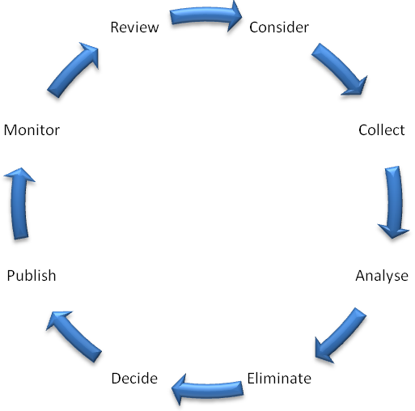

Include the following information as part of your equality analysis:
- Name of policy or subject of review/decision
- Purpose of the policy/review/decision - what is it trying to achieve?
- Department responsible

- Person responsible for policy/review/decision
- Name(s) of assessor(s) if different
- Date of Equality Analysis
- For formal policies:
  - Has the policy been subject to EA previously?
- If so, what are the main changes?:
  - Which committee formally approves this policy?
- Who has responsibility for its update and when will this be undertaken?

Stage 1 - Considering any potential impact:
- How important is the policy to equality and good relations? Please explain.
- Who could be affected and how?
- Can you identify any potential adverse impact on groups with protected characteristics?

Stage 2 - Collecting the relevant data:
- What evidence have you gathered to help you to assess the impact of this policy on particular groups? Please give details.
- Have you taken any additional steps to fill the information gaps where relevant? Please give details.
- What consultation has been undertaken as part of this equality analysis? Please state who has been consulted, how and when.
- What were the results of the consultation? Please summarise.

Stages 3 and 4 - Analysing the evidence and eliminating or reducing any adverse impact found:
- Is there, or could there be, an adverse impact (direct or indirect discrimination) on people with any of the following protected characteristics? Please explain.
  - Age
  - Disability
  - Gender re-assignment
  - Race (including ethnic and national origin, colour and nationality)
  - Religion or belief
  - Sex (including pregnancy and maternity)
  - Sexual orientation
  - Marriage and civil partnership (discrimination in employment only)
  - Other – eg, part-time
- Where any adverse impact is identified, please detail the following:
  - Any adverse impact and any possible causes

  - The action(s) identified to address any adverse impact
- Where any adverse impact cannot be addressed, please explain the justification.
  - Is there, or could there be, an opportunity to advance equality of opportunity or foster good relations? If so, please detail the following:
  - The protected characteristic(s) affected
  - The action(s) needed to advance equality and/or foster good relations

Stage 5 - Making a decision and communicating
- Your decision should be one of the following:
- No major change – your analysis demonstrates that the policy is robust, that the evidence shows little or no potential for discrimination and that you have taken all appropriate opportunities to advance equality and/or foster good relations between groups.
- Adjust the policy – this involves taking steps to remove barriers or to better advance equality.
- Continue the policy – this means adopting your proposals, despite any adverse effect or missed opportunities to advance equality, provided you have satisfied yourself that it does not unlawfully discriminate.
- Stop and remove the policy – if there are adverse effects that are not justified and cannot be mitigated, you will need to consider stopping the policy altogether.
- Where any adverse impact has been identified and addressed, you need to consider the impact of your final decision on other equality groups and how this will be communicated.
- Is there any potential positive impact or opportunity that can be highlighted

Stage 6 - Publishing the Equality Analysis and Keeping Evidence
- Where appropriate, include the following statement at the end of the document: ‘Equality issues have been taken into account during the development of this document/policy/review and all protected characteristics have been considered as part of the Equality Analysis undertaken.'
- When you are in a position to make your Equality Analysis public, please make sure that you send a copy of the completed checklist to HR so that they can publish the information on StaffNet.
- Keep a copy of this completed checklist and any associated documents, communications, data, or information for future reference.

Stage 7 - Monitoring and Review
- Identify how you are going to monitor any impact, where applicable.
- Identify a date for review, where appropriate.

For example, a major change, decision or new policy that may have a significant impact on equality issues should be monitored to assess if any further issues arise and a date should be set for a formal review including an Equality Analysis.

For minor changes, decisions or reviews that have little or no potential impact on equality issues there may be no need to monitor or review in a formal way.

Information and support:
If you need any help completing an EA, or any advice, please contact hrhelpdesk@stmarys.ac.uk.

