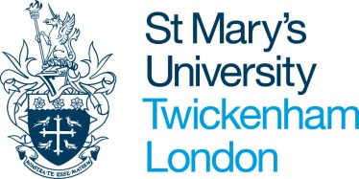

Title IV U.S Federal Student Aid
Confirmation of Attendance & Satisfactory Academic Progress (SAP)
Official Form

Please Note: It is the student’s responsibility to obtain and submit the confirmation sheet to the Federal Aid Office, at federalaid@stmarys.ac.uk.

Directions: Please present this form to your academic programme director for them to complete. Once they have signed off on your academic progress please return to The Federal Aid Office. Loan funds will not be disbursed until receipt of fully completed form.
Student Name (please print)

Student ID no.

Academic Year

Faculty

Course

Has there been any change to student’ mode/course of study? | YES | NO
If yes please give details:

Note to Faculty: The above-named student is in receipt of US Federal Loans (Title IV funds). In order to comply with US Government federal regulations, the US Loans Team must seek confirmation of attendance and academic progress.
Loan funds will not be disbursed to the student without receipt of this confirmation
Further details on US Federal Loans can be found here: http://www.stmarys.ac.uk/international/country-information/usa/federal-aid.htm
As the student’s academic programme director/tutor, please can you provide confirmation that the student has been in regular attendance at tutorials/lectures etc., and has made satisfactory academic progress over the year so far. (This can be based on; your academic judgement, performance in lectures, exam results, essay and assignment results etc.) We are aware that the timing of this form does not always correspond with marks release or assessment periods.
If you have any queries please contact Shani Moncrieffe-Plentie at federalaid@stmarys.ac.uk

I confirm that the above mentioned student has been in regular attendance at St Mary’s University and is making satisfactory academic progress toward the end of their course.

Signature:

Name: | Date:

