

**SITS at St Mary’s University**

Introduction

Student Records

Programme Codes

Reports

MAV’s

Table of Contents

1 Getting Started 3

1.1 SITS: Client and e-Vision 3

2 Understanding Programme Codes 4

2.1 MCR Marketing Course Record 6

2.2 CRS Course Code 6

2.3 ROU Route Code 6

2.4 Module Diets 6

3 How to access SITS 7

4 Useful Information and Shortcuts 8

4.1 Student Status Codes 8

4.2 Modes of Attendance 8

4.3 Withdrawal Codes 8

4.4 Keyboard Shortcuts 9

4.5 Client Screen Navigation 10

5 Student Records 11

5.1 How to view student records via Client 11

5.2 STU: Student Details Screen 11

5.3 SCE Student Course Enrolment Detail 12

5.4 SPR Student Programme Record 13

5.5 CRS Course Details 14

5.6 How to view student records via e-Vision 15

6 Reports 17

6.1 Class Registers 17

6.2 Student Programme List 18

6.3 Leave of Absence Report 19

6.4 Module Detail 19

7 The Importance of MAVs 19

### Getting Started

#### 1.1 SITS: Client and e-Vision

SITS (Strategic Information Technology Systems) is the Student Record System (SRS) used at St Mary’s University. SITS is the single repository for student information and management from application to graduation and beyond.

SITS has 2 interfaces, Client which is used predominately by the support services and e-Vision which is the web friendly version and is accessible to all academic staff.

This document will provide basic information to allow you to understand SITS and how to access the information you will need throughout the academic year.

SITS is a modular system and is broken down into the areas below which follow the Academic Model and reflects the student academic journey.

**MAS**

Marketing and Admissions

**CAMS**

Credit Accumulation Management System

**SRS**

Student Record System

Student Module Information.

Focuses on the programme routes, exit routes, credit accumulation and intended awards

Student.

Focuses on the programme details, duration and regulations

Applicant.

Deals with the marketing and admissions details of the programme

### 2 Understanding Programme Codes

The tables used for programme codes set up exist in the 3 main user menu areas of SITS;

* MAS (Marketing and Admissions System)
* SRS (Student Registration System)
* CAMS (Credit Accumulation Management System)

The tables required for any course and the menu areas in which they are found are shown below.

|  |  |  |
| --- | --- | --- |
| **Table code** | **Table name** | **Table code** |
| ROU | Route | CAMS |
| PWG | Pathway group | CAMS |
| PWT | Pathway type | CAMS |
| PWY | Pathway | CAMS |
| PRG | Programme | CAMS |
| AWD | Award | CAMS |
| PRU | Programme route | CAMS |
| PAW | Programme award | CAMS |
| CRS | Course | SRS |
| CBK | Course block | SRS |
| CBO | Course block occurrence | SRS |
| VCO | Valid course option | SRS |
| MCR | MAS course option | SRS |
| VAR | Valid Admissions Route | MAS |

Programme Codes in SITS follow this structure which is predominately used by admissions: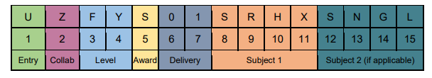

|  |  |  |
| --- | --- | --- |
| **Item** | **Sequence Number** | **Detail** |
| Entry  The method of entry the student has chosen to apply to SMU | 1 | U = UCAS  D = Direct Entry |
| Collaborative Partner | 2 | C= Collaborative  Z = Non collaborative |
| Level  The level of the programme the student has applied to | 3 and 4 | UG (Undergraduate)  PT (Postgraduate Taught)  PR (Postgraduate Research)  PC (PGCE)  FY (Foundation Year)  FD (Foundation Degree) |
| Intended award | 5 | A reference list based on the awards specified in the academic regulations has been produced and values are tied to the level code specified.  Examples below  S = Bachelor of Science  L = LLB |
| Delivery Sequence number  Used to distinguish between different deliveries of the same programme | 6 - 7 | A 2 digit number starting from 01 |
| Subject 1 | 8-9-10-11 | SRHX = Sport Rehabilitation |
| Join Type if applicable | 8 if applicable | A = And (50:50)  W = With (Major/Minor) |
| Subject 2 if applicable | 12-13-14-15 | Only applies to undergraduate  degree programmes  **Choose the required code from  the ‘Subject Code’ list  ***SNGL (if programme is single  honours) |

#### **2**.1 MCR Marketing Course Record

The **MCR** Code comes under the admissions portion of the academic model and shows programme delivery. An example of the BSc Sports Rehabilitation (with Foundation Year) programme would be displayed as:

1. UZFYS01SRHXSNGL (Undergraduate degree with a foundation year via UCAS entry)

2. DZFYS01SRHXSNGL (Undergraduate degree with a foundation year via DIRECT entry)

3. UZUGS01SRHXSNGL (Undergraduate degree via UCAS entry)

4. DZUGS01SRHXSNGL (Undergraduate degree via DIRECT entry)

#### 2.2 CRS Course Code

The **CRS** Code displays the destination record available for the programme. It represents the student portion of the academic model. The CRS does not take into consideration mode of entry, delivery or year of entry. So despite four options of entry (MCR), all students will placed on the same CRS record.

**UGSRHXSNGL**

#### 2.3 ROU Route Code

The Route Code – **ROU** – holds information about the academic content of the course and does not show information on course delivery.

ROU/CRS in majority of cases apart from Joint Hons programmes, they have a 1:1 relationship meaning that the ROU and CRS code is the same.

**UGSSRHXSNGL**

UG - Undergraduate

S – Bachelor of Science

SRHX – Sport Rehabilitation

#### 2.4 Module Diets

In SITS a student’s programme is called a diet. Their diet is made up of core and optional modules. Students are able to select their optional modules from online using MySITS at the appropriate time in academic year.

### 3 How to access SITS

Staff’s ability to access data is dependent on job role and need.

All academic staff will have access to **e-Vision** which is the web-friendly portal and allows for reports and information to be viewed and accessed via:

St Mary’s University Website

Systems

SITS e:Vision Portal

**SITS Client** is the technical side and is used by Admissions, Finance, Registry, QS and Administrators to view in detail student and programme records. Access to Client is limited to the support services and accessed via a SITS icon located on your desktop/ laptop.

Students are able to access MySITS via the student pages of St Mary’s website. They use this platform to view their student record, online enrolment and also to choose optional modules as appropriate.

### 4 Useful Information and Shortcuts

#### 4.1 Student Status Codes

|  |  |  |  |  |  |
| --- | --- | --- | --- | --- | --- |
|  |  | **Screens in Client** | | | |
| **Code ID** | **Category** | **STU** | **SCJ** | **SCE** | **SPR** |
| **C** | **Current** | **\*** | **\*** | **\*** | **\*** |
| **DORM** | **Dormant (HESA)** |  |  | **\*** |  |
| **EE** | **Eligible for Registration** |  |  | **\*** |  |
| **ED** | **Eligible for Debtor** |  |  | **\*** |  |
| **L** | **Leave of Absence** |  |  | **\*** |  |
| **LD** | **Leave Disciplinary** |  |  | **\*** |  |
| **LE** | **Enforced Leave of Absence** |  |  | **\*** |  |
| **PE** | **Provisional Enrolment** |  |  | **\*** |  |
| **S** | **Interruption of Study** |  |  | **\*** |  |
| **T** | **Transferred (Internal)** |  | **\*** | **\*** | **\*** |
| **W** | **Withdrawn** | **\*** | **\*** | **\*** | **\*** |
| **X** | **Completed** |  | **\*** | **\*** | **\*** |

#### 4.2 Modes of Attendance

|  |  |
| --- | --- |
| **Code** | **Category** |
| **FT** | **Full time** |
| **PT** | **Part time** |
| **FA** | **Full time accelerated** |
| **SR** | **Suspended Repeat** |
| **FW** | **Writing up FT** |
| **PW** | **Writing up PT** |
| **FD** | **Dormant Previous FT** |
| **PD** | **Dormant Previous PT** |
| **SB** | **Sabbatical** |

#### 4.3 Withdrawal Codes

|  |  |
| --- | --- |
| **Code** | **Descriptor** |
| **W00** | **WD Withdrawn pending appeal** |
| **W01** | **WD Academic Failure** |
| **W02** | **WD Transferred** |
| **W03** | **WD Health Reasons** |
| **W04** | **WD Death** |
| **W05** | **WD Financial Reasons** |
| **W06** | **WD Other Personal Reasons** |
| **W07** | **WD Written Off, Time lapse** |
| **W08** | **WD Disciplinary** |
| **W09** | **WD Gone into Employment** |
| **W10** | **WD Other Reasons** |
| **W11** | **WD Academic Misconduct** |
| **W98** | **WD Reason unknown** |

#### 4.4 Keyboard Shortcuts

The table below shows a list of SITS Shortcuts you can use to navigate the system.

|  |  |  |  |
| --- | --- | --- | --- |
| **Toolbar icon** | **Description** | **Function** | **Ctrl …** |
|  | Clear the screen | F12 |  |
|  | Retrieves records | F5 | R |
|  | Stores records for those who have permissions in SITS | F6 | S |
|  | Prints records | F11 | P |
|  | Displays the SITS message | F9 | M |
|  | Add record for those that have permission |  |  |
|  | First Record |  |  |
|  | Previous Record (Page Up) |  |  |
|  | Next Record (Page Down) |  |  |
|  | Last record |  |  |
|  | Cut selected text |  | X |
|  | Copy selected text |  | C |
|  | Paste selected text |  | V |
|  | Clear Field | F7 |  |
|  | Zoom into field |  | Z |
|  | Help | F1 | H |

#### 4.5 Client Screen Navigation

Menu Bar which will vary according to table

Title of the table and acronym

Programme Name

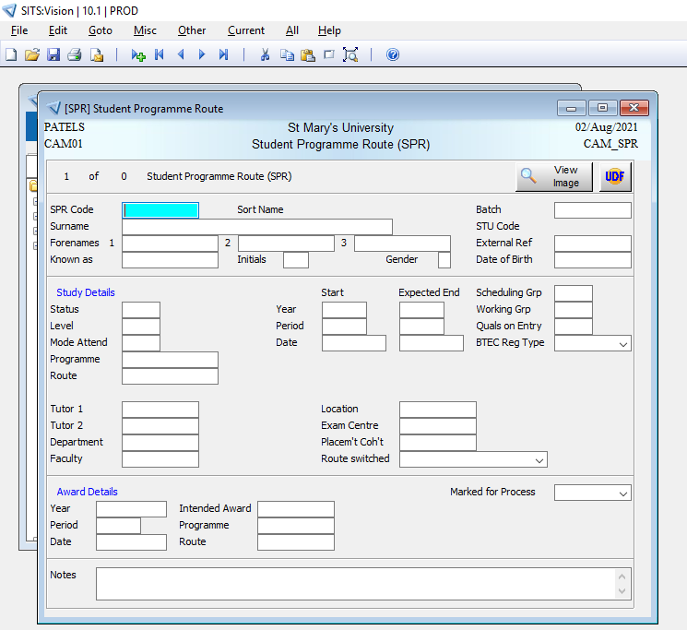

Entry Screen area.

If highlighted – you can enter data

If not highlighted then non editable

Message Line

Occurrence Line (changes depending on number of records that have been retrieved)

Component eg CAMS, SRS or MAS

Screen Name

### 5 Student Records

All applications either via UCAS or Direct Entry will be stored in SITS at the admissions stage. Upon ATR (Applicant Transfer Process), the students’ records will move to Registry and this signifies the start of their academic journey at St Mary’s University. This process creates the relevant student records in SITS. (Note students can also be RAT, Reverse Applicant Transfer).

#### 5.1 How to view student records via Client

Once you have accessed Client via the desktop icon, you will come to the main SITS Menu System screen. You can view the different screens in Client by typing the 3 letter code in the blue highlighted field and click Run.

There are numerous screens available to view student data which are dependent on what you are looking for.

#### 5.2 STU: Student Details Screen

This shows all the basic information about a student name, address, next of kin, fee status.

**Action**: SITS Menu Screen enter **STU**, click RUN (green arrow). In the STU screen enter the Regnum in the ‘student number’ field and **F5 (or tab)** to Retrieve. You can search using any multiple field eg Surname, DoB. You can use the wildcard * as well. The wild card can only be accessed via the numerical keypad.

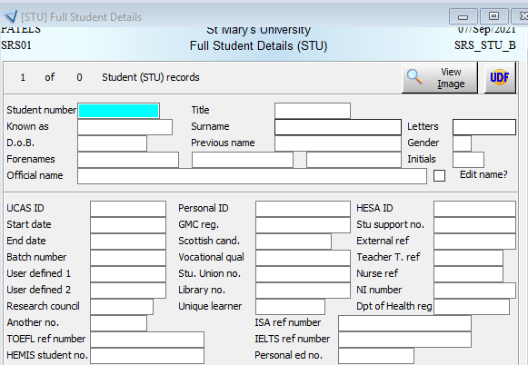

#### 5.3 SCE Student Course Enrolment Detail

This screen displays information relevant to the student’s course details.​

**Action 1**: SITS Menu Screen enter **SCE**, click RUN (green arrow).

**SCJ**: Enter regnum/1 in and F5 or tab to retrieve. All enrolment details relating to the student will appear. You can search using any and multiple fields eg surname, DoB, Academic Year, Status etc.

Alternatively, Use the Course field to look up all students on a course.

**Action 1:** Double click in Course and a new window will open, select Display All and select the course you need

**Action 2:** Enter the course code directly into Course Field eg UGLLAWXSINGL

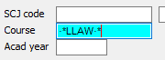**Action 3**: Use the wildcard function (*) on your keyboard to retrieve courses which all show LAW in the title, example below. NOTE the wildcard function only works if the following appears in the search field



You can move between records by using the forward arrow in the navigation bar.



View of SCE

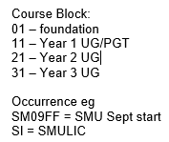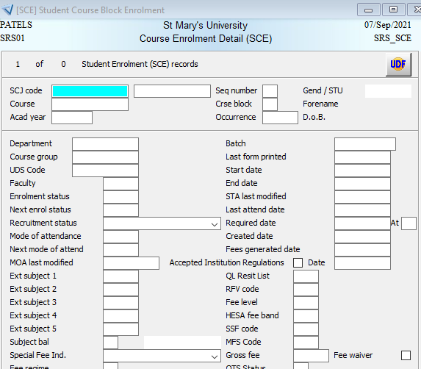

#### 5.4 SPR Student Programme Record

This screen displays information relevant to the student’s course details.

**Action 1:** SITS Menu Screen enter **SPR**, click RUN (green arrow).

**Action 2**: Enter the Regnum/1 in the ‘SPR’ field and **F5 (or tab)** to Retrieve. All programme details relating to the student will appear. You can search using any and multiple fields eg Surname, DoB, Year etc

**Action 3:** Find all students on particular Route. Double click in the Route Field and select Display All. Choose your code from here.

**Action 4:** In the Route Field use the wildcard function to choose Add Criteria > Type wildcard (*) and one or part of word from the route title and wildcard (*) > F5 to retrieve > double-click the route ‘code’ that you need and this will appear in the ‘Route’ field in SPR​.

NOTE the wildcard function only works if the following appears in the search field



To check **Module Takings** of a particular student in SPR

Action 1: From the SPR Screen, Enter the student regnum eg 123456/1

Go to **Other** (along the navigation bar) > **Module**> **Taking**

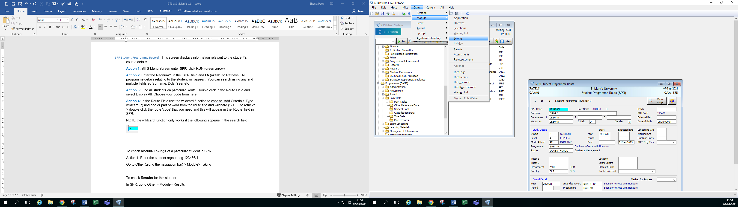

To check **Module Results** of a particular student in SPR

Action 1: From the SPR Screen, Enter the student regnum eg 123456/1

Go to **Other** (along the navigation bar) > **Module**> **Results**

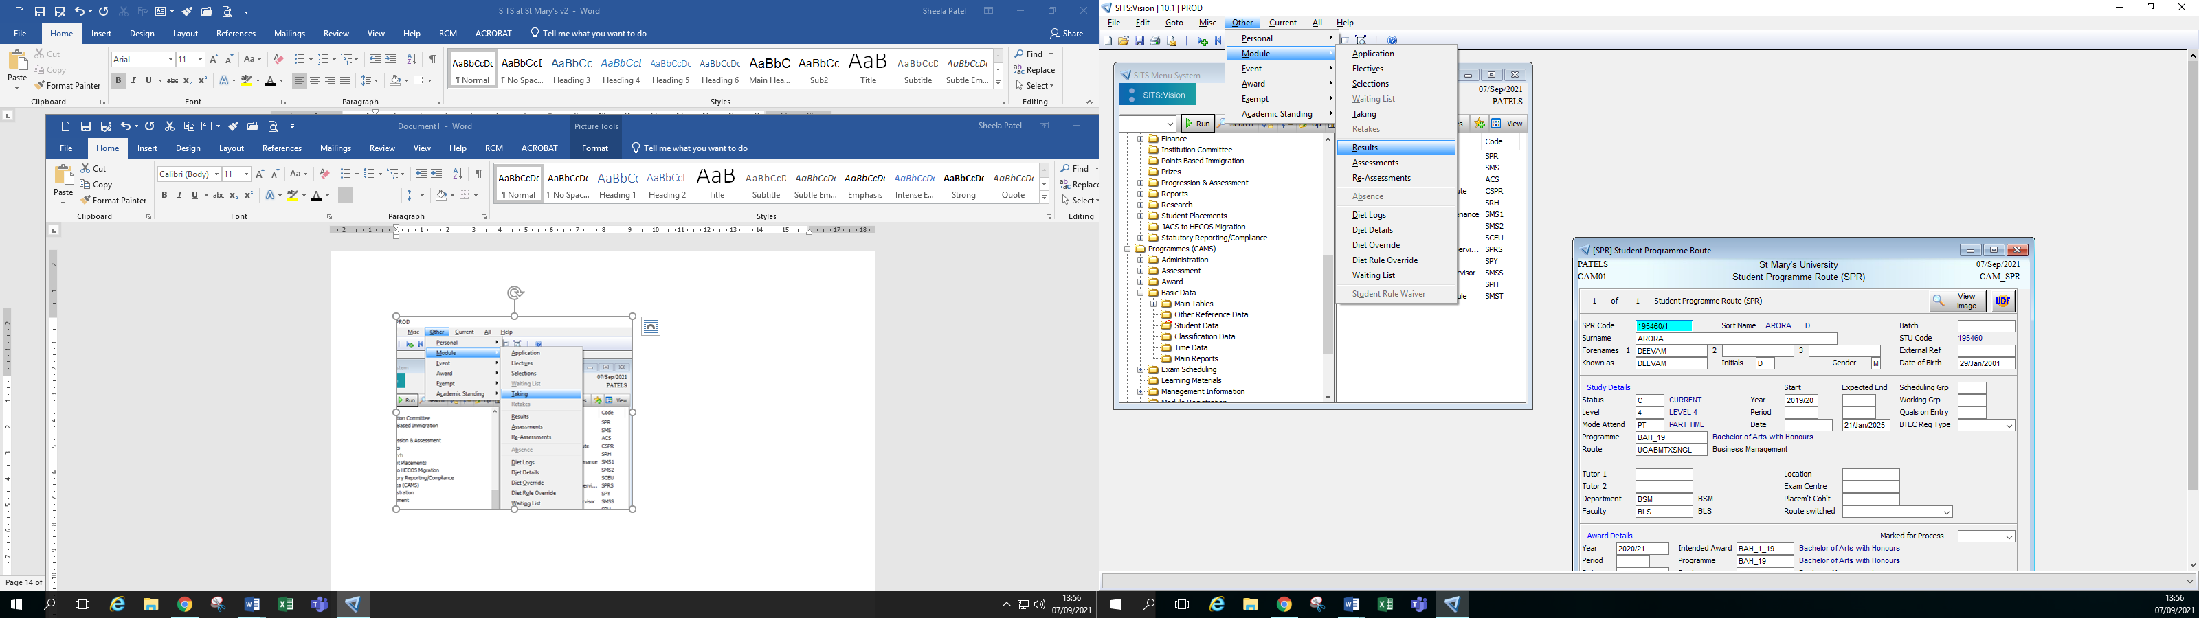

#### 5.5 CRS Course Details

This screen displays information relevant to St Mary’s courses and can help you find course codes.

**Action1**: SITS Menu Screen enter **CRS**, click RUN (green arrow). Input course code in ‘Course Code’ **OR** double click in the field to search for a course code. Select Display All and choose your option.

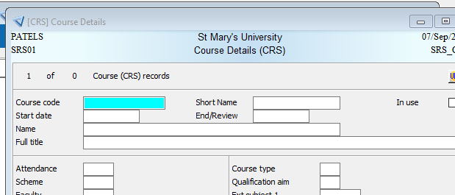

#### 5.6 How to view student records via e-Vision

Academic colleagues do not have access to Client, they can only access student records via e-Vision. This is the web-based version of the Student Record System and be accessed off campus, on mobile phones and macs.

**Action 1**: From the staff pages on St Mary’s website: <https://www.stmarys.ac.uk/staff/links.aspx>

**Action 2:** Select SITS: E-Vision Portal

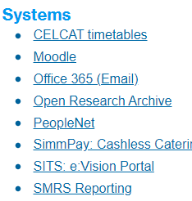

**Action 3:** Enter your PC login details

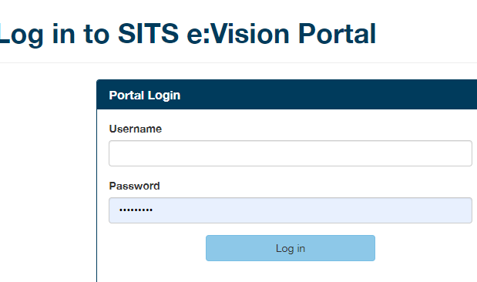

This will take you to main page for e-Vision.

**Action 4:** Select Admin from the top bar.

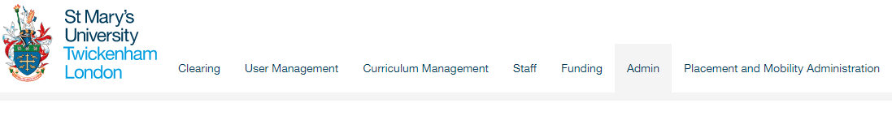

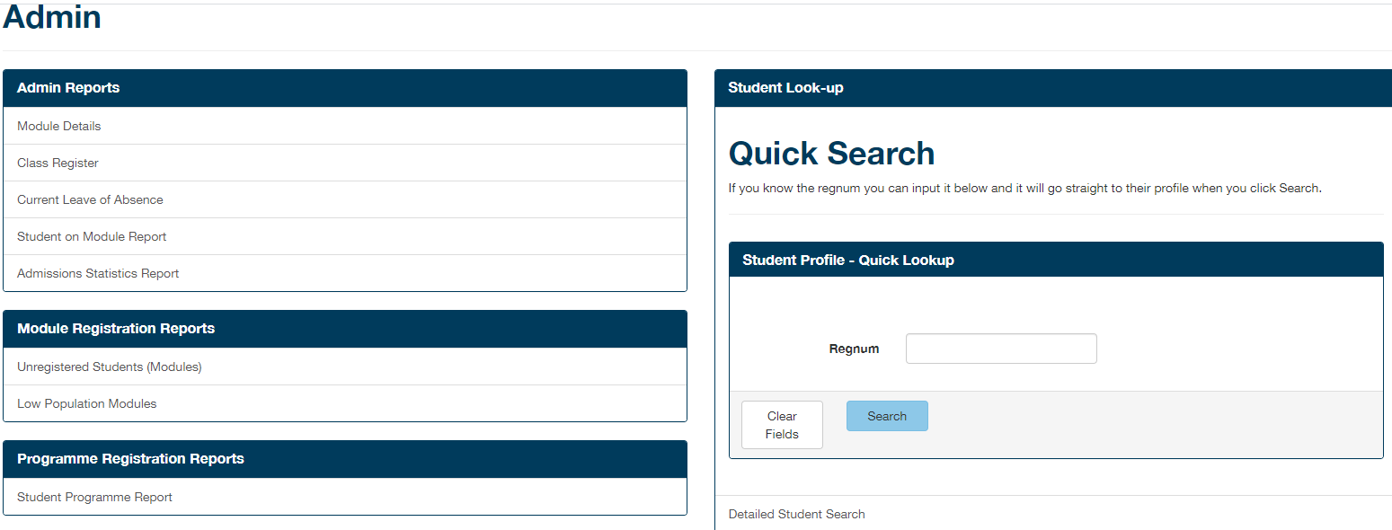

**Reports are listed on the Left Hand Side of the Screen:**

Class Registers – list of students per module

Student Programme Report – list of students on your programme

Current Leave of Absence- list of students who are on LoA

**Student Look-up is located on the Right Hand Side of the Screen**

**Action 1:** In the Regnum Field you can enter the Regnum or type in the students name and options will appear for you to confirm. Click Search to confirm your choice.

This will take you to the student profile where you can view further student information: contact information, Modules, Assessments

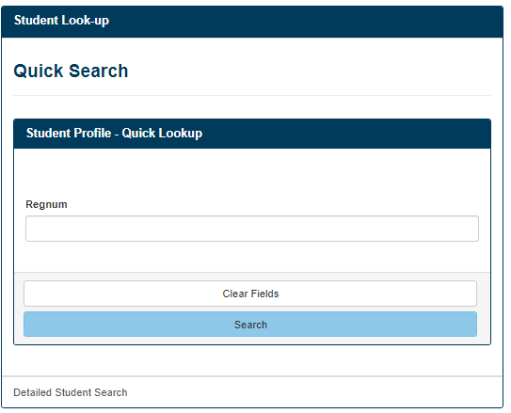

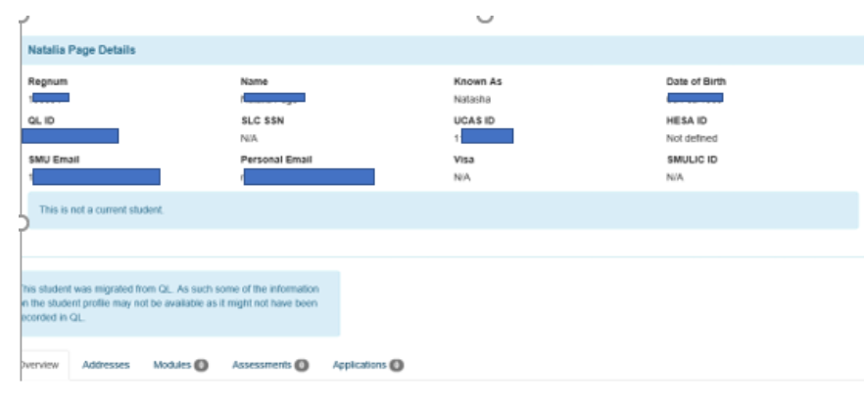

### 6 Reports

#### 6.1 Class Registers

**Action 1:** Select Class Registers

**Action 2:** Enter your options:

Module Search – module code or start typing in the key word eg Nutrition and options will appear for you to select

Academic Year – select from the drop down

Period – select from the drop down

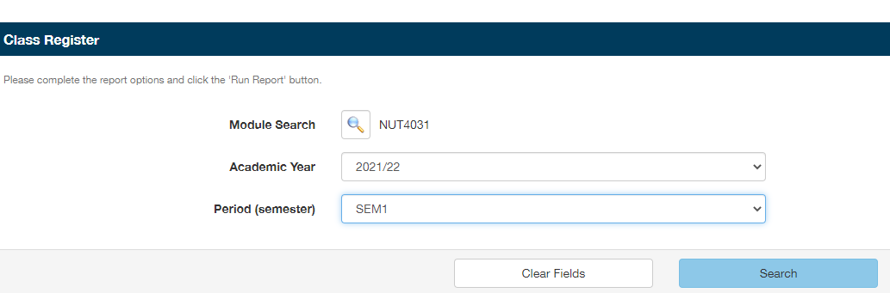

**Action 3:** You can sort the list by Regnum, Name or Status by clicking in the white space next to the title and a grey arrow will appear.

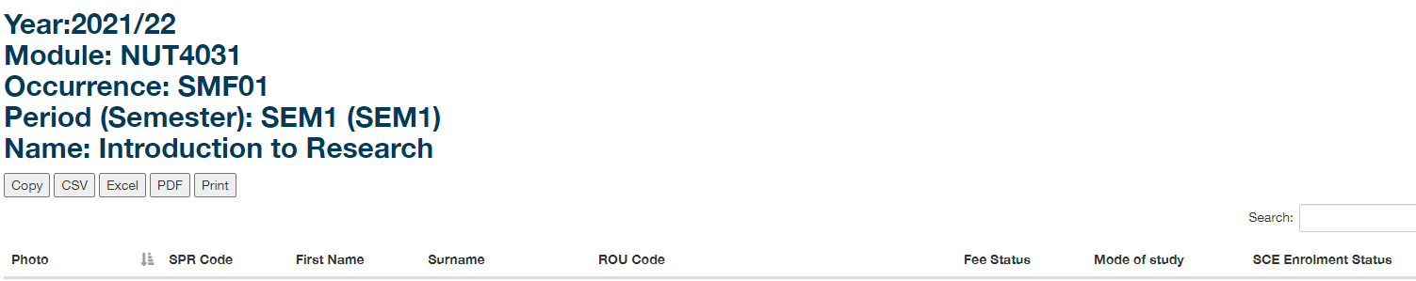

#### 6.2 Student Programme List

**Action 1:** Navigate to e-Vision and Admin tab as stated above

**Action 2:** Click Student Programme Report

**Action 3:** and Enter your options and click View - screen shot below

Enter Academic Year

Enter Programme: if you start typing your programme title then variations will appear for you to confirm.  If you know your programme code, then enter that.

Enter Level of Study using the drop down

Enter Partner - it defaults to St Mary's Twickenham.  This shows our collaborative partners

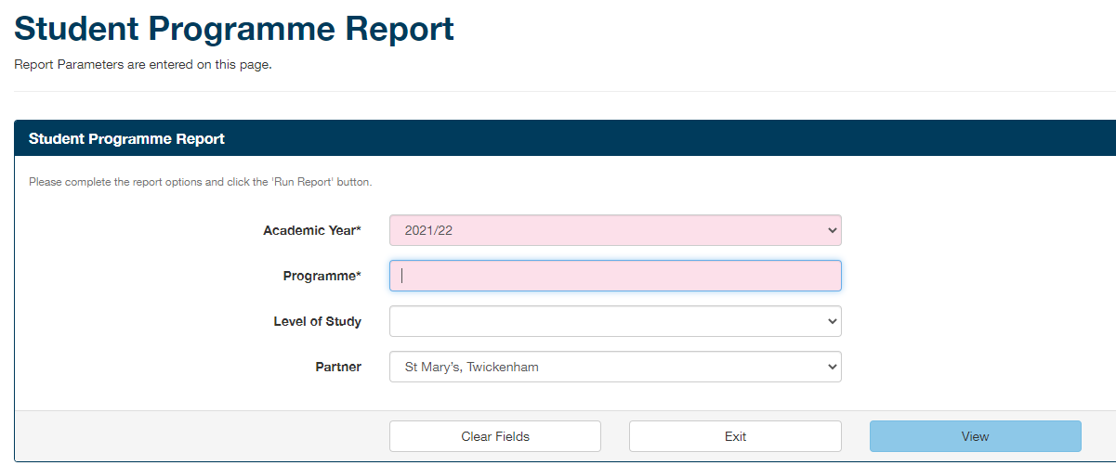

You can extract the programme list via Excel or click Print to extract as a PDF.

Copy of Student Programme Report – redacted. You can sort by using the grey arrows against Regnum and Name

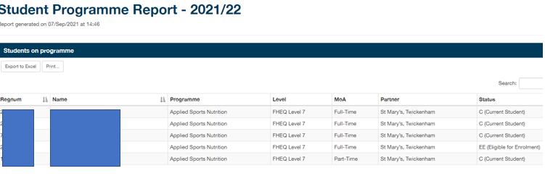

#### 6.3 Leave of Absence Report

Following the same route as above you can extract a LoA report which you can filter using your programme code. Clicking on the student regnum will take you to the relevant student profile page.

#### 6.4 Module Detail

Following the same route as above you can view module information.

The main tables required for any modules include

* MOD: This is the main module screen and module codes includes the prefix from the programme subject code as in section 2 above. New module codes are assigned in line with the Quality and Standards validation, revalidation and modifications processes.
* MAP: Module assessment pattern list details of approved/validated elements of assessment.
* MAB: Module assessment body
* MAV: Module availability list details of when a module is made available to students as detailed in the programme specification document. For example, in semester 1, semester 2, or both. **NOTE**: Changes to these must be approved via the Quality and Standards validation, revalidation and modifications processes.

### 7 The Importance of MAVs

MAVs need to checked throughout the year (to confirm semester dates/ running / not running) and in particular before optional module selection and module rollover at the end of the academic year, in readiness for the new year. If a MAV is incorrect in SITS there maybe multiple downstream issues eg access to Moodle for students, impact on student optional module selection and marks entry.

|  |  |
| --- | --- |
| Version Control |  |
| Document Name | SITS at St Mary’s University v5 |
| Document created by | UABM |
| Dated | 9.9.21 |