Mentor Toolkit




Contents

Rationale ....................................................................................................Page 2

NCETM and Mastery.................................................................................. Page 3

Subject Specific Guidance …………………………………………………….Page 5

Effective Instruction in mathematics ………………………………………… Page 10

Lesson Observation Prompts (linked to APLs) ……………….....................Page 13

Reflective Questions: Post Lesson Observation Discussion...................... Page 14

Links to support with planning, teaching and assessing…………………… Page 17

Developing Mathematical Subject Knowledge.......................................... Page 21

Rationale

This Mentor Toolkit has been devised by the primary ITT workgroup for London South West Maths Hub and is a collaboration of ITT providers from the Universities of: Roehampton, St Mary’s and Kingston. It provides guidance for mentors in providing high quality subject specific feedback, guidance and support to student teachers in their teaching of mathematics.

Teaching for Mastery
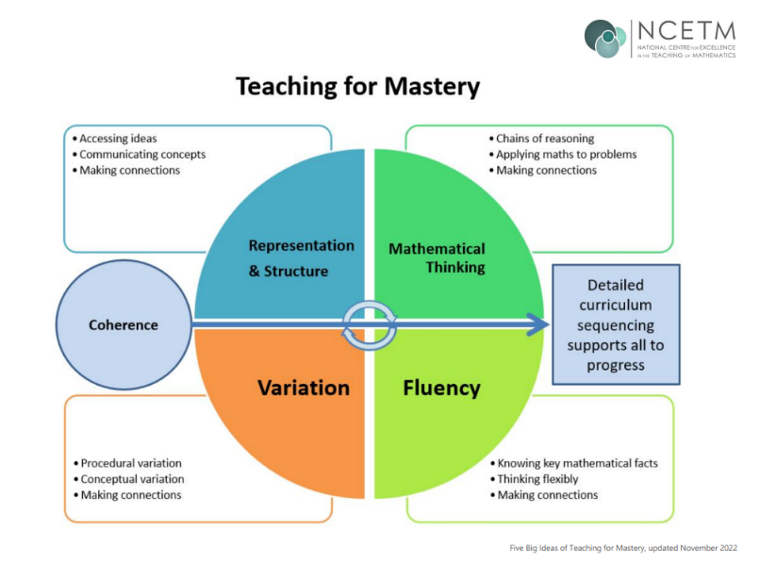
In addition to the five big ideas, detailed below, mindset is key to teaching for mastery; this includes the belief that all children can do, and should be engaged in, mathematics.

Coherence
Lessons are broken down into small, connected steps that gradually unfold the concept, providing access for all children and leading to a generalisation of the concept and the ability to apply the concept to a range of contexts.

Representation and Structure
Representations used in lessons expose the mathematical structure being taught, the aim being that students can do the maths without recourse to the representation

Mathematical Thinking
If taught ideas are to be understood deeply, they must not merely be passively received but must be worked on by the student: thought about, reasoned with and discussed with others

Fluency
Quick and efficient recall of facts and procedures and the flexibility to move between different contexts and representations of mathematics

Variation
Variation is twofold. It is firstly about how the teacher represents the concept being taught, often in more than one way, to draw attention to critical aspects, and to develop deep and holistic understanding. It is also about the sequencing of the episodes, activities and exercises used within a lesson and follow up practice, paying attention to what is kept the same and what changes, to connect the mathematics and draw attention to mathematical relationships and structure.

Taken from: Five Big Ideas in Teaching for Mastery | NCETM

Further information about mastery

Information for school leaders School leaders | NCETM

The Essence of maths teaching for Mastery The Essence of Maths Teaching for Mastery

Progress report on teaching for mastery in primary schools Teaching for mastery

A video overview on teaching for mastery in primary A video overview on teaching for mastery at primary | NCETM
Subject Specific Guidance: Mathematics in the Early Years

Pupils should have opportunities to:

Develop a strong grounding in number to develop the necessary building blocks to excel mathematically.

Secure a base of vocabulary from which mastery of mathematics is built.

Engage with key mathematical ideas, concepts and relationships

Access appropriate manipulatives and models to support their understanding of structures and relationships, such as pebbles, counters and tens frames to organise counting

Engage in experiences that facilitate connections between manipulatives and concepts
Discuss and explain strategies and approaches
Develop fluency through a focus on:
  - visualising and reasoning about structures
  - fostering connections and pattern spotting
Solve problems and make generalisations
Count confidently, developing a deep understanding of the numbers to 10, the relationships between them and the patterns within those numbers, including odds and evens and equal distribution of quantities.

Learn to subitise
Secure automatic recall of stage appropriate number facts, including number bonds and doubles
Develop spatial reasoning skills across all areas of mathematics including shape, space and measures

Verbally count and recognise the pattern of the counting system
Compare quantities in different contexts and recognise when quantities are greater than, less than or the same as another quantity

Planning (individual lessons and teaching sequence) should indicate:

How the learning environment promotes mathematical enquiry, confidence and consolidation of learning

Prior learning and small steps progression

Clarity and coherence in relation to each mathematically focussed activity or adult-led session

Activities that promote understanding and deepen the learning; consideration of which elements of learning might be delivered by an adult to a whole group, a small group and which through child-initiated learning and continuous provision

How the outdoor and indoor environments will be used to promote mathematical learning

Relevant mathematical ideas and concepts, structures, facts and relationships that are the focus of lessons
Possible misconceptions and difficulties and ways to elicit these
Appropriate contexts, manipulatives and models to engage and scaffold learning
Key questions that promote connections between models and concepts
Modelling, strategies and key vocabulary and opportunities to practise
Key questions that foster explanation, fluency, making connections, reasoning, pattern spotting and generalising

Strategies to assess the children’s understanding (rather than ability to follow a procedure)

Teaching, Delivery and Organisation

Include use of motivating and meaningful contexts, including through continuous provision

Include worked examples of key mathematical ideas and concepts
Demonstration of appropriate use of manipulatives and models
Ask questions and consolidate learning by providing activities which:
  - provide opportunities for discussion and reflection
  - develop mathematical thinking and deepen understanding mathematical language
  - deepen understanding through a focus on reasoning
  - foster fluency: a network of structures, connections and relationships
  - are challenging and foster resilience

Avoid the temptation to rush through concepts, be sure to allow time to embed ideas

Provide opportunities to practise, over learn and embed in long term memory

Develop mathematically in different ways and at different rates, based on the needs of the unique child.

Become a resilient, capable, confident and self-assured early mathematician

Develop a positive attitude towards mathematics, talking about what they find out with adults and peers and not being afraid to ‘have a go’

Learning and assessment

A mixture of planned and ‘in the moment’ assessments are used effectively to establish a clear view of a child’s development, progress and interests.

A range of evidence is used to assess learning, including planned observations (long and short), informal notes, records of discussions with children, examples (through photographs or videos where appropriate) of children’s learning and work. Assessment from this full range of sources must come from child initiated as well as adult-led learning opportunities.

Conceptual, procedural and linguistic fluency: use of mathematical vocabulary and age-appropriate clarity of explanation

Depth of understanding through:
  - efficient recall and application of ideas, concepts, strategies and facts
  - ability to make connections and understand relationships
  - confidence in reasoning, pattern spotting and generalising
- ability to solve problems

Subject Specific Guidance: Mathematics in KS 1 and KS 2 and KS 3

Planning (individual lessons and teaching sequence) should indicate:
- Prior learning and small steps progression
- Clarity and coherence in relation to each individual lesson’s focus
- Relevant mathematical ideas and concepts, structures, facts and relationships that are the focus of lessons
- Possible misconceptions and difficulties and ways to elicit these
- Appropriate contexts, manipulatives (e.g. place value apparatus) and models (e.g. array for multiplication) to engage and scaffold learning
- Key questions that promote connections between models and concepts
- Modelling, strategies and key vocabulary and opportunities to practise
- Activities that promote understanding and deepen the learning; carefully considered tasks and, if using worksheets, consider variation through meaningful questions
- Key questions that foster explanation, fluency, making connections, reasoning, pattern spotting and generalising
- Strategies to assess the children’s understanding (rather than ability to follow a procedure)
- Strategies to promote an inclusive and collaborative mathematical community of learners
Teaching, Delivery and Organisation
Include use of motivating and meaningful contexts
Teacher modelling and pupil reasoning about key mathematical concepts and processes through approaches such as:
- I do we do you do
- step by step guidance
- modelled examples
Demonstration of appropriate use of manipulatives and models
Ask questions and set tasks that:
- provide opportunities for discussion and reflection
- develop mathematical thinking and deepen understanding mathematical language
- deepen understanding through a focus on reasoning
- foster fluency: a network of structures, connections and relationships
- are challenging and foster resilience
Avoid the temptation to rush through concepts, be sure to allow time to embed ideas
Provide opportunities to practise, over learn and embed in long term memory
Foster a safe, collaborative and inclusive community; mistakes are welcomed and all contributions are valued.
Learning and assessment:
Conceptual, procedural and linguistic fluency: use of mathematical vocabulary and clarity of explanation.
Anticipating and responding to misconceptions and difficulties
Depth of understanding through:
- efficient recall and application of ideas, concepts, strategies and facts
- ability to make connections and understand relationships
- confidence in reasoning, pattern spotting and generalising
- ability to solve problems

Effective Instruction in Mathematics

Pupils are required to be fluent and to reason and solve problems in relation to the concepts, skills and facts outlined within the mathematics primary curriculum content (DfE, 2013). The following instructional approaches have been identified as key to engaging, scaffolding and embedding learning in mathematics.

Formative Assessment
Planning and teaching that activates prior knowledge ensures optimum levels of challenge because it reduces the potential for working memory overload. Teachers should take time to thoroughly assess their pupils’ readiness for the new learning by obtaining knowledge of their levels of prerequisite understanding, their difficulties and their misconceptions.
In addition to anticipating misconceptions, teachers should monitor pupils’ understanding during the learning process. When teaching, teachers should notice and attend to pupils' individual difficulties. It is important to note that formative assessment is only valuable when there is clarity regarding the mathematical focus of the lesson.

Using Contexts to Engage
Relevant and realistic contexts, as starting points to engage pupils in learning, support the introduction of abstract big ideas. Posing questions using language and contexts that connect to pupils' lived experiences provides a window to unfamiliar and abstract mathematics. Contexts are recommended at the beginning of a teaching sequence because they facilitate connection to abstract procedures and concepts and to mathematical language and symbols, making them accessible to all learners.

Using Representations
Visual and concrete models provide cognitive support when making sense of the mathematical structure or relationship.
The combination of the visual, the abstract mathematical notation and the verbal is what makes the representation powerful when supporting pupils to visualise in mathematics. Pupils should notice the mathematical structure, idea or pattern in the concrete or visual representation and talk about how this is connected to the abstract notation. The act of writing or drawing further supports the learning and so opportunities for pupils to diagrammatise what they visualise is an important aspect of pupils’ enactive experiences.

Questioning
Teachers can develop pupils' mathematical thinking through questioning. Some strategies and questions that foster reasoning:
- Teacher questioning that encourages pupils to notice regularity encourages pattern spotting that is vital to mathematical thinking
- Asking how, or more importantly why, to further probe for responses are essential to fostering reasoning and deepening understanding
- Teachers might pose how and why questions and allow time for pupils to develop their responses
- Exploring examples and non-examples deepens conceptual understanding
- Deliberate mistakes create controversy and foster reasoning
- Asking whether statements are true or false and why
- Using prompts that ask pupils to look at what's the same and what's different

High quality conversation can be developed by giving children time to talk to a partner and respond to questions such as ‘do you agree/disagree?’, ‘could you explain it a different way?’, and ‘did anyone get the answer another way?. Simply asking a child to restate another’s contribution or asking pupils to build on what other students have said can encourage refinement of ideas and create communities in which all pupils talk.

Practice
Practice is not about providing detailed step-by-step instructions that need to be
followed by rote. The quality of the repetition is key. Some suggested practice opportunities are detailed here:
- Worked examples in which solutions are provided
- Reduced support through modelling an ‘I do’ (teacher led), ‘we do’ (teacher and pupil), ‘you do’ (pupil) approach
- Reviewing learning and daily review of facts, errors and vocabulary
- Interleaving practice where pupils are set different kinds of problems with mixed levels of challenge
- Procedural variation through carefully thought through examples in which there is some regularity despite some things changing; strings of questions that highlight essential and non essential features so that there is an aspect of variance,alongside an aspect of constancy. For example:

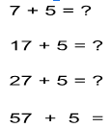

Rich Tasks
The ability to use and apply mathematical knowledge to other areas, to think critically, and to solve problems is key to providing depth and challenge in mathematics lessons. Rich tasks provide opportunities for pupils to investigate and interrogate big ideas and to apply their declarative and procedural knowledge. Pupils' thinking is extended because connections between ideas are fostered, and understanding of mathematical concepts is deepened.
Problem solving is a creative endeavour when opportunities for personal interpretation and an element of choice are provided. Pupils can make comparisons between their different strategies and in doing so they can refine their own approaches. The derivation of multiple perspectives fosters an ethos that moves away from a focus on answers and onto a focus on the act of doing mathematics through investigation and conjecture. Opportunities to make conjectures, to explain ideas, and develop one another’s thinking through collaborative engagement, supports development of a positive disposition towards the subject. Key skills for life such as resilience, perseverance and creativity are also fostered through a focus on rich tasks and problems.

Lesson Observation Prompts
Use the prompts below to support your written feedback on the observation form to help maintain a focus on mathematical learning.
Expectations and Behaviour Management  (TS 1 and 7) | Does the student teacher present mathematical learning with confidence?  Are all contributions valued and is this an environment in which pupils feel safe to make mistakes?  Are mathematical learning behaviours modelled/praised?
Curriculum  (TS 3) | Do all children have an opportunity to develop fluency, to reason and to solve problems in relation to foundational concepts?  Are misconceptions preempted and addressed?
Pedagogy  (TS 2, 4 and 5) | What scaffolding allows all pupils to access the mathematical learning focus?  Is this lesson a carefully constructed learning sequence that will ensure lasting change in pupils’ mathematical understanding?  Does the student teacher provide opportunities for all pupils to extend and deepen their learning?
Assessment (TS 6) | Are activities well matched to pupils’ prior learning and understanding?  Are there a range of strategies employed to check pupils’ mathematical understanding during the lesson?  How do student teachers react to pupils’ mathematical difficulties?
Professional Behaviours (TS 8, Part 2) | How are support staff used to assist the student teacher in developing and deepening pupils’ mathematical learning?

Reflective Questions: Post Lesson Observation Discussion

Non-Negotiable Questions
These questions will start post lesson observation discussion to ensure that the discussion and feedback is focused on the student teacher’s mathematical knowledge for teaching:

- What is the mathematical learning focus of this lesson?
- How successfully did pupils engage with the mathematical learning focus?

Based on responses you might then use the reflective questions to further support the student teacher to reflect on their practice and to develop their mathematical subject knowledge for teaching.

Reflective questions to support feedback
Foundation | Developmental | Consolidation
The mathematical focus of lesson(s): planning, teaching assessing
What was the mathematical focus of the lesson?  How did you communicate the key  mathematical learning focus in the lesson? The teacher makes connections to the key focus throughout the lesson (input, examples, feedback..).  What concepts / facts / procedures / mathematical thinking / reasoning were involved in this lesson? The teacher identifies the mathematical knowledge and skills needed to do the mathematics.  What opportunities to apply mathematical learning were there? What links were made to relevant contexts? The teacher has actively chosen contexts understandable by the pupils which exemplify the key mathematical idea. | What was the mathematical focus of the lesson?  Can you reflect on the pupils’ mathematical learning in relation to the focus of the lesson?  Can you differentiate between pupils’ conceptual understanding, their fluency and ability to reason and think mathematically and apply the learning? | What was the mathematical focus of the lesson?  Can you reflect on the pupils’ mathematical learning in relation to the focus of the lesson?  Can you reflect on pupils’ conceptual understanding, their fluency and ability to reason and think mathematically and apply learning with confidence?  Can you clearly evaluate pupils’ misconceptions and difficulties and depth of understanding in this lesson and consider how these will be used to inform future lessons?
Can you explain how you prepare to teach?  How do you ensure thorough understanding to teach the mathematical content?  How did you identify the mathematical content focus for this lesson?  How have existing materials been used to plan and teach the pupils in this class?  How does this lesson fit in the learning sequence? | Can you explain how you prepare to teach?  Can you reflect on your own subject knowledge, research and preparation for teaching of mathematical content.  How does the mathematical content of this lesson connect to previous learning? And next steps in learning?  How has progression through the lesson developed all pupils’ learning? | Can you explain how you prepare to teach?  Can you reflect with confidence on your approaches to developing subject knowledge, research and preparation for teaching of mathematical content?  How does the mathematical content of this lesson connect to previous learning? And next steps in learning?  How has progression through the lesson developed all pupils’ learning?  How have existing materials/schemes been adapted as a result of assessments?
Using Representations
Can you explain your choice of representation?  Why did you choose this representation? How familiar are the pupils with it? What did you need to do to support their understanding of it? What do the pupils' responses suggest about how this representation supported their understanding?  The teacher has actively chosen the representations included within the lesson.  Can you talk about the pupils’ understanding of the representations and structures?  What mathematical structures were you hoping to draw the pupils’ attention to? The teacher draws attention to pattern and structure within the representation.  Did the pupils understand the representations you used and were they helpful to them? How do you know? Pupils use teacher demonstrated representations to solve problems posed by the teacher.  How did your teacher modelling support pupils’ understandings of the representations? ... of the mathematics? The teacher models problems using representations. | Can you explain your choice of representation?  Why did you choose this representation? How does this representation expose the structure of the mathematics? What did pupils’ responses reveal about their understanding of the structure presented within your chosen representations? Was it an effective choice? The teacher has made a deliberate choice of representations included within the lesson. The teacher uses selected representations consistently over a range of examples.  Can you talk about the pupils’ understanding of the representations and structures?  What do pupils’ responses suggest to you about their understanding of the mathematical structures?  Pupils can talk about and recognise underlying structures in the representations.  How did the representations help you to you assess understanding? How aware are you of different pupils’ understanding of the representations you used? Pupils use representations with  understanding demonstrated through their reasoning (use of manipulatives, dialogue, etc).  The teacher and the pupils make connections between language, symbols, images, and manipulatives for a representation.  How did you support pupils in constructing and using the representations appropriately? Were there any misconceptions arising and how might you use these? Pupils model problems using representations. | Can you explain your choice of representation?  Why did you choose this representation? What do pupils’ responses reveal about the connections they are making across concepts and their understanding of relationships?  The teacher has made a deliberate choice of representations across lessons/topics with regular use and access for pupils.  Can you talk about the pupils’ understanding of the representations and structures?  Why did you choose this representation? What do pupils’ responses reveal about the connections they are making across concepts and their understanding of relationships?  The teacher has made a deliberate choice of representations across lessons/topics with regular use and access for pupils.  How did your teaching choices support pupils in making mathematical connections between  representations? How does this support their deeper understanding of the mathematical structures? How is this moving them towards more abstract thinking? Pupils make connections between different representations and make choices about representations, showing understanding of underlying structures. This supports their understanding of the symbolic.  How did your questioning prompt pupils to use the representations to reason more deeply about mathematics?  Both the teacher and the pupils actively compare and contrast representations to deepen thinking.
Questioning, Tasks and Modelling
Can you explain where opportunities were provided for pupils to:  - Reason and explain? E.g. how do you know or why do you say?  - Think mathematically? E.g. what do you notice?  - Use mathematical vocabulary?  - Explain in full sentences?  Can you identify reasons for choice of questions, tasks and modelling in developing the learning? | Can you reason and reflect on opportunities provided for pupils to:  - Reason and explain? E.g. How do you know or why do you say that?  - Think mathematically? E.g. what do you notice?  - Use mathematical vocabulary?  - Clearly explain to the class/group/peer in full sentences?  Can you reflect on your choice of questions, tasks and modelling and their value in fostering the learning? | Can you confidently reason and reflect on opportunities provided for pupils to:  - Reason and explain? E.g. how do you know or why do you say that?  - Think mathematically? E.g. what do you notice?  - Use mathematical vocabulary  - Clearly explain to the class/group/peer in full sentences  Can you confidently reflect on questioning, tasks, modelling and explanations and their value in relation to the above?  Can you reflect on the effectiveness of questions, tasks and modelling in bringing about the specific mathematical learning focus of the lessons and can you consider difficulties and misconceptions that occurred with clarity about next steps?
Developing a classroom ethos for mathematical learning
Can you consider how you foster an ethos for mathematical learning, for example:  - Is there a celebration of mathematical thinking / talk?  - Do pupils feel safe to make mistakes?  - Do pupils demonstrate curiosity, resilience and confidence when they answer questions/attempt problems?  Is there a sense of community and collaboration? | Can reflect on how you foster an ethos for mathematical learning, for example:  - How do you celebrate mathematical thinking and talk?  - How are right and wrong answers responded to?  - How do you provide feedback?  - How do you engage all pupils?  - How do you foster curiosity, collaboration and resilience?  How do you allow for and respond to the range of strategies pupils might use? | Reflect on the effectiveness of your role in fostering an ethos for mathematical learning, for example:  - How effectively do you make use of pupils’ responses and their difficulties to enhance the teaching and learning?  - How effectively do you connect prior and new learning for all pupils?  - How effectively do you support and challenge all pupils?  - How effectively do you engage pupils and improve their contributions?  - How effectively do you provide feedback on learning?  - How effectively do you foster curiosity, collaboration and resilience?

Key links to support planning, teaching and assessment in mathematics
Early Years
EYs Framework 2021
https://assets.publishing.service.gov.uk/government/uploads/system/uploads/attachment_data/file/896810/EYFS_Early_Adopter_Framework.pdf
Early Years Maths Resources for Number, Patterns and Connections and Spatial Reasoning 2021 https://help-for-early-years-providers.education.gov.uk/mathematics
Early years Development Matters (2021) https://assets.publishing.service.gov.uk/government/uploads/system/uploads/attachment_data/file/988004/Development_Matters.pdf
Birth to Five Matters
Early Childhood Maths Group https://earlymaths.org/
NCETM: Early Years https://www.ncetm.org.uk/in-the-classroom/early-years/
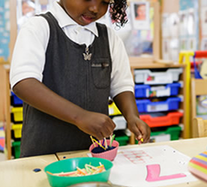
Number Blocks (BBC programmes) with support materials on NCETM https://www.ncetm.org.uk/classroom-resources/ey-numberblocks-support-materials/
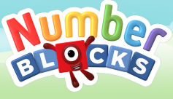
A useful website for teachers in Early Years is DREME TE http://prek-math-te.stanford.edu/ Videos are available alongside guidance about key concepts and how to plan, teach and assess e.g. http://prek-math-te.stanford.edu/counting/counting-and-enumeration-assessment-videos
Erikson Institute Early Maths Collaborative https://earlymath.erikson.edu/why-early-math-everyday-math/big-ideas-learning-early-mathematics/
Learning Trajectories https://www.learningtrajectories.org/
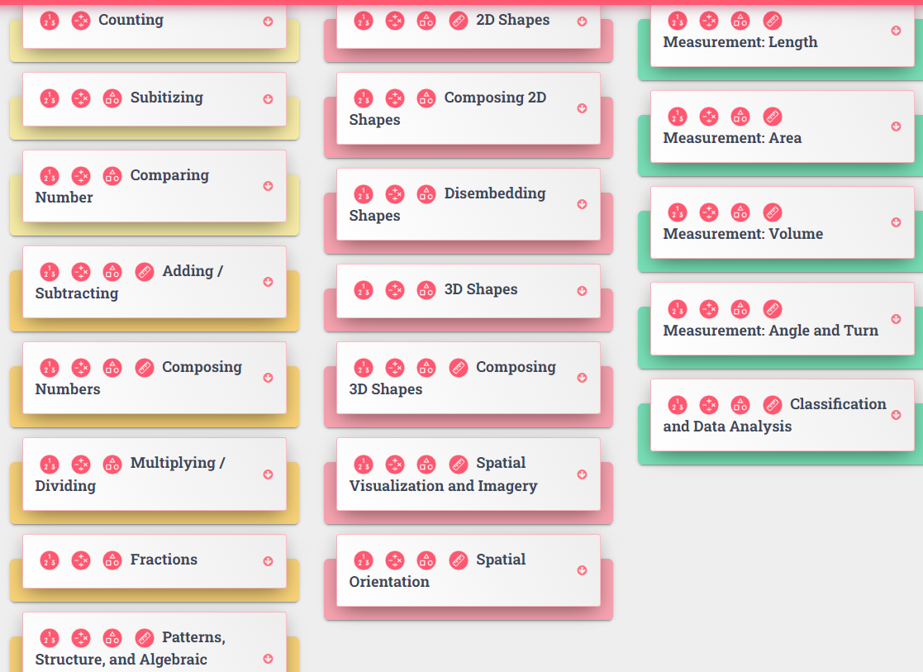
Subitiser

Key links to support planning, teaching and assessment in mathematics
KS1 and KS2
Teaching mathematics in primary schools - GOV.UK

NCETM Guidance and Resources In the Classroom | NCETM
NCETM Spines Y1 – Y6 Primary Mastery Professional Development | NCETM
- Planning Y1 – Y6 addition and subtraction
- Planning Y1 – Y6 multiplication and division
- Planning Y1 – Y6 fractions

Primary Assessment Materials | NCETM: rich questions to support you in making assessments about pupils’ depth of understanding of key concepts.
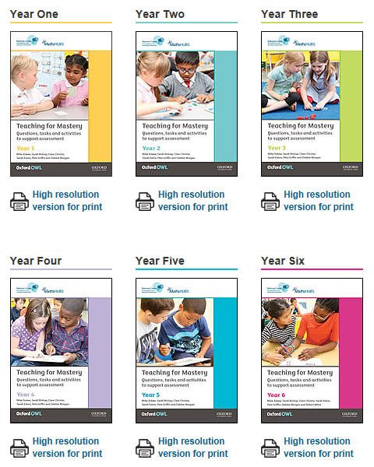

Mathematical Challenges: Rich Tasks and Problems (organised by phase: y1/2, y3/4, y5/6): http://www.bgfl.org/bgfl/custom/files_uploaded/uploaded_resources/12212/mathspuzzlesall.pdf

Subitising links, including arrays
- Subitiser
- Points | Dots - Number Talk Images

Learning Trajectories: 3yrs - 10yrs - activities, articles and videos https://www.learningtrajectories.org/learning_trajectories

Key links to support planning, teaching and assessment in mathematics

EYFS-Secondary

NRICH: a website full of rich tasks and problems as well as articles that teachers can use to support them in developing pupils’ ability to reason and solve problems.
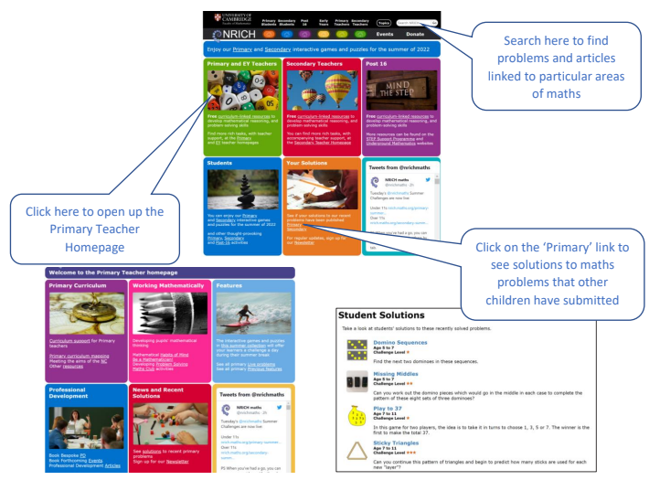

Interactive models for key resources such as Dienes, Cuisenaire, fractions walls, double sided counters etc MathsBot.com
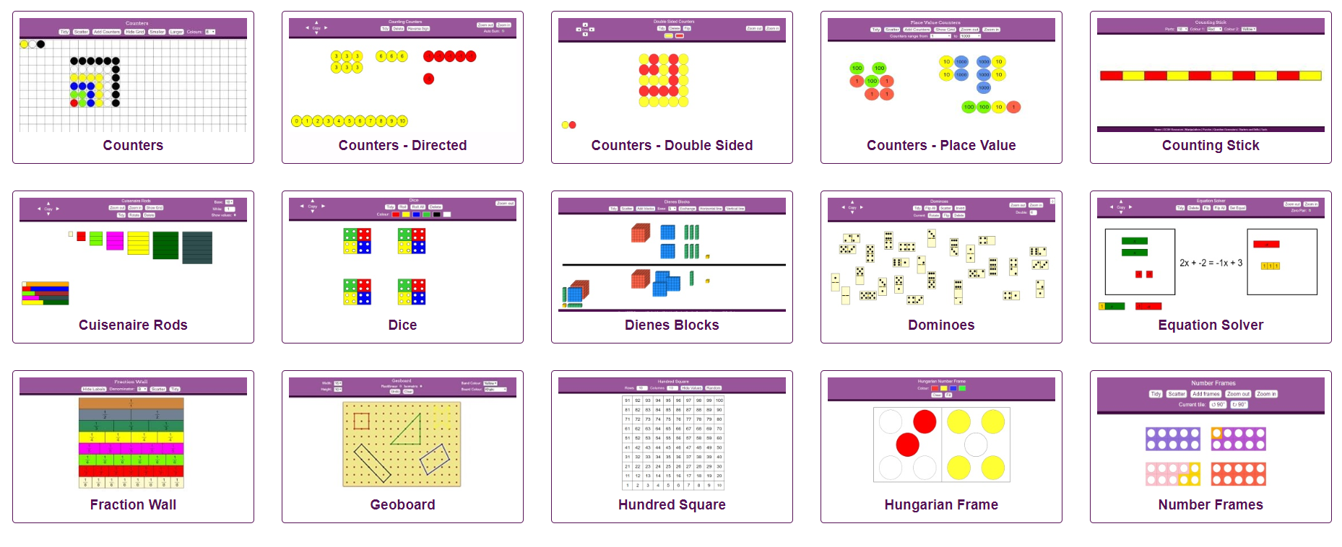

Interactive Teaching Programmes are useful to support your whole class teaching with models. ITPs - Mathsframe

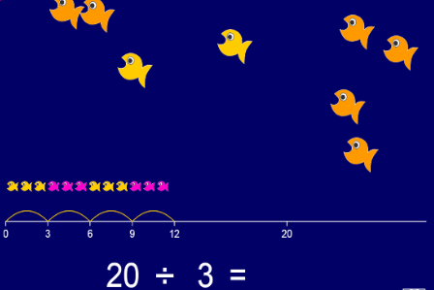

Primary to Secondary Transition

Checkpoints | NCETM: Diagnostic maths activities to help teachers develop their assessment of students' prior learning for KS3

Secondary Mastery Professional Development

Secondary Mastery Professional Development | NCETM
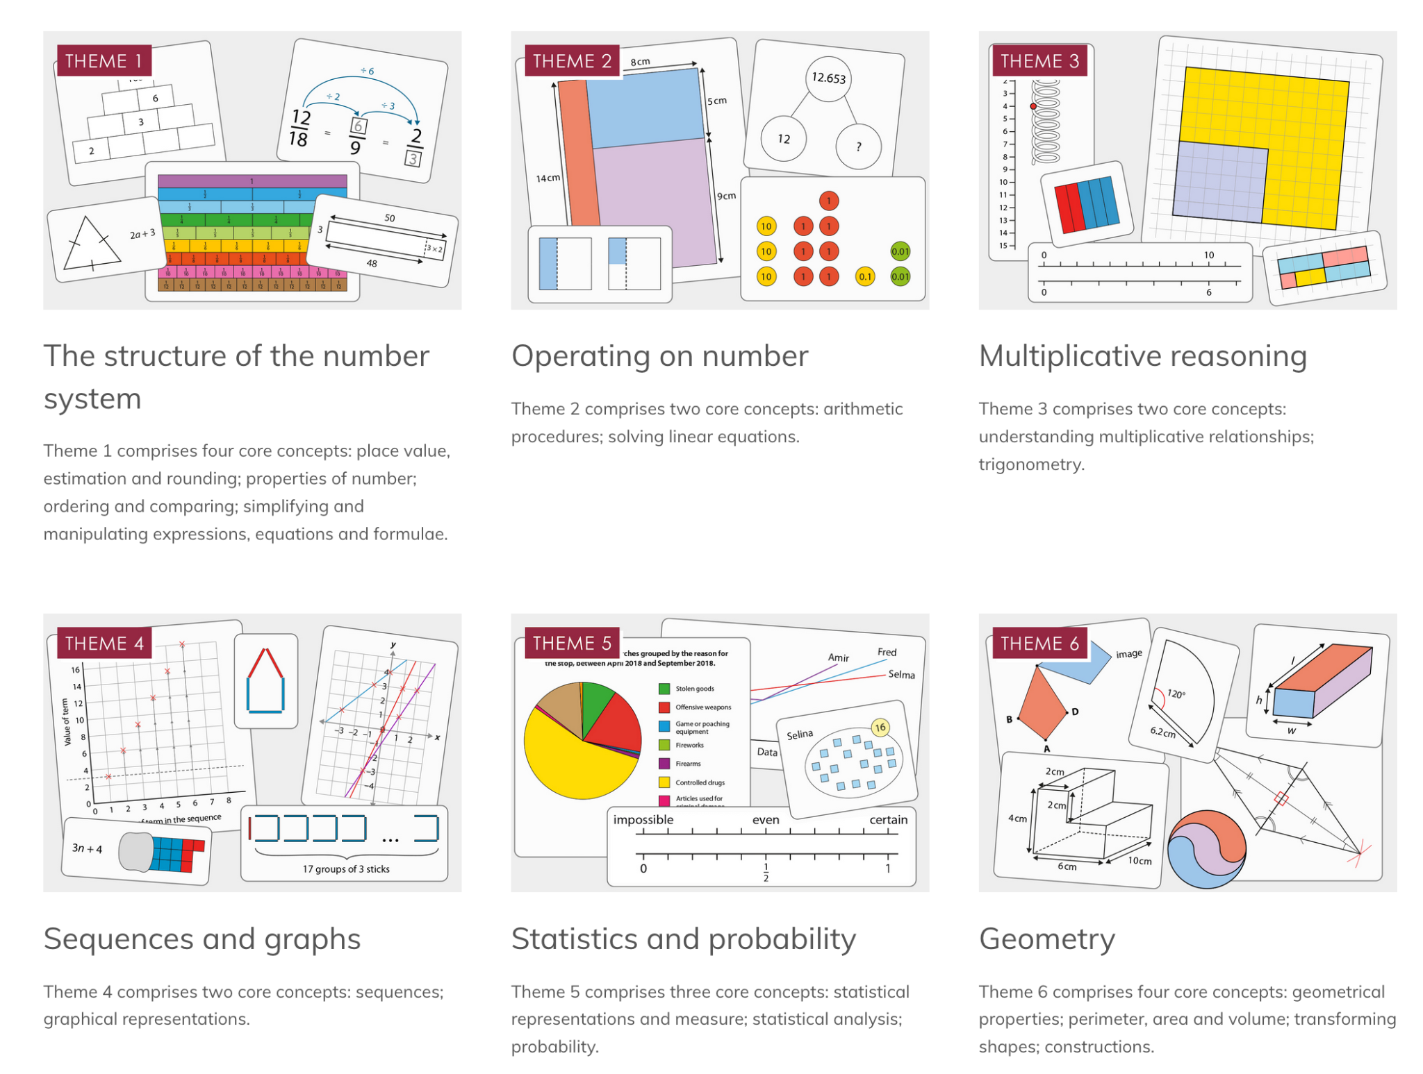
Developing Maths Subject Knowledge

At times you may need to support trainees in developing their subject knowledge. Below is a list of some resources you can signpost your trainee to in regards to developing their subject knowledge.

National numeracy materials National Numeracy
This online resource is a tool to assess your own maths ability and identify any gaps in your
knowledge. By completing the questions, this website then gives you ideas for how to develop your own maths and has online sessions and teaching that you can use to improve your own maths. The questions you are asked get harder or easier depending on your answers and it’s really supportive throughout. This would be a good one to use to develop your own subject knowledge.

Espressos – links to recent research Espresso | Cambridge Mathematics
Espressos provide an insight into current research on a range of mathematics topics. They will enhance trainees' understanding of the pedagogical and content subject knowledge required to teach and will also support them in using research to inform their practice. These Espressos are updated every 2 months. A selection of expressos have been highlighted below that focus specifically on content knowledge:
1. Learning and assessing times tables
4. Early number sense
12. Introducing early algebraic thinking
13. Effective teaching of early measurement
14. Introducing comparison between data sets
15. Introducing negative numbers
22. Early graphicacy
23. Concepts of the mean
25. Introduction to fractions
27. Spatial skills
28. Proportional reasoning
29. Exploratory data
31. Introduction to combinations
32. Concepts of time
34. The equals sign
35. The number line
36. developing concepts of ratio
37. Early concepts of probability
38. Teaching and learning of percentage
39. Teaching and learning similarity
40. Fraction equivalence
41. Rich data sets
42. Division and multiplication

NCETM primary subject knowledge audit
Primary Subject Knowledge Audit | NCETM
The materials have been designed to help you assess your confidence in teaching the content of the KS1 and KS2 curriculum. The materials are divided into four mathematical areas with up to twelve ‘question documents’ in each area.

KS1 and KS2 SAT papers.
National curriculum assessments: practice materials - GOV.UK All SATS papers and their respective mark schemes are freely available on the government website.

Key Text: Mathematics Explained for Primary Teachers by Derek Haylock https://elevate.talis.com/roehampton/player/modules/6287953dc750a8cca448715a/epubs/645bc1acba85f045fdca6d60?chapter=0

