St Mary’s University - Fitness to Practise Policy and Procedures

1. Introduction
The University recognises that conferring academic qualifications leading to a professional qualification and admission to a professional body, and/or statutory registration, creates an obligation to be satisfied that the student will be a safe and suitable entrant to the given profession. Because of their responsibilities to the general public, students following such programmes should demonstrate high standards of behaviour, and must be physically and mentally fit to undertake the demands of their profession.
While different professions will have their own disciplinary standards and expectations of behaviour, these procedures should be followed when student’s Fitness to Practise is called into question. When considering issues relating to Fitness to Practise, public safety must always be the overriding consideration, however staff should also take advice from Equality, Diversity and Inclusion (EDI) in relation to the Equality Act 2010 when applying the Fitness to Practise regulations. Student Wellbeing should be consulted where students who have a disability and/or long-term health condition require reasonable adjustments to enable them to access this procedure.
It is anticipated that this policy may be used most commonly where students are out on the work placements that form a core part of their course, but it is not limited only to this.
2. Scope of the Policy
This policy applies to those programmes listed in Appendix B. Students are also subject to University Student Disciplinary procedures. Matters considered under the terms of the Student Disciplinary Procedure may also be considered under the terms of the Fitness to Practise Policy if the University considers that issues relating to professional practise should be addressed separately.
3. Policy
Students whose behaviour and discipline indicates that they present a risk to the public should not be permitted to proceed and/or graduate with a registerable degree or award. The University reserves the right to terminate the studies of a student whose programme leads to a professional qualification, professional registration, or which provides the basis to practise such a profession, should a student behave in such a way to make the student unfit to be admitted to that profession. The University may, similarly, terminate the studies of a student whose ability to perform in an appropriately professional way presents a danger to themselves, or others and which raises significant doubts about their suitability to practise professionally.
Students may be required to undertake medical checks or provide medical evidence as proof of their fitness to practise in some cases. Where a placement occupational health practitioner raises doubts about a student’s suitability for the intended profession the Fitness to Practise policy should be invoked.
Where a student is subject to the Fitness to Practise procedure, an outcome will be decided based on the outcomes listed under section 13.3 at stage one of the procedure, or section 15 at stage two. This policy permits the university to terminate a student’s period of registration and award an interim or exit award where appropriate.
4. Fitness to Practise and Student Disciplinary and Behaviour Procedure
The Fitness to Practise procedures are separate from the Student Disciplinary Procedure. Where there are allegations of inappropriate behaviour, if there is any doubt as to whether an issue should be dealt with under the Student Disciplinary Procedure or the Fitness to Practise procedures, the Fitness to Practise procedures will normally take precedence.
If a student has a case being considered under the Student Disciplinary Procedure, they will have the same right of appeal within the boundaries of this procedure, regardless of their referral to the Fitness to Practise procedure. However, if the behaviour being considered by the disciplinary panel is related to the case referred to the Fitness to Practise procedure, it is anticipated that the Student Disciplinary Procedure will be paused if recommendations are made following the Initial Investigation (Stage One) of the Fitness to Practise procedure.
Once a student has been through the Fitness to Practise procedures it will not normally be necessary for them to additionally be subject to the Student Disciplinary Procedure. However, such cases will be considered on a case-by-case basis in consultation with the Head of Registry Services.
If, as a result of an investigation held under a separate procedure to the Fitness to Practise procedure, a student on a Fitness to Practise course receives a Notice to Quit from Halls of Residence, the Faculty or Institute will be notified, and the student may be subject to the Fitness to Practise procedures.
5. Fitness to Practise and Academic Misconduct procedures
The Fitness to Practise procedures are separate from the Academic Misconduct procedures. However, it may additionally be necessary for a student to be taken through the Fitness to Practise process on a programme governed by Professional, Regulatory or Statutory Bodies (PSRBs). If a student has been found guilty of academic misconduct it is possible that they may additionally be deemed not fit to practise. In these instances, it may not be necessary to carry out the Initial Investigation (Stage One) and the case can be referred directly to a stage two Fitness to Practise hearing (see sections below). Where a student has been referred to Fitness to Practise after having been through the Academic Misconduct process, the Fitness to Practise investigation should not revisit the facts of the Academic Misconduct case.
6. Fitness to Practise and Fraudulent Applications
When evidence or information is obtained that a student who has completed the enrolment process may have submitted fraudulent information or documentation as part of their application to the University, the process outlined in the Admissions Policy should be followed.
7 Fitness to Practise and DBS checks
Where not subject to a Disclosure and Barring Service (DBS) check prior to admission, students whose courses fall under these procedures must disclose any criminal convictions (including spent convictions) to the University before entering the course. Any student covered by these procedures must disclose any subsequent conviction while registered as a student. Students will be provided with guidance about the consequences for registration within the profession concerned. If a student fails to disclose a conviction, the student will be referred to a Fitness to Practise panel.
8. Confidentiality
The University is committed to complying fully with the Data Protection Act 2018 and the General Data Protection Regulations in its handling of personal data. Disclosure of information will be restricted to those parties involved in the consideration and administration of Fitness to Practise cases. There are, however, circumstances where the University’s commitment to confidentiality is overridden by other considerations. These are:
- When a student’s health and safety, or that of others, is considered to be at risk.
- When a student is considered to be at serious risk of abuse or exploitation.
- When disclosure is required by law.
- When a student’s current behaviour or health requirements compromise the University’s responsibilities to outside agencies, including Practise placements and partner institutions.
- When a student’s current behaviour or health requirements compromise the University’s responsibilities to other students to the extent that those other students are being adversely affected to the serious detriment of their academic progress
9. Fitness to Practise Operating Procedures
- Written records must be kept of all meetings. Digital recordings should not be allowed.
- Student expenses associated with these Regulations will not be reimbursed by the University regardless of the subsequent outcome.
- Students are expected to engage with the Fitness to Practise process and attend meetings when requested to do so. Should a student not be able to attend a meeting at the specified date and time, they are required to contact the member of staff responsible for organising the meeting as soon as possible to provide a valid reason for his/her inability to attend. A valid reason would be the attendance at a class or examination, prior personal commitments, particularly for part-time students and those with caring responsibilities, or non-attendance due to illness with the student required to provide supporting evidence (e.g., timetable, medical certificate). If a valid reason is provided, the meeting will normally be rescheduled.
- In the event that a student does not attend a meeting without valid reason, the panel (or Lead Investigator, if this is a Stage One Initial Investigation) should review the information to satisfy themselves that the student has been sent the appropriate notification. If a panel /Lead Investigator decides that the student has been duly notified and determines that they have sufficient evidence to enable them to make a decision, the matter may be considered in the student’s absence.
10. Provision for Precautionary Measures including an Emergency Suspension
Where a member of staff becomes aware of any concerns relating to a student’s fitness to practise, then they should refer this matter to their Head of School. The Head of School will seek the permission of the Provost (or their designated nominee, see Appendix C) to raise an initial investigation into the matter. In cases where the Head of School considers that an allegation gives rise to serious concerns about the health and/or safety of the student, fellow students or staff members or members of the public, a risk assessment will be undertaken in liaison with Registry and Student Services using all available information in order to determine whether a suspension or partial suspension is necessary on health and safety grounds. Any precautionary action taken by the University must be reasonable and proportionate.
Where it is felt that an emergency suspension should take place, permission will be sought from the Provost and the student will be notified of the start and end date of the suspension in writing. The suspension will normally occur with immediate effect.
Where appropriate, a placement provider and /or the relevant PSRB will be notified, and the student may also be immediately suspended from their placement. Where students are on employment-based courses, the Faculty will notify the student’s employer.
11. Notification of Allegation
Allegations may be made by members of staff, students, employers, placement providers or others. Any allegations which call into question a student’s Fitness to Practise should usually be made in writing to the Head of School (or nominee) of the relevant Faculty, accompanied by any relevant evidence (e.g: results of DBS checks, incident reports etc).
Where it is suspected that the allegation is intended to be malicious or vexatious, the matter may be referred to the Student Disciplinary or Staff Disciplinary procedures, and the matter would be dealt with separately under these procedures.
12. Grounds for Allegation
Where staff members flag a concern, departmental staff and management should first define a plan to support the student in dealing with any difficulties. A clear improvement plan should be agreed informally with the student, with the necessary steps being documented and timelines set. A period for review should be agreed. If there is no improvement in the conduct or behaviour, then the following may be deemed as grounds for calling a student’s suitability for the programme into question:
- alcohol, drug or substance abuse
- inappropriate behaviour including harassment, abuse of others, violence or threats of violence, indecency, drug-dealing, exploiting children or vulnerable people and unprofessional behaviour
- conviction for a criminal offence or accepting a caution for an offence where the offence is such as to render the student unfit to Practise and/or would be unacceptable to a professional body. Such offences would include offences of violence against the person
- acting in a way that does not adhere to the university and/or placement provider safeguarding policies
- concerns about a student’s fitness to work which in the opinion of an occupational health practitioner would raise doubts about suitability for the intended profession or calling
- failure to declare fully all issues related to physical or mental fitness for the profession
- obstructing University staff in the performance of their duties or their duty of care to others.
- exploiting the client or pupil to establish a sexual relationship
- acting in an inappropriate manner on or away from University premises
- failure to rectify behaviour that has been subject to any disciplinary actions under the University's regulations
- failure to respect client, professional client, teaching staff or pupil confidentiality
- repeated inappropriate behaviour towards others such as unwanted contact, sexual advances, use of inappropriate or unprofessional language
- falsification of pupil, client or other professional records
- a finding of academic Misconduct that leads to concern about the suitability of the student to enter their given profession
- Persistent lateness, sickness, or other absence, meaning that the learning outcomes of the programme/placement cannot be met (attendance less than 50% as a guide)
- theft of university or placement provider’s property
- Inappropriate use of university or placement provider’s property or estate
This list is not exhaustive. Behaviour which may give cause for concern may take place within or outside the university.
13 Fitness to Practise Procedures
13.1 Initiation of Procedures
On receipt of information regarding any areas of concern which may render a student not fit to practise their profession, the Head of School (or their designated nominee) will undertake an initial investigation to establish whether there are grounds for concern regarding a student's fitness to practise.
13.2 Initial Investigation (Stage One)
Where the Head of School, following an investigation with any other involved members of staff, or third-party participants, decides that there is cause for concern, the student concerned will be invited to a meeting with the Head of School. The Head of School will notify the student of the concerns raised and explain how they fall below the professional expectations of programme. The student should be provided with evidence of the issues of concern before the meeting. The meeting should take place no more than ten days after the initial concern has been raised.
13.2 Initial Investigation Meeting
The student may be accompanied to the meeting by a friend or by an officer of the Student Union, but not by a solicitor or by anyone acting in a professional capacity. At the end of the meeting, the student should understand
- the nature of the concerns
- why such concerns have been raised, and next steps
13.3 Outcome of Initial Investigation Meeting
Following the initial investigation meeting, the Head of School may:
- Consider that there is no reason for concern and take no further action under the Fitness to Practise procedure.
- Establish a written action plan, to include details of any follow-up meetings and monitoring if appropriate which is agreed, which is to be signed and dated by the student.
- Decide that the grounds are so serious as to threaten the safety of others and may seek the approval of the Provost (or nominee) for an immediate suspension of the student’s studies in accordance with the precautionary action principles set out in the Student Disciplinary Procedures
- Require the student to complete a formal medical assessment in order that a report can be made on their fitness to practise on medical grounds. Where a student refuses to attend a health assessment the university may seek the approval of the Provost for an immediate temporary suspension of the student’s studies.
- Counsel the student to join an alternative route or programme in order to complete their academic studies, and support the student in transferring to a programme which is not governed by placement or PSRB requirements.
The student should be notified of the relevant outcome within 5 working days of the meeting being held, and any actions should be in place no longer than 15 days after the Initial Investigation (Stage One) meeting.
Where it is felt that the matter cannot be satisfactorily resolved using one of the above options, the Head of School (or nominee) will refer the student to the Fitness to Practise Panel and a Fitness to Practise hearing (Stage Two) will be convened by the Head of Registry Services. This should take place no more than fifteen days after the initial investigation meeting (Stage One) and the student will be notified that the case is being progressed to Stage Two within five days of the Stage One investigation.
14 Fitness to Practise Panel
The membership of the Fitness to Practise Panel will be:
- The Provost (or nominee) who will act as Chair.
- The Dean of Faculty (or nominee)
- A member of Academic staff who has links with professional courses.
- A representative of the profession to which the course for which the student is registered may lead to admission.
- An officer of the Student Union acting as a representative for the student.
The Head of Registry Services or their nominee will act as Secretary to the Panel.
No member of the Panel may be or have been directly connected with the teaching or supervision of the student whose case is under consideration, nor must they have any interest or involvement in the circumstances under consideration.
The Head of Registry Services will
- give the student at least ten working days' notice of the date of the Hearing and provide details of the case they have to answer
- provide copies of all documentation, including witness statements, relating to the case and a copy of these Procedures.
- inform the student of the right to be accompanied at the Hearing by a friend.
- provide the names of the members of the Fitness to Practise Panel.
- provide the student with the names of any witnesses that the University proposes to call
- require the student to submit any written evidence they may wish to present in support of their case, no later than four days before the time arranged for the Fitness to Practise hearing
- request the name and status of any person who will accompany the student
- request the names of any witnesses the student wishes to call.
If the student wishes to object to a member of the Fitness to Practise Panel they must do so as soon as possible and in any event at least five days before the time fixed for the Hearing. The only ground for objection is that of possible bias arising from either:
- involvement in the Fitness to Practise process at an earlier stage
- involvement in a related appeal Hearing, disciplinary Hearing or grievance procedure or
- prior knowledge of the matter or the student.
The Faculty or Institute will be represented at the Hearing by the Dean of Faculty (or nominee), who should have no previous involvement in the matter) They will present the case to be considered by the Panel. Where a potential case has been flagged by parties outside of the student’s professional placement or faculty, this matter should be referred to the Head of Registry Services in the first instance. The Head of Registry will then refer this matter to the student’s Head of School to agree the next steps under the Fitness to Practise policy. The student will be notified of the outcome.
Where a student is unable to attend due to ill health, an alternative date for the hearing should be agreed. Where this date is not met, a decision will be made in the absence of the student. An emergency suspension may be sought in the intervening period.
15. Fitness to Practise Hearing (Stage Two)
The case and concerns that have been raised about the student’s Fitness to Practise will be summarised by the Provost who will point to the relevant evidence.
The student will be given the right to reply. The Fitness to Practise Panel will undertake a full and frank conversation with the student and establish the facts. Once all the evidence and concerns have been covered, the student will be asked to leave the meeting and advised that a formal written outcome will be notified to them within ten working days. This letter will form the completion of procedures.
The Fitness to Practise Panel will have the power to:
- Permit a student to continue with the course
- Permit a student to continue with the course but under additional supervision and within an additional reporting procedure
- Impose disciplinary sanctions on the student, consistent with disciplinary procedures set out in the Student Disciplinary Procedures
- Suspend the studies of a student for a specified time or until the occurrence of a specified event to be decided by the Panel
- Recommend a requirement to re-sit an assessment or assessments to the relevant University Examination Board
- Recommend that the student be transferred to an alternative route or programme in order to complete their studies without the requirement of completing a placement or adhering to PSRB regulations.
- Recommend that the student be referred to the Fitness to Study process
- Recommend to the relevant University Examination Board the termination of to the opportunity for a professional qualification, but permit registration for an alternative academic qualification
- Recommend to the relevant University Examination Board that the student's studies be terminated.

The decision along with the rationale of the Panel will be notified to the student in writing by the Secretary to the Panel within ten working days of the Panel Hearing.

The Head of School will also be notified of the outcome within ten working days, and, if appropriate, it will be their responsibility to inform the relevant professional body.

A student whose studies are terminated for reasons of unsuitability to practise may be eligible for an exit award, depending on the number of credits secured and subject to the considerations of the Fitness to Practise Panel. Any termination will take place with immediate effect.
16. Right to Appeal
A student may appeal against the decision of the Fitness to Practise Panel, in writing to the Head of Registry Service by email to appeals@stmarys.ac.uk within ten working days specifying the grounds of appeal.
The grounds for appeal are limited to the following:
- New evidence which could not have been brought to the attention of the original meeting of the Panel
- There is evidence of a procedural irregularity in the Disciplinary of the Fitness to Practise Panel
- The sanction imposed was disproportionate.
The Head of Registry Services will carry out an initial review of any appeal to establish whether the grounds put forward are present. If the Head of Registry Services determines that grounds are present, the appeal will be considered by the Fitness to Practise Appeals Panel.
The membership of the Fitness to Practise Appeal Panel will be:
- A member of the University Board of Governors, not a member of the University’s staff, who will act as Chair
- A member of Academic Staff of the University
- A senior representative of the profession to which the course for which the student is registered may lead to admission. This person should be external
The Head of Registry Services or nominee will act as Secretary to the Panel.
No member of the Fitness to Practise Panel which heard the initial case will be a member of the Fitness to Practise Appeals Panel. No member of the Fitness to Practise Appeals Panel may be or have been directly connected with the teaching or supervision of the student whose case is under consideration, nor must they have any interest or involvement in the circumstances under consideration.
The Head of Registry Services will give the student at least ten working days' notice of the date of the Hearing and composition of the of the Fitness to Practise Appeals Panel at least five working days in advance of the Hearing.
The student may be accompanied at the Hearing by a friend. The name of this friend must be given to the Head of Registry Services in advance of the Panel meeting.
The Fitness to Practise Appeals Panel will review the record of the evidence, decisions and rational of the Fitness to Practise Panel.
The Fitness to Practise Appeals Panel may decide to:
- uphold the decision and sanction(s) of the Fitness to Practise Panel
- uphold the original decision of the Fitness to Practise Panel but modify the sanction(s)
- uphold the appeal.
The decision of the Hearing will be communicated to the student in writing, within five working days of the decision being made. The decision of the Fitness to Practise Appeal Board will be final and this will complete procedures at St Mary’s.

Version 1 – Final agreed by Academic Board April 2023

Appendix A – Flow Chart of Procedure

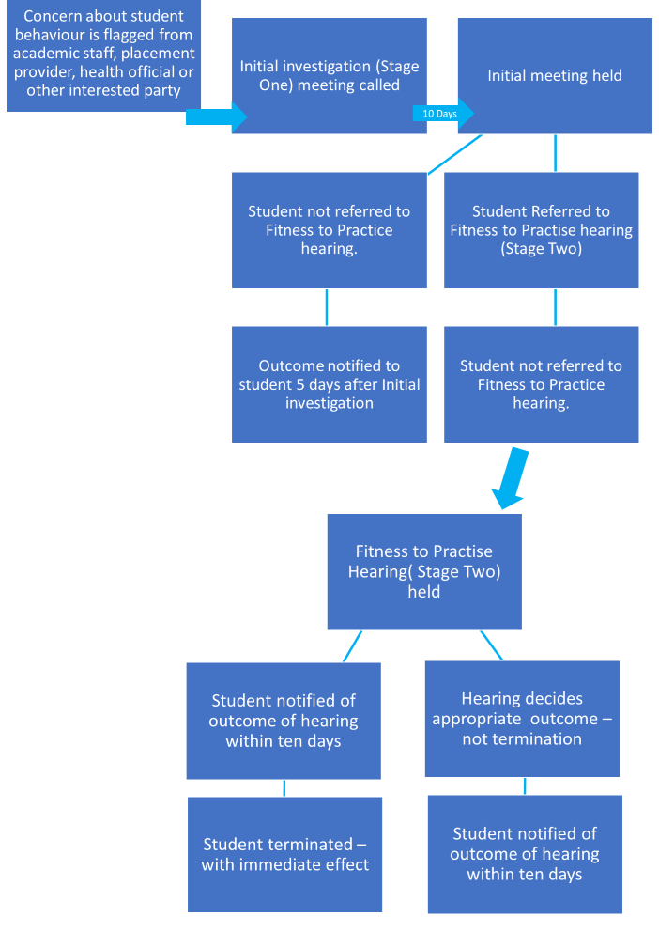

Appendix B
This policy is applicable to the following programmes
- Primary Education with QTS
- PGCE and PfCE Secondary and Primary
- BSc Physiotherapy
- MSc Physiotherapy
- BSc Sport Rehabilitation
- MSc Sport Rehabilition
- BSc Nutrition
- Msc Nutrition
- BSc Computer Science
- MSc Computer Science

Appendix C – Suggested Nominees
Title | Suggested Nominee | Alternative Nominee
Head of School | Course Lead | Head of Student Experience
Head of Registry Services | Student Conduct and Complaints Manager | Director of Student Operations
Dean of Faculty | Head of School | Head of Student Experience
Provost | Chief Operations Officer | Director of Student Operations

Helen A’Court/Registry Services, March 2023
Document title | Fitness to Practise Policy and Procedures
Version | 1
Person responsible | Head of Registry Services
Author | Helen A’Court
Document date | March 2023
Last amended | March 2023
Effective from | March 2023
Review date including impact assessment | March 2024

