**APH6001 – Exam paper**

**Formulae sheet**

**Fourier transform**

$$F\left(f\left(x\right)\right) =\frac{1}{\sqrt{2π}}\int_{0}^{∞}{f\left(t\right)}e^{-iωt}dt$$

**Integrals**



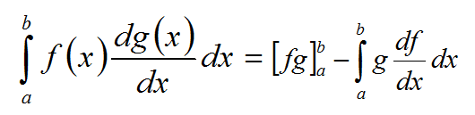

Integration by parts

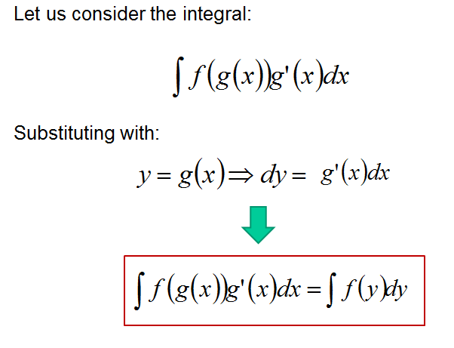

Integration by substitution

Common integrals:

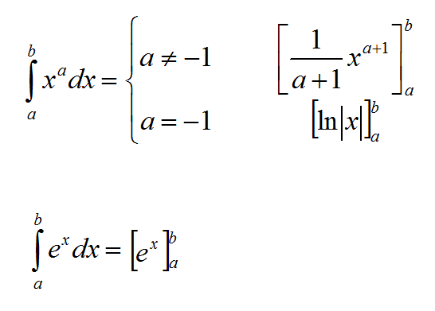

$$\int_{-c}^{c}{\frac{1}{\sqrt[3]{a^{2}+b^{2}}}da={\left[\frac{a}{b^{2}\sqrt{a^{2}+b^{2}}}\right]}_{-c}^{c}}$$

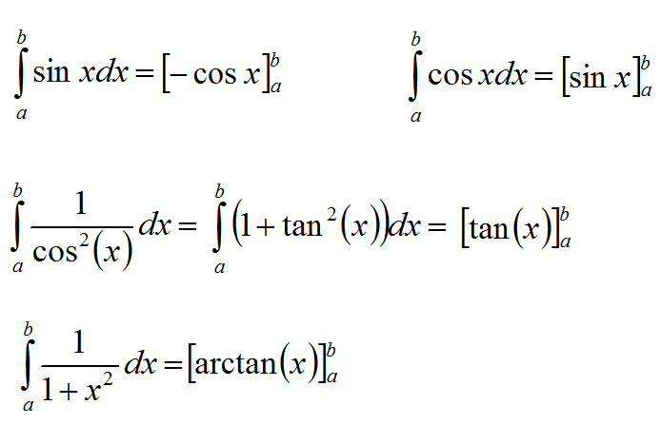

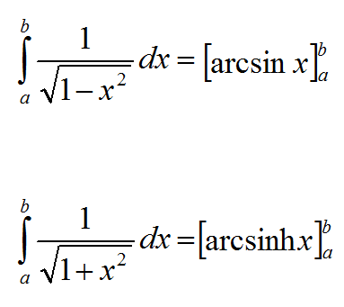

**Laurent series**

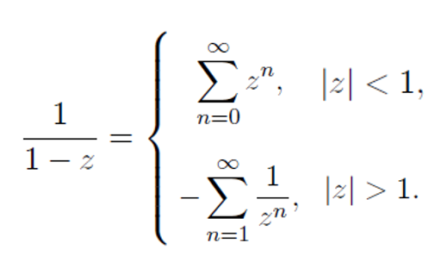

**Scalar product**



**Trigonometric identities**



