ST MARY’S UNIVERSITY
TWICKENHAM, LONDON
BA/BSc or MA/MSc Degree Examination students registered for
Level SIX

Title: 3D Manufacturing

Code: APH6010
Semester: Resit

Date: 1st July 2019
Time: 09:30-11:30 AM

TIME ALLOWED: TWO HOURS

Answer all questions from Section A and three questions from Section B. Calculators are permitted.

Section A (Answer all questions, 25 marks available)

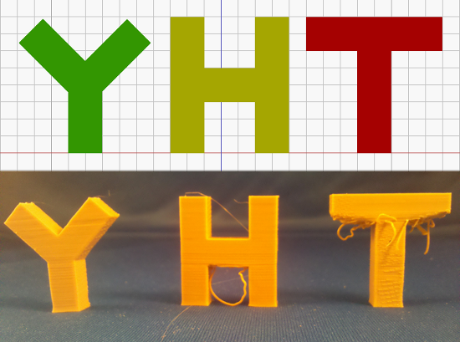
Figure 1: Upper image - a side view of 3D letter designs of 'Y', 'H' and 'T', where the print bed is indicated by the red horizontal line. Lower image - the resulting printed letters.

1. Explain the reason for the poor quality of the ‘T’ and ‘H’ shape in the lower image of Figure 1, and suggest a method of improving the print quality of these shapes. [5 marks]

2. Sketch the behaviour of the elastic modulus with temperature for polymeric materials with weak and strong inter-chain bonding. Label the glass and melting transitions on your sketch. [5 marks]

3. Explain the process of electron beam additive manufacturing.[5 marks]

4. Sketch the main functional components of a powder bed fusion system.[5 marks]

5. A object’s design has the copyright license of CC-BY-ND. What are the copyright limitations in reproducing this object? [5 marks]

Section B (Answer three questions, 75 marks available)

- (a) Figure 2 shows the production of a radical molecule from
Azobisisobutyronitrile. Define what is meant radical molecule and describe its role in photopolymerization. [8 marks]

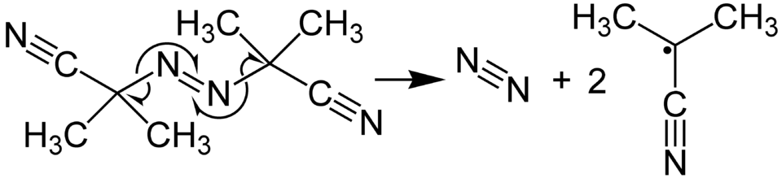
Figure 2: The radical production process in Azobisisobutyronitrile upon absorbing a photon.

(b) Sketch and label a Stereolithography additive manufacturing system,
label each component and state its role in the system. [10 marks]

(c) A laser with power 250mW and wavelength 340nm is used within an additive manufacturing system. Calculate the rate of photons absorbed by Azobisisobutyronitrile molecules and the time taken to create 5 nano-moles of radicals. State any assumptions made. [4 marks]

(d) Sketch a plot of the solidified region in the stereolithography resin for a laser travelling in a straight line. Indicate the cure depth and line width on your plot. [3 marks]

- (a) Euler buckling of a column of length L, with circular cross-section of
radius r, occurs at the critical stress given by

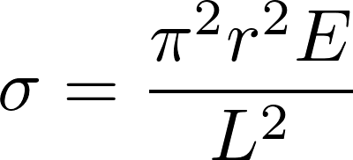
where E is the material elastic modulus. Why is Euler buckling important in the fused deposition modelling (FDM) manufacturing technique?
[5 marks]

(b) Why is a polymer above the glass transition temperature more likely to undergo Euler buckling near the entrance to a nozzle in a FDM printer? [4 marks]

(c) Estimate the critical buckling force acting on a 1.75mm diameter polylactide filament with an elastic modulus of 3.5 GPa. The length of unsupported filament is 6cm. [4 marks]

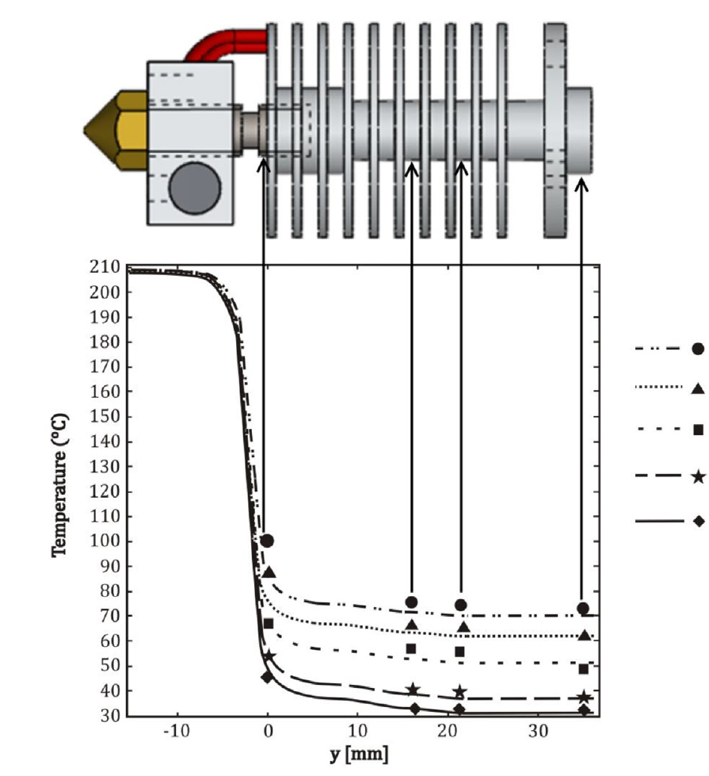
Figure 3: The temperature profile inside 1.75mm diameter polylactide acid (PLA) filament along the length of the nozzle. The points indicate different levels of air speed (from fan cooling) at 0.25 m/s, 0.3 m/s, 0.4 m/s, 0.7 m/s and 1.0 m/s for circle, triangle, square, star and diamond markers respectively.

(d) Figure 3 shows the temperature profile of PLA filament in a nozzle for a FDM manufacturing system. In this test, the nominal heater power is 20W, of which 3W of heating enters the filament. The specific heat of PLA is 1800 J/kg/K and density of 1.3 g/cm³.

(i) Suggest a reason for why the filament in the nozzle, shown in Figure 3, is more likely to jam for air speeds less than 0.4 m/s. [4 marks]
(ii) Estimate the volume and mass flow rate of molten material for a print speed of 10 mm/s. [4 marks]

(iii) Estimate the time taken to heat up the filament to its melting point within the nozzle. [4 marks]

Give reasons for all of your answers and stating any assumptions.

- (a) Assuming the pinhole camera model, show that the depth Z to an
imaged point is given by

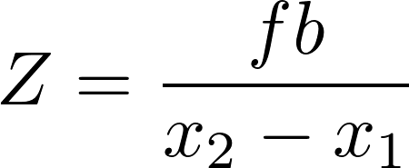

where x₂ and x₁ are the x-coordinates, in the image plane, of the same point imaged in two views. The focal length is given by f and the translation distance (the baseline) is given by b. [7 marks]

(b) Describe an algorithm that can match two points in each image and how you would characterize its performance. [3 marks]

(c) Find an mathematical expression for the uncertainty in the depth as a function of the uncertainty in the disparity. [5 marks]

(d) A point is imaged at (-60,0) and (60,0) in pixel coordinates in the left and right images respectively. The stereovision camera has 3.75 micrometre square pixels, a resolution of 1280 by 960 pixels, a focal length of 3.8mm, and baseline of 0.24m. Calculate the depth to the imaged point and the uncertainty for a disparity uncertainty of 2 pixels. [5 marks]

(e) For many views of the same object, voxel carving can be used. State what is meant by a voxel and explain the voxel carving surface reconstruction algorithm. What are its limitations? [5 marks]

- (a) Explain what is involved in the following steps of the generalized
additive manufacturing process:

(i) Surface export (or extraction)
(ii) Slicing
(iii) Post-processing, giving two examples of operations. [6 marks]

(b) Explain the difference between copyright and patent protection with reference to additive manufacturing design. [6 marks]

(c) Give an estimated minimum feature resolution of a fused deposition modelling printer in the plane of the print bed, and state reasons to support your estimate. [5 marks]

(d) Discuss the advantages and disadvantages that the process of additive manufacturing confers to the production of prototypes. [8 marks]
END OF EXAMINATION

