ST MARY’S UNIVERSITY
TWICKENHAM, LONDON
MSc Degree Examination students registered for
Level SEVEN

Title: Genetics in Health and Disease

Code: NGE7002
Semester: ONE

Date: January 10th 2020
Time: 9:30 am – 12:30 pm

TIME ALLOWED: THREE HOURS

Section A:

Answer all questions in this section. There is one correct answer for each question (2 marks each). Please provide your answers as a list in the booklet, not on this exam paper.

- Mutations in the p53 gene can be:

- Inherited
- Sporadic
- found in approximately 50% of all tumours
- all of the above

- According to the modern theory of evolution, gradual accumulation of small genetic changes usually results in:

- Speciation
- Linkage disequilibrium
- Mutations
- None of the above

- Adoption studies in obesity have shown that:

- adoptees’ weight is more similar to that of the biological parents than the adoptive parents
- there is no association between BMI of non-identical twins separated at birth
- there is a significant relationship between identical twins raised apart
- all of the above

- Migration changes the genetic structure by introducing new genes into a population. This phenomenon is called:

- Mutation
- Gene flow
- Evolution
- Micro-evolution
- Around 85% of all cases of colorectal cancer are due to:

- Mutations in the adenomatous polyposis coli (APC) gene
- Mutations in DNA repair genes
- Mutations in the p53 gene
- None of the above

- Which inheritance pattern does the diagram below show?

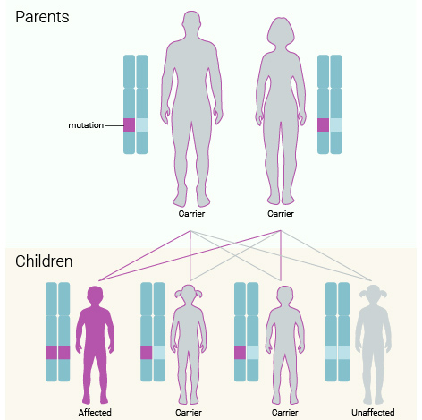

- Autosomal dominant
- Autosomal recessive
- X-linked dominant
- X-linked recessive

- There is evidence to suggest that different types of N-acetyltransferases (NAT) may affect risk of developing colorectal cancer. According to that evidence, which of the following statements is correct?

- NAT 1 is linked with a higher risk than NAT2
- NAT1 is linked with a lower risk than NAT2
- NAT2 slow is linked with a higher risk than NAT2 fast
- NAT2 fast is linked with a higher risk than NAT2 slow

- Which of the following is not a risk factor for developing breast cancer:

- Age at menarchy
- Age at first birth
- Pregnancy weight gain
- Parity

- Which of the following is correct?

- An oncogene is a modified gene that increases the malignancy of a tumour cell.
- A proto-oncogene is a normal gene that can become an oncogene
- Both a and b are correct
- Neither a nor b are correct

- A disease or condition present among a population at all times is called:

- an endemic
- a pandemic
- a cluster
- none of the above

- Which of the following is not a step in the process of atherogenesis?

- Macrophage accumulation
- Vascular smooth muscle cell apoptosis
- Platelet oxidation
- Monocyte migration

- BRCA proteins:

- play an important role in DNA repair mechanisms
- interact with transcription factors
- are involved in gene regulation
- all of the above

- The most common ApoE allele in Caucasians is:

- E3/E3
- E3/E4
- E2/E3
- E2/E4

- The “brain derived neurotrophic factor” gene is associated with:

- Lower basal metabolic rate
- Appetite regulation
- Both a and b
- Neither a nor b

- The extent to which a particular gene or set of genes is expressed in the phenotypes of individuals carrying it, measured by the proportion of carriers showing the characteristic phenotype is called:

- Genetic divergence
- Genetic drifting
- Genetic equilibrium
- Genetic penetrance

Section B:

Answer TWO questions from this section (35 marks each).

- Discuss the role and importance of single nucleotide polymorphisms in the FTO (20 marks) and MC4R (15 marks) genes in relation to weight management.

- Discuss the increased use of personalisation in medicine. Include biological (25 marks) and non-biological (10 marks) elements of personalisation in your answer. You may use nutrition as an example throughout.

- Provide a detailed overview of genetic effects on carcinogenesis of the colorectum (20 marks). Include descriptions and definitions of proto-oncogenes, oncogenes and tumour suppressor genes in your answer (15 marks).

END OF EXAMINATION

