ST MARY’S UNIVERSITY
TWICKENHAM, LONDON
MSc Degree Examination students registered for
Level SEVEN

Title: Genetics in Health and Disease

Code: NGE7002
Semester: ONE

Date: 01 July 2019
Time: 09:30-12:30pm

TIME ALLOWED: THREE HOURS

Section A: Answer all questions in this section. There is one correct answer for each question (Two marks each).
Please provide your answers for section A as a list in your answer booklet, do not answer on this exam paper.
- A disease or condition present among a population at all times is called:

- an endemic
- a pandemic
- a cluster
- none of the above

- What pattern does this pattern of inheritance follow?
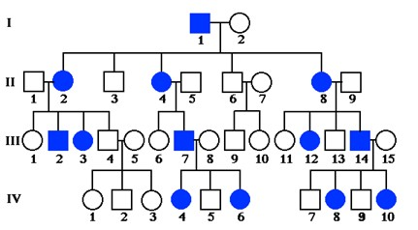

- Autosomal dominant
- Autosomal recessive
- X-linked dominant
- X-inked recessive

- The phenomenon of genetic change through chance alone in a population, is called:

- Genetic drifting
- Natural selection
- Genetic divergence
- Migration

- According to the Hardy-Weinberg equation, the gene pool of which type of a population remains constant over multiple generations?

- Evolving
- Non-evolving
- Divergent
- Non-divergent

- Which of the following is not a step in the process of atherogenesis?

- Macrophage accumulation
- Vascular smooth muscle cell apoptosis
- Platelet oxidation
- Monocyte migration

- Mutations in the p53 gene can be:

- Inherited
- Sporadic
- found in approximately 50% of all tumours
- all of the above

- Which of the following is not a dietary carcinogen?

- Polycyclic aromatic hydrocarbons
- N-nitroso compounds
- Free carbon donors
- Heterocyclic amines

- Place the following atherogenic processes in the order that they appear during plaque formation:

- Endothelial injury – LDL oxidation- Macrophage infiltration - Smooth muscle cell proliferation-Thrombosis
- Endothelial injury – Macrophage infiltration - Smooth muscle cell proliferation-LDL oxidation –Thrombosis
- LDL oxidation– Macrophage infiltration - Smooth muscle cell proliferation- Endothelial injury -Thrombosis
- LDL oxidation- Macrophage infiltration - Endothelial injury- Smooth muscle cell proliferation-Thrombosis

- Absence of functional APC protein leads to:

- Increased cell division
- Increased DNA damage
- Increased apoptosis
- All of the above

- There is evidence to suggest that different types of N-acetyltransferases (NAT) may affect risk of developing colorectal cancer. According to that evidence, which of the following statements is correct?

- NAT 1 is linked with a higher risk than NAT2
- NAT1 is linked with a lower risk than NAT2
- NAT2 slow is linked with a higher risk than NAT2 fast
- NAT2 fast is linked with a higher risk than NAT2 slow

- Which of the following is not a risk factor for developing breast cancer?

- Age at menarchy
- Age at first birth
- Pregnancy weight gain
- Parity

- In the diagram below, the question marks refer to

- Increased FTO expression
- Decreased FTO expression
- Increased MC4R activation
- Decreased MC4R activation

- Which of the following statements is correct?

- Adoption studies reveal that adoptees’ weight is more similar to that of the adoptive parents than the biological parents
- Adoption studies reveal that adoptees’ weight is more similar to that of the biological parents than the adoptive parents
- Adoption studies reveal that adoptees’ weight does not follow any pattern related to that of the biological or the adoptive parents
- None of the above

- Which inheritance pattern does the diagram below show?

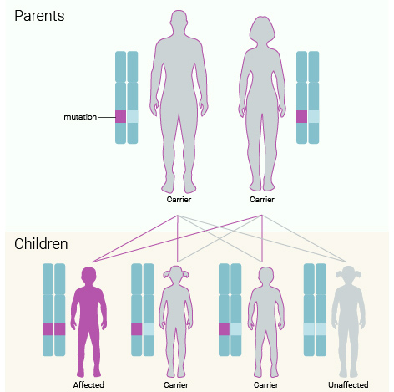

- Autosomal dominant
- Autosomal recessive
- X-linked dominant
- X-linked recessive

- Which of the following is correct?

- An oncogene is a modified gene that increases the malignancy of a tumour cell.
- A proto-oncogene is a normal gene that can become an oncogene
- Both a and b are correct
- Neither a nor b are correct

Section B: Answer TWO questions from this section (35 marks each)

- Provide a detailed overview of polygenic obesity as this is presented through the Genetic Investigation of Anthropometric Traits (GIANT) consortium (35 marks)

- Provide a detailed overview of genetic effects on the carcinogenesis of the colorectum (20 marks). Include descriptions and definitions of proto-oncogenes, oncogenes and tumour suppressor genes in your answer (15 marks).

- Provide a detailed overview of the association of the ApoE gene with cardiovascular disease (20 marks). Include evidence from Genome-Wide Association Studies in your answer (15 marks).

END OF EXAMINATION

