ST MARY’S UNIVERSITY
TWICKENHAM, LONDON
BA/BSc Degree Examination students registered for
Level FOUR

Title: Basic Biomechanics

Code: SPS4041
Semester: Resit

Date: 04 July 2019
Time: 13:30-15:00pm

TIME ALLOWED: ONE HOUR THIRTY MINUTES

Answer ALL questions. Please write your answers in the examination answer book provided.

This examination is divided into two sections:

Section A consists of 50 multiple choice questions. You should attempt to answer all questions in section A.

Section B consists of 11 short answer and calculation questions. You should attempt to answer all of them. In this section you must show your calculations and units as marks are awarded for this.

There are 110 marks available in total. There are 50 marks for section A and 60 marks for section B.

You will need a non-programmable calculator.

A formula sheet has been provided.
SECTION A

- A horizontal plane through the body dividing it into top and bottom sections is termed:
a) Sagittal
b) Frontal
c) Longitudinal
d) Transverse

- How many cervical vertebrae are there in the human body?
a) 5
b) 7
c) 16
d) 12

- In order of proximal to distal the bones of the foot are:
a) Tarsals, phalanges, metatarsals
b) Phalanges, Tarsals, metatarsals
c) Tarsals, metatarsals, phalanges
d) Metatarsals, Tarsals, phalanges

- An example of a saddle joint is the:
- Radio-ulnar joint
- Radio-carpal joint
- Elbow joint
- Ankle joint

- The sternum is an example of:
a) A long bone
b) A flat bone
c) An irregular bone
d) A sesamoid bone

- Which of these is a bi-articular muscle?
- Soleus
- Gluteus maximus
- Brachialis
- Gastrocnemius

- Which of the following is not a function of the skeleton?
- Produces force
- Protects vital organs
- Provides shape
- Cell production

- What is the anatomical name for the shoulder joint?
- Talo-crural
- Sub-talar
- Radiocarpal
- Gleno-humeral

- When something is anterior, it is:
  - Towards the front
  - Away from the midline
  - Towards the back
  - Towards the feet

- Where would you find the Supraspinatus tendon?
a) Shoulder
b) Hip
c) Ankle
d) Knee

- Which muscle is involved in knee extension?
a) Rectus Femoris
b) Vastus Lateralis
c) Vastus Medius
d) All of the above

- Which of these is a uni-articular muscle?
- Semitendinosus
- Semimembranosus
- Vastus lateralis
- Rectus femoris

- The Acetabulum is found in the:
- Hip
- Shoulder
- Knee
- Elbow

- When something is inferior, it is:
- Furthest away from the midline of the body
- Towards the head
- Towards the feet
- Closest to the midline of the body

- Which of these muscles is not an ankle plantarflexor?
- Tibialis anterior
- Gastrocnemius
- Soleus
- Plantaris

- Which of these muscles anteriorly flexes the spine?
- Erector Spinae
- Trapezius
- Rectus Abdominis
- Lattisimus Dorsi

- Which of these muscles is a hip abductor?
- Gracilis
- Tensor Fasciae Latae
- Adductor magnus
- Pectineus

- What is the function of a tendon?
  - To link muscles to bones
  - To link muscles to muscles
  - To link bones to bones
  - All of the above

- Which muscles extend the shoulder?
- Bicep brachii, Teres major, anterior deltoid
- Latissimus dorsi, Teres major, anterior deltoid
- Latissimus dorsi, Teres major, posterior deltoid
- Teres major, Pectoralis major, posterior deltoid

- Which muscle does not flex the knee?
- Rectus Femoris
- Semitendinosus
- Semimembranosus
- Biceps Femoris

- Which of these muscles is involved in elbow flexion
  - Pronator Teres
  - Tricep brachii
  - Brachialis
  - Anterior Deltoid

- How is internal rotation defined?
- A decrease in the angle between 2 articulating bones
- An increase in the angle between 2 articulating bones
- Rotating a limb away from the midline of the body
- Rotating a limb towards the midline of the body

- An abductor is a skeletal muscle which:
- Moves a limb away from midline
- Flexes a muscle
- Moves a limb towards the midline
- Moves a limb up

- Which of these muscles are an antagonistic pair?
- Pectoralis major and pectoralis minor
- Anterior deltoid and Trapezius
- Biceps brachii and brachioradialis
- Bicep brachii and tricep brachii

- What are the main actions of the rhomboids?
- Depress and adduct the scapula
- Elevate and depresses the scapula
- Elevate and abduct the scapula
- Elevate and adduct the scapula

- The femur is an example of:
- A long bone
- A sesamoid bone
- A flat bone
- An irregular bone

- The scapula is an example of:
- A long bone
- A sesamoid bone
- A flat bone
- An irregular bone

- Where would you find the posterior cruciate ligament?
- Hip
- Ankle
- Shoulder
- Knee

- What are the names of three abdominal muscles?
- Rectus Abdominis, Transverse Abdominis, Posterior Abdominal Oblique
- Rectus Abdominis, Teres Abdominis, Internal Abdominal Oblique
- Bicep Abdominis, Frontal Abdominis, External Abdominal Oblique
- Rectus Abdominis, Transverse Abdominis, External Abdominal Oblique

- Which muscles are primary evertors of the foot?
a) Gastrocnemius and soleus
b) Tibialis anterior and tibialis posterior
c) Extensor hallucis longus and flexor digitorum longus
d) Peroneus brevis and peroneus longus

- Newton’s second law of linear motion is known as the ‘Law of…
- Reaction
- Inertia
- Acceleration
- Momentum

- A negative value of angular displacement is associated with which direction of rotation?
  - Clockwise
  - Anti-clockwise
  - Either clockwise or anti-clockwise
  - None of the above

- When jumping into the air body mass is accelerating downwards at:
- 9.81 m/s²
- 9.81 m/s
- 0 m/s²
- 0 m/s

- A scalar is defined by:
  - Magnitude only
  - Magnitude and direction
  - Direction only
  - None of the above

- Which variable is a vector?
- Speed
- Displacement
- Distance
- None of the above
- Wayde van Niekerk completed the 400 m sprint in a time of 43.03 s. What was his average speed?
- 9.30 m/s
- 0.11 m/s
- 17212 m/s
- None of the above

- Which of the following is not a method that can be used to calculate an object’s centre of mass?
- Segmentation method
- Reaction board method
- Balance method
- Trigonometry method

- Which of following increases the stability of an object?
- Raise the centre of mass
- Lower the centre of mass
- Reduce base of support
- Place centre of mass outside of base of support

- Which of the following influences terminal velocity:
  - Drag
  - Gravity
  - Air density
  - All of the above

- What is the unit for velocity?
  - m/s
  - m
  - m/s²
  - s

- What is the unit for angular velocity?
- Degrees/s
- m/s²
- rad/s
- m/s

- A Formula 1 driver completes 1 lap of a 1.5 km track. Displacement is:
- 1.5 km
- 0 m
- 1 m
- None of the above

- How many degrees (°) are there in one and a half revolutions:
- 450°
- 720°
- 360°
- 540°

- What is the equation to calculate the length of one of the short sides (labelled ‘B’) of a right angle triangle, where the other short side is labelled ‘A’ and the longest side labelled ‘C’?
- B² = A² + C²
- B² = C² - A²
- B² = A² - C²
- B² = C² + A²

- If you have the adjacent and hypotenuse side lengths of a right angle triangle, which function allows you to calculate the angle?
- Inverse Sin
- Sin
- InverseTan
- Inverse Cos

- To convert degrees to radians:
  - Multiply by π and divide by 180
  - Multiply by 180 and divide by π
  - Divide by 360
  - Multiply by 180

- Momentum can be calculated by:
  - Mass x velocity
  - Mass / velocity
  - Mass / time
  - Force x mass

- Diverging streamlines around an object represent
a) Slowing down
b) Speeding up
c) No change in the speed
d) None of the above

- n earlier separation point of the boundary layer around an object relative to a later separation point creates:
- A smaller area of low pressure behind the object
- High pressure behind the object
- A larger area of low pressure
- None of the above

- Which of the following affects the stability of an object?
- The height of the centre of mass
- The centre of gravity position relative to the base of support
- The size of the base of support
- All of the above

SECTION B

- A mounting bike rider follows a time trial route:
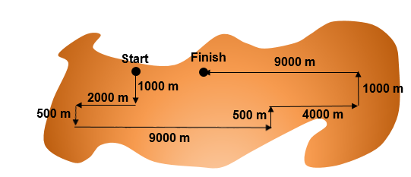

- What was the rider’s completed distance? (2 marks)

- What was the rider’s completed displacement? (3 marks)

- A runner accelerates from 0.8 m/s to 6.1 m/s over a period of 5 s. Then decelerates from 6.1 m/s to 5.2 m/s over a period of 24 s.
  - What is their average acceleration? (3 marks)

  - What is their average deceleration? (3 marks)

- A weightlifter flexes their knee during the squat phase of a powerlift from 165° to 55° in 0.2 s.
- What is their angular velocity during the squat? Report your answer in °/s. (3 marks)

- Convert the answer from part a) to rads/s. (2 marks)

- State Newton’s first law of motion. (2 marks)

- Name two factors that influence stability. (2 marks)

- Name one method of measuring the centre of mass in a human and give one advantage and one disadvantage of using this method (3 marks)

- Name the three types of drag encountered in sport and describe how the shape of an object influences the relative contribution of these to the total drag experienced. (5 marks)

- What is the acceleration of an 80 kg object after impact with a force of 1275 N? (3 marks)

- A wide receiver with a mass of 112 kg travels in a straight line at a speed of 4.5 m/s towards a corner back of 138 kg. The corner back is travelling towards the wider receiver in the same line but at -3.8 m/s. They collide and move off with a constant velocity (v) in the same direction:

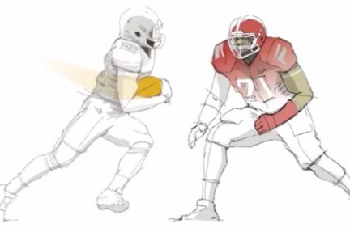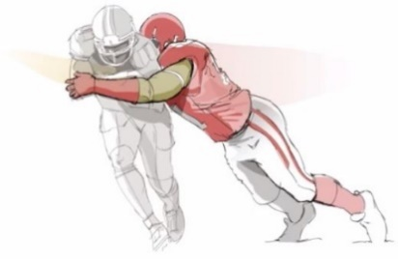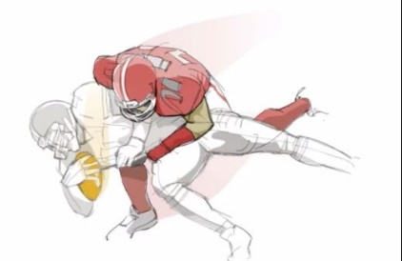

  - Calculate the final velocity (v) of the players after the collision. (5 marks)

- The medial gastrocnemius is pulling with a resultant force of 240 N at an angle of 22°. The lateral gastrocnemius is pulling with a resultant force of 200 N at an angle of 21°
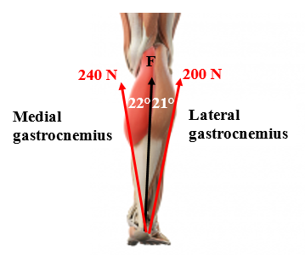
Using trigonometry, what is the magnitude of the vertical force vector (F) for:

- The medial gastrocnemius? (4 marks)
- The lateral gastrocnemius? (4 marks)
- Which muscle exerts the most vertical force? (1 mark)

- An ice skater performs a spin routine rotating anti-clockwise for 12 revolutions. Calculate:
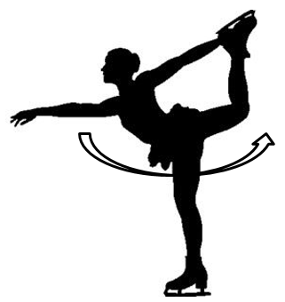

- Their angular distance in degrees. (2 marks)

- Their angular displacement in degrees. (3 marks)

- A pole vaulter leaves the ground with a horizontal velocity of 1.1 m/s and a vertical velocity of 0.3 m/s:
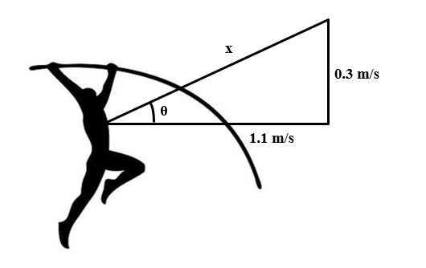
    - Calculate the resultant velocity (x) of the pole-vaulter using Pythagoras’ theorem. (5 marks)

    - Calculate the angle (θ) using Trigonometry. (5 marks)

END OF EXAMINATION

