ST MARY’S UNIVERSITY
TWICKENHAM, LONDON
BA/BSc Degree Examination students registered for
Level FOUR

Title: Basic Biomechanics

Code: SPS4041
Semester: TWO

Date: May 22nd 2019
Time: 9:30 – 11:00 AM

TIME ALLOWED: ONE HOUR THIRTY MINUTES

Answer ALL questions. Please write your answers in the examination answer book provided.

- This examination is divided into two sections:

Section A consists of 50 multiple choice questions. You should attempt to answer all questions in section A.

- Section B consists of 13 short answer and calculation questions. You should attempt to answer all of them. In this section you must show your calculations and units as marks are awarded for this.

- There are 110 marks available in total. There are 50 marks for section A and 60 marks for section B.

- You will need a non-programmable calculator.

- A formula sheet has been provided.

SECTION A

- A vertical plane through the body dividing it into front and back sections is termed:

a) Sagittal
b) Frontal
c) Longitudinal
d) Vertical

- How many lumbar vertebrae are there in the human body?

a) 5
b) 8
c) 16
d) 12

- The two bones of the lower arm are the:

a) Radius and Humerus
b) Humerus and Ulna
c) Ulna and Radius
d) Tibia and Fibula

- An example of a hinge joint is the:

- Radio-ulnar joint
- Shoulder joint
- Elbow joint
- Sterno-Clavicular joint

- The tibia is an example of:

a) A long bone
b) A flat bone
c) An irregular bone
d) A sesamoid bone

- Which of these is a bi-articular muscle?

- Teres minor
- Teres major
- Biceps Brachii, long head
- Deltoid

- Which of the following answers are two of the functions of the skeleton?

- Protects vital organs, provides shape
- Cell production, produces force
- Provides shape, produces hormones
- Produces force, protects vital organs
- What is the anatomical name for the knee joint?

- Talo-Crural
- Sub-Talar
- Mid-Tarsal
- Tibio-Femoral

- When something is posterior, it is:

  - Towards the front
  - Away from the midline
  - Towards the back
  - Towards the feet

- Where would you find the anterior cruciate ligament?

a) Shoulder
b) Hip
c) Ankle
d) Knee

- Which muscle is involved in shoulder extension?

a) Latissimus dorsi
b) Anterior deltoid
c) Rectus Abdominis
d) Pectoralis major

- Which of these is a uni-articular muscle?

- Gracilis
- Rectus femoris
- Semimembranosus
- Pectineus

- Which of the following bones in the lower limb is mostly involved in weight-bearing during standing?

- Patella
- Fibula
- Calcaneus
- Coccyx

- When something is superior, it is:

- Furthest away from the midline of the body
- Towards the head
- Towards the feet
- Closest to the midline of the body

- Which of these muscles is not a hip flexor?

- Semitendinosus
- Psoas major
- Iliacus
- Rectus femoris

- Which of these muscles laterally flexes the spine?

- Erector Spinae
- Trapezius
- Biceps Brachii
- Deltiods

- Which of these muscles is not a hip abductor?

- Gracilis
- Tensor Fasciae Latae
- Gluteus Medius
- Gluteus Minimus

- What is the function of a ligament?

  - To link muscles to bones
  - To link muscles to muscles
  - To link bones to bones
  - All of the above

- Which muscles flex the shoulder?

- Bicep brachii, Brachialis, Brachioradialis
- Pectoralis minor, Biceps brachii, Anterior deltoid
- Pectoralis minor, Pectoralis major, Biceps brachii, Anterior deltoid
- Pectoralis major, Biceps brachii, Anterior deltoid

- Which muscle does not dorsiflex the ankle?

- Tibialis posterior
- Tibialis anterior
- Extensor digitorum longus
- Extensor hallucis longus

- Which of these muscles is involved in knee flexion

  - Rectus femoris
  - Soleus
  - Bicep femoris
  - Vastus medialis

- How is external rotation defined?

- A decrease in the angle between 2 articulating bones
- An increase in the angle between 2 articulating bones
- Rotating a limb away from the midline of the body
- Rotating a limb towards the midline of the body

- An adductor is a skeletal muscle which:

- Moves a limb away from midline
- Flexes a muscle
- Moves a limb towards the midline
- Moves a limb up

- Which of these muscles are an antagonistic pair?

- Pectoralis major and pectoralis minor
- Semimembranosus and semitendinosus
- Biceps brachii and brachioradialis
- Rectus abdominis and erector spinae

- What is the action of the gluteus maximus?

- flex and medially rotate the hip
- flex and laterally rotate the hip
- extend and medially rotate the hip
- extend and laterally rotate the hip

- The patella is an example of:

- A long bone
- A sesamoid bone
- A flat bone
- An irregular bone

- The Vertebrae are an example of:
- A long bone
- A sesamoid bone
- A flat bone
- An irregular bone

- Where would you find the pubofemoral ligament?

- Hip
- Ankle
- Shoulder
- Knee

- What are the names of the three hamstring muscles?

- Rectus femoris, Semimembranosus, Sartorius
- Biceps femoris, Sartorius, Semitendinosus
- Rectus femoris, Semitendinosus, Semimembranosus
- Biceps femoris, Semitendinosus, Semimembranosus

- Which muscles are external rotators of the shoulder?

a) Biceps brachii and teres minor
b) Latissimus Dorsi and Pectoralis Major
c) Triceps Brachii and Teres Major
d) Teres minor and Infraspinatus

- Newton’s third law of linear motion is known as the ‘Law of…

- Reaction
- Inertia
- Acceleration
- Momentum

- A positive value of angular displacement is associated with which direction of rotation

  - Clockwise
  - Anti-clockwise
  - Either clockwise or anti-clockwise
  - None of the above

- When standing on the ground, body mass is accelerating downwards at:

- 9.81 m/s²
- 9.81 m/s
- 0 m/s²
- 0 m/s

- A vector is defined by:

  - Magnitude only
  - Magnitude and direction
  - Direction only
  - None of the above

- Which variable is a scalar?

- Speed
- Displacement
- Acceleration
- None of the above

- Dina Asher-Smith completed the 200 m sprint in a time of 21.89 s. What was her average speed?

- 9.14 m/s
- 0.11 m/s
- 4378 m/s
- None of the above

- Which of the following is a method that can be used to calculate an object’s centre of mass?

- Force plate method
- Reaction board method
- Pythagoras method
- Trigonometry method

- How can you reduce torque (moment) to increase stability when standing still?

- Raise the centre of mass
- Lower the centre of mass
- Put arms out to side
- Put arms across chest

- Centre of mass of any object is defined as a point:

  - Around which mass is equally distributed
  - Through which the line of action of the weight force acts
  - Through which the force of gravity acts
  - All of the above

- What is the unit for momentum?

  - kg·m/s
  - N m/s
  - m/s kg
  - Nm

- What is the standard unit for displacement?

- cm
- mm
- m
- m/s²

- A cyclist completes 1 lap of a 250m velodrome. Displacement is:

- 250 m
- 0 m
- 1 m
- None of the above

- How many degrees (°) are there in three and a half revolutions?

- 630°
- 184.45°
- 1080°
- 1260°

- What is the equation to calculate the length of one of the short sides (labelled ‘A’) of a right angle triangle where the other short side is labelled ‘B’ and the longest side labelled ‘C’?

- A² = B² + C²
- A² = C² - B²
- A² = B² - C²
- A² = C² + B²

- If you have the adjacent and opposite side lengths of a right-angle triangle, which function allows you to calculate the angle?

- Inverse Sin
- Sin
- InverseTan
- Inverse Cos

- To convert radians to degrees:

  - Multiply by π and divide by 180
  - Multiply by 180 and divide by π
  - Divide by 360
  - Multiply by 180

- Work is equal to:

  - Force x distance
  - Momentum x distance
  - Force x acceleration
  - Power x distance

- Converging streamlines around an object represent:

- Speeding up
- Slowing down
- No change in speed
- Streamlines can't converge

- By making an object’s shape more streamlined (e.g. changing from a sphere to a tear drop shape) which form of drag is reduced most?

a) Skin drag
b) Water drag
c) Profile drag
d) Curve drag

- During a sprint start from blocks performance is enhanced by:

- Greater vertical displacement of the centre of mass
- Keeping the centre of mass over the base of support
- Greater posterior displacement of the centre of mass
- Less vertical displacement of the centre of mass

SECTION B

- A long distance runner completes twelve and a half laps of a 400 m track during a race.

- What was the athlete’s completed distance? (2 marks)

- What was the athletes’ completed displacement? (2 marks)

- A 4 x 100 m relay team completes a race in a total time of 42.57 s. The 100 m split times for each of the four sprinters is in the table below.

- Calculate the average speed of each sprinter’s split. (4 marks)

Split | Time (s) | Distance (m) | Average speed (m/s)
1 | 10.35 | 100
2 | 10.92 | 100
3 | 10.85 | 100
4 | 10.45 | 100

- Calculate the average speed of the team over the whole race. (2 marks)

- A rugby player accelerates from 0 m/s to 1.4 m/s over a period of 5.5 s. What is their average acceleration? (3 marks)

- A wheel chair athlete extends their elbow during the downstroke of the push against the wheel from 35° to 100° in 0.18 s.

- What is their angular velocity during the downstroke? Report your answer in °/s. (3 marks)

- Convert the answer from part a) to rads/s. (2 marks)

- If angular velocity is maintained, how long would it take to fully extend the elbow from 100° to 180° (4 marks)

- State Newton’s first law of motion. (2 marks)

- Name one advantage and one disadvantage of the reaction board method for measuring human body centre of mass. (2 marks)

- Explain two ways a cyclist can reduce drag (4 marks)

- Define centre of mass. (2 marks)

- What force must be applied to a 70kg object to accelerate it by 0.8 m/s²?
(3 marks)

- A power forward with a mass of 120 kg travels in a straight line at a speed of 2.2 m/s towards a shooting guard with a mass of 135 kg. The shooting guard is travelling towards the power forward in the same line but at -0.6 m/s. They collide and move off with a constant velocity (v) in the same direction:
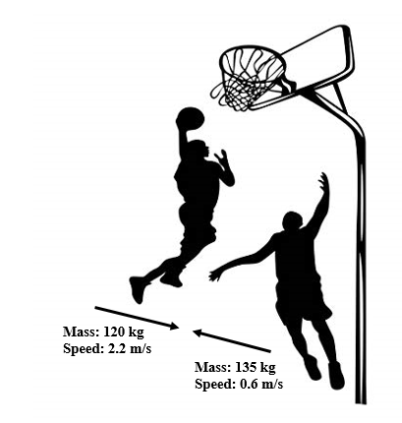

  - Calculate the final velocity (v) of the players after the collision.
(5 marks)
- The deltoid muscle is pulling with a resultant force of 195 N at an angle of 40°: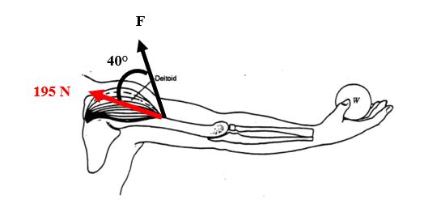

    - What is the magnitude of the vertical force vector (F)? Use trigonometry. (5 marks)

- A gymnast performs a backward one and a half somersault, in an anti-clockwise direction (as shown in the figure below). Please use the appropriate sign in your answer

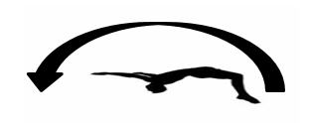

- Calculate their angular distance in revolutions. (2 marks)

- Calculate their angular displacement in revolutions. (3 marks)

- A javelin thrower releases the javelin with a horizontal velocity of 3.7 m/s and a vertical velocity of 1.6 m/s:

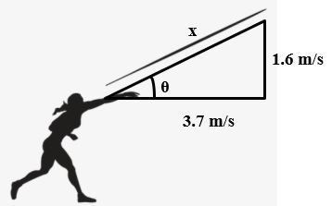

- Calculate the resultant velocity (x) of the javelin at release using Pythagoras’ theorem. (5 marks)

- Calculate the angle (θ) using Trigonometry. (5 marks)

END OF EXAMINATION

