ST MARY’S UNIVERSITY
TWICKENHAM, LONDON
BA/BA(ITT)/BSc Degree Examination students registered for
Level FIVE

Title: Sports Biomechanics

Code: SPS5041 Semester: One

Date: 8th January, 2020 Time: 1:30 – 3:00 PM

TIME ALLOWED: ONE HOUR AND THIRTY MINUTES

A formula sheet has been provided to help you answer the questions.

You are permitted to use calculators for this exam.

Answer ALL questions in the answer book provided. There is a total of 75 marks available. Some of these marks are available for correct units and correct rounding of your answers.

Formula Sheet

Linear Motion | Angular Motion
v = s ÷ t | ω = θ ÷ t
a = Δv ÷ t | α = Δω ÷ t
F = m × a | T = I x α
I = F × Δt | M = F × d
F × Δt = m × v_{f} – m × v_{i} | H = I × ω
F = μ × R

W = F × d
W = ∆KE + ∆PE
KE = ½ x m × v²
PE = m × g × h
SE = ½ x k × x²
P = W ÷ t
P = F × v
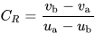
v = u + a × t
s = u × t + ½ × a × t²
v² = u² + 2 × a × s

- In 2D video analysis, what is the role of a calibration/scaling object? (2 marks)

- Explain why an increased iris is required when a fast shutter speed is selected in 2D video analysis. (4 marks)

- If you want to measure knee angle using 2D video analysis, which three anatomical landmarks would you need to digitise? (3 marks)

- Which of Newton’s laws is the basis of force measurement? (1 mark)

- During a vertical jump, in which direction would the greatest ground reaction force be recorded? (1 mark)

- The figure below represents the anterior-posterior ground reaction force recorded during a run.

  - Using the letters on the diagram, identify the period where a braking force is being exerted (1 mark)
  - Using the letters on the diagram, identify the period where a propulsive force is being exerted (1 mark)
  - Is the runner speeding up or slowing down? (1 mark)

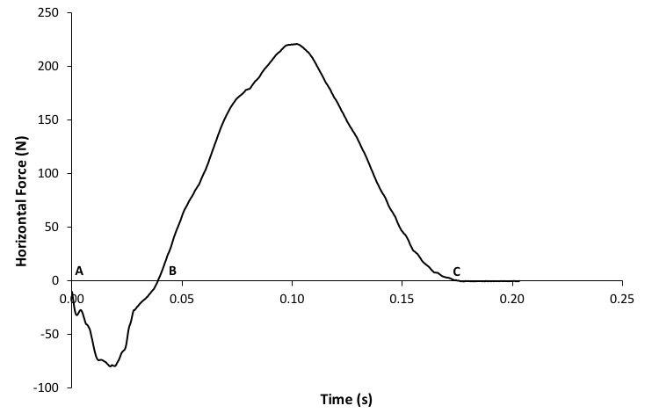

- A cricket players’ elbow extends from 44° to 175° when throwing a ball. If this movement took 0.13 s, calculate the average angular velocity of elbow extension. (3 marks)

- During the final 100 m of a 5000 m race, Mo Farah increases his horizontal centre of mass velocity from 8.0 m/s to 9.5 m/s. If it takes him 0.80 s to do this;

- Calculate the average horizontal acceleration of his centre of mass over this time period. (3 marks)

- Given that Mo Farah’s mass was 61 kg during this race, calculate the average horizontal force that he required to achieve this acceleration. (3 marks)

- Identify the THREE basic tasks of gait. (3 marks)

- Define what is meant by the term coefficient of friction. (1 mark)

a) Calculate the angular momentum of an airborne trampolinist who is rotating at 2.3 rad/s and has a moment of inertia of 7.1 kg·m². (3 marks)

- The trampolinist then tucks in and reduces her moment of inertia to 5.5 kg·m². Work out what her angular velocity has changed to. (3 marks)

- A weightlifter lifts a 95 kg weighted barbell to a height of 1.8 m.

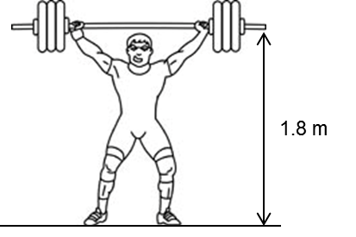

- What is the potential gravitational energy of the barbell at the end of the lift? (3 marks)

- If the lifter performs the lift in 0.9 seconds, what is the average power produced during the lift? (3 marks)

- If the lifter drops the weight from the final lift position, what would the velocity of the weight be the moment before it strikes the ground? (4 marks)

- A pole-vaulter uses a pole with a stiffness constant of 1250 N/m. Calculate how much strain potential energy is stored in the pole when it deforms by 1.4 m. (3 marks)
- Calculate the coefficient of restitution when a tennis player hits a volley. The ball is travelling into the racket at 7 m/s and the racket moves towards the ball with a velocity of 3 m/s. Immediately after the ball is hit, the ball has a velocity of 5 m/s and the racket is travelling at 1 m/s. (5 marks)

- What does a coefficient of restitution of 1 represent? (1 mark)

- In the correct order, list the four typical steps involved in a qualitative biomechanical analysis of a sporting skill (as used in the four-task model proposed by Knudson and Morrison, 2002). (4 marks)

- In theory, the optimum projection angle for a shot put is 45°. Explain why research has shown elite shot-putters use a lower projection angle than this. (4 marks)

- Neglecting air resistance, what can we say about the horizontal velocity of a projectile during flight? (1 mark)

Use the equations of constant acceleration to help you answer question 19.

- Owen Farrell takes a place kick, 40 m from the try line. He kicked the ball with a velocity of 22 m/s at an angle of 38° above the horizontal.

  - What were the horizontal and vertical velocities of the ball? (6 marks)

  - How long would it take for the ball to reach the goal? (3 marks)

  - What height was the ball when it crossed the try line? (4 marks)

  - Did the ball pass over the crossbar (i.e. 3.0 m high)? (1 marks)

END OF EXAMINATION

