ST MARY’S UNIVERSITY
TWICKENHAM, LONDON
BA/BSc Degree Examination students registered for
Level FIVE

Title: Muscle Physiology

Code: STC5003
Semester: TWO

Date: May 16th 2019
Time: 09.30-11.00 AM

TIME ALLOWED: ONE AND A HALF HOURS

Attempt ALL ten questions. Questions carry 10 marks each. Answer each question in the same answer booklet.

- Explain the neural and structural adaptations that occur in response to a long-term resistance training programme. As part of your explanation, identify the functional significance of each adaptation. (10 Marks)

- Provide brief notes outlining potential factors that might signal a hypertrophy response in muscle, as well as their proposed mechanism of effect, following strength training (10 marks).

- Define the term neuroplasticity and outline the levels where CNS adaptations occur (10 marks).

- Describe the key features of the graph in Figure 1 (4 marks) and the reasons for the change in lactate response as a result of endurance training (6 marks).
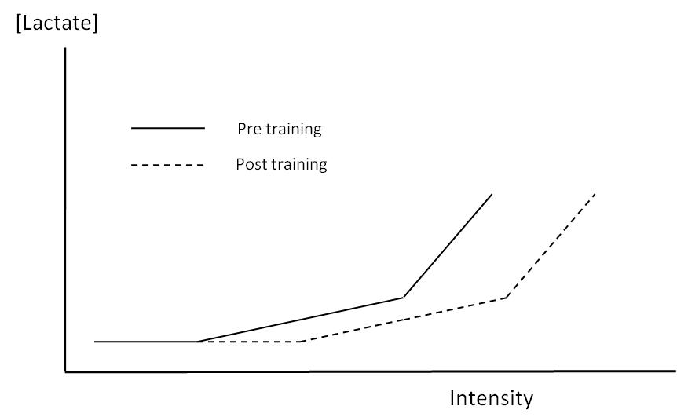
Figure 1. Blood lactate response to increasing exercise intensity.
- Following a bout of heavy eccentric exercise, muscle fibres are often damaged resulting in soreness for 48-72 hours. Describe the likely mechanisms of the repeated bout effect that are observed in response to loading of this nature. (10 marks)

- What adaptations occur in skeletal muscle as a result of chronic endurance training, which might result in an improved performance? (10 marks)

- Exercise induced muscle damage occurs following an unaccustomed bout of mainly eccentric exercise. Give a short overview of the symptoms associated with it (10 Marks).

- List five enzymes that have been reported to change with repeated sprint training (10 marks).

- Compression garments are frequently used by athletes in training and recovery. Outline the mechanisms by which compression may:

- Enhance performance (5 marks)
- Accelerate recovery (5 marks)

- How does pennation angle change following a long-term strength training programme? Include a diagram to support the answer (10 marks).

END OF EXAMINATION

