
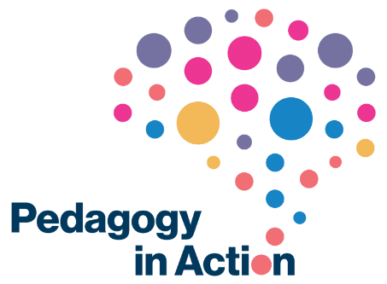
Blog Style Guide
Author name | Full name and LinkedIn tag
Title of blog | (Up to a maximum of 8 words)
Short biography | Up to a maximum of 50 words e.g. Orana Kalinga is the programme director for a St Mary’s teaching programme, and in demand for consultancy projects within universities. You can find out more about her book Widening participation in Learning and Teaching in Higher Education Courses by clicking here.
Head shot | Please provide a headshot for your biography.
Lead image (optional) | Please describe the type of image you are looking for. We source the images for the blog posts in order to clear the copyright, but if you have an original image which you hold copyright for yourself, please feel free to include it here.
Brief summary | A brief introductory summary of the blog including the author’s name, job title and institution e.g. In advance of the St Mary’s University event on the ways of encouraging wider participation from community groups in Higher Education, programme director, Orana Kalinga shares her thoughts on widening participation as the leader’s dilemma.  (Up to a maximum of 40 words)
Body text | Up to 750 words. This includes quotes, headers and references.  Please do provide the links to any references in the post. We will hyperlink these into the blog post.

General guidelines
- Writing style should be conversational academic rather than formal.
- The use of sub-headings is encouraged to make blogs easy to read and digital friendly.
- Avoid jargon and ‘in-house’ terms. Please explain any terms that may not be familiar to an international audience (explanation can be provided via URLs to websites).
- What’s in it for the reader? Before compiling the text please try and identify at least one ‘take-home’ point that will benefit the reader. This should be included in the ‘brief summary’.
- Please keep in mind that the viewable area of a webpage is relatively small. In order to engage and retain the reader your text should reflect a more journalistic style (conclusion, explanation, details).
- While personal opinions are welcome, direct criticism of named individuals/institutions should be avoided.
- End with a ‘call to action’ – it is notoriously difficult to get people to use the ‘comments’ facility on any blog, so any post should end with a question that encourages a response from the reader.

Nicola Tierney, Pedagogy in Action blog editor.

