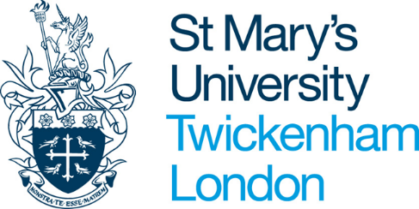
Guidelines for Visiting Academic Scholars
1. Visiting Academic Scholars are expected to make their own arrangements regarding visas/work permits, travel, insurance, housing and health/vaccinations. Preference may be given to applicants from institutions with which St Mary’s University (SMU) has an affiliation. All applicants should be competent users of English. St Mary’s University Doctoral College will normally issue a formal letter of invitation to the Visiting Academic Scholar.
Applicants can be doctoral students, post-doctoral research fellows or academics wishing to set up potential collaborations with St Mary’s academic staff. However, doctoral students will not receive supervision that can be regarded as a replacement for their home institution supervisors (for example, comments on drafts of chapters of theses): the purpose of any visit should be to broaden research experience.
During their stay Visiting Scholars will receive:
- St Mary’s University ID card
- Use of the Library and computing facilities (including SMU email address)
- Desk space within the Doctoral College and use of research facilities
- Opportunities to discuss research with members of staff
- Observation of classes, by arrangement
- Advice on preparing papers for publication
- Access to University workshops and research seminars
- Assistance in accessing information resources and research facilities in the London area
- Visiting scholars will be able to attend SMU open seminars and public lectures as well as take part in the events run by the Chaplaincy.
- On satisfactory completion of the visit, scholars will be provided with attendance certificates.
2. The University does not normally offer:
- Individual office space or residential accommodation
- Formal academic supervision
- Registration to SMU awards or assessment
3. Other points to note:
- Residential accommodation on the University campus is very limited and prospective Visiting Academic Scholars should not rely on its availability. However, St Mary’s Accommodation Office can provide help and advice in finding alternative local accommodation.
- It is not possible to conduct research within schools in the UK without a DBS (Disclosure and Barring Service) check. Responsibility for arranging for a DBS check to be completed, or for arranging to undertake research in schools will lie with the Scholar. Please visit http://www.homeoffice.gov.uk/agencies-public-bodies/dbs/ for more information.
4. Fees
A fee of £1,000 per semester will normally be payable to St Mary’s University for the period of the scheme. Visit periods shorter than one semester may be charged at £250 per month, pro-rata.

