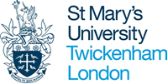
Research Student Skills Record
Name:
Institute/Faculty:
DoS:

Please briefly reflect on the experience you have gained and advancements you have made in the following categories over the past year.

Knowledge and intellectual abilities:
The knowledge and intellectual abilities needed to be able to carry out excellent research

Personal effectiveness
The personal qualities, career and self-management skills required to take ownership for and control of professional development

Research governance and organisation
The knowledge of the standards, requirements and professional conduct that are needed for the effective management of research

Engagement, influence and impact
The knowledge, understanding and skills needed to engage with, influence and impact on the academic, social, cultural and economic context

Please confirm the training courses that you have attended either at St Mary’s through the Research Development Programme or elsewhere:

