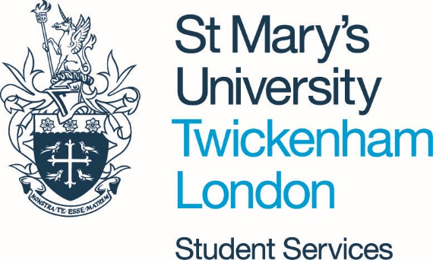

Accommodation Information and FAQs

Last updated: 03/03/2022

As of 24 February 2022, the Government guidance around Coronavirus and self-isolation has changed. People who have symptoms or test positive for Covid-19 are no longer required to self-isolate. However, we are continuing to encourage safer behaviours across the University for all students, as your home away from home should feel safe and comfortable.
Along with the Government guidance, students who have symptoms or test positive for Covid-19 are advised, where possible, to self-isolate in their accommodation and limit contact with other people for at least five full days. Students should then continue to follow the advice until they have received two negative tests results on consecutive days.

All communal areas such as entry ways and stair cases will be cleaned daily by the Housekeeping team.

These areas may be used by more than one household to access their accommodation areas; therefore, residents should move through them as briefly as possible.

Where possible, we encourage all students who are experiencing symptoms or have tested positive to wear masks in communal areas and limit close contact with others.

Guidance for students self-isolating in accommodation on campus and Frequently Asked Questions

Contents
Self-isolating in campus accommodation 2
Frequently Asked Questions 3
When to get a test? 3
How do I self-isolate? 3
Someone in my halls is self-isolating, what should I do? 3
How will self-isolation in halls be arranged? 3
If I am self-isolating in halls how will I access the meal plan? 3
What should I do if there is a fire alarm while I am self-isolating? 4
How can I take care of my mental health and wellbeing during self-isolation? 4
I have other accommodation related questions 4

Self-isolating in campus accommodation
If you are self-isolating in your accommodation on campus, you should notify the University by completing the coronavirus self-notification form.

A member of our Student Life team will check in with you, to discuss any individual support requirements and advise you how to contact Catering to arrange meals during your isolation.

You should ask friends or relatives if you require help with shopping or picking up medication. Alternatively, you are likely to be able to order medication by phone or online via your Doctor’s surgery.

If you find that you are experiencing difficulties in getting access to supplies, we may be able to assist you. You should contact studentlife@stmarys.ac.uk if you require any additional support.

If you have tested positive for Coronavirus you should avoid interacting with others as much as possible. You should ensure that you wash your hands regularly for at least 20 seconds and avoid using communal areas at the same time as other residents. Shared facilities such as bathrooms or kitchens should be wiped down after use.

Frequently Asked Questions

When to get a test?
You should get a test as soon as possible if you have any symptoms of coronavirus.
The symptoms are:
- a high temperature
- a new, continuous cough
- a loss or change to your sense of smell or taste
- Fatigue

You can order PCR test kits for home delivery until 1 April 2022. From Friday 1 April, the Government will end the free testing programme for most people. Tests will become commercially available and free tests will only continue to be available for those who are vulnerable or older.

I have tested positive for Covid-19, what should I do?
From 24 February, you are no longer legally required to self-isolate if you have tested positive for Covid-19.

However, the advice from the UK Government remains that you should:
- stay in your room
- avoid contact with other people for at least five full days
- you can test yourself on the fifth and sixth days and, provided both tests are negative and you do not have a high temperature, you can resume your normal routine.

Someone in my halls is self-isolating, what should I do?

You are no longer required to self-isolate if someone you have been in close contact with is symptomatic or has tested positive.

How will self-isolation in halls be arranged?
Following notification that you are isolating, The University will contact you to support your self-isolation.

We will attempt to contact you as soon as possible, so please ensure that your mobile is switched on, and that you have given the correct contact details when you notify the University.

If I am self-isolating in halls how do I access the meal plan?
If you have notified the University that you are isolating in halls, a member of staff will get in touch to discuss practical arrangements for your self-isolation period. Students should follow any instruction given by the Catering team to organise the delivery of food, which may include nominating a friend to collect meals on your behalf.

Students are expected to contact Catering directly if they require meal deliveries while they isolate. Please email catering@stmarys.ac.uk or call 0208 240 4069 on weekdays till 5pm or 07909996535 on weekends.

Can I still access communal facilities if I am self-isolating?
Whilst sharing a kitchen with others, it is essential that you keep the area clean and hygienic. The Housekeeping team will clean communal kitchens daily, but are only able to do this if the area is free from obstructions and is kept tidy.
Do not leave dirty dishes in the sink or on the draining board. Wash your dishes using your usual washing up liquid and warm water and dry them thoroughly, remembering to use a separate tea towel. These should then be placed in your cupboard or stored in your room.
Shared bathrooms will be cleaned daily by the Housekeeping team. However, you should also ensure that you keep them clean between uses (for example, wiping surfaces you have come into contact with).
If you live in University accommodation on campus, and a cleaner is working in a shared kitchen or bathroom, please allow them to finish their work before entering the room.

What happens if I have a maintenance issue in my room during my self-isolation?
If you are self-isolating, maintenance will only attend to urgent repairs. If you require maintenance you can notify the team at fmhelp@stmarys.ac.uk or in an emergency by calling Security on 020 8240 4335. If maintenance need to attend your room while you are self-isolating you will be asked to clean any surfaces beforehand and wear a face mask while they attend.

What should I do if there is a fire alarm while I am self-isolating?
If there is a fire alarm you will need to;
- Leave the room,
- Consider wearing a mask or face covering,
- Try to avoid close contact with others,
- Where possible, let the fire warden know that you are self-isolating.

I am an international student; do I need to arrange a test when I arrive?
International Students can visit the dedicated page on our website for the most up to date travel advice.

How can I take care of my mental health and wellbeing during self-isolation?
Student Services offers you somewhere to discuss, in confidence, any concerns you have that may affect your studies or your time at University. We are here to listen and provide advice and guidance where necessary; whether you need a solution to a specific concern or require ongoing support. For further information and contact details click here.

Togetherall is a digital mental health support service available to all St Mary’s students. It’s available online, 24/7, and is completely anonymous so you can express yourself freely and openly. Professionally trained guides monitor the community to ensure the safety and anonymity of all members. There are also useful resources you can work through, including tailored self-help courses on anxiety, sleep, depression and more.

Student Space have a guide dedicated to maintain your wellbeing whilst isolating.

I have other accommodation related questions
If you have any other accommodation related questions please email accommodation@stmarys.ac.uk

