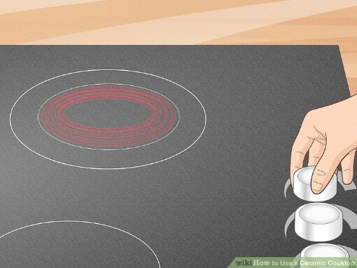
Turn the designated knobs to get your cooktop heated up. Look around your cooktop for specific knobs that control the temperature of your cooking zones. Keep in mind that these knobs may be behind the cooktop, or alongside of it.
- Keep area adjacent to the cooker clear of items that may be affected by heat

Place your pots and pans on to the appropriate location.
- Do not over fill pans
- If using a frying pan use a minimal about for cooking oil and do not over heat so it starts to smoke
- Do not deep fry anything!
- Make sure you have turned off the cooker once you have finished cooking
- Electric hobs can remain hot for quite a while after cooking so do not place anything on the hob

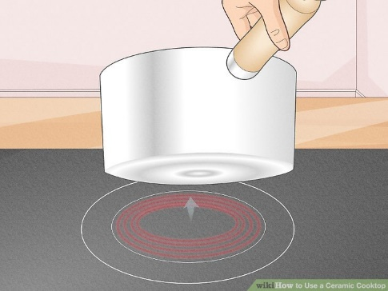

Remember never leave the food cooking unattended and report any faulty cookers to the maintenance help desk.

