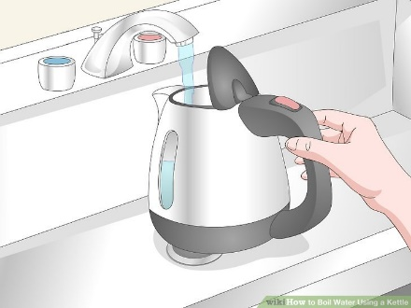

**Set the kettle on its base.** Lower the kettle down into position so that the bottom rests securely over the centre prong. You may hear a faint clicking sound once it’s seated properly. Make sure the kettle is plugged into the nearest wall outlet.

* Before turning on your kettle, it’s a good idea to remove any objects in the immediate vicinity that could be damaged by heat.

**Fill your electric kettle with water.** Open the lid and run water into the kettle until it’s at least halfway full—under- or overfilling it could damage it or present a possible safety hazard. If there’s a fill line indicated somewhere on your kettle, make sure the water doesn’t sit higher than this point.

* Most electric kettles are made to hold up to about 1.7 litres of water.

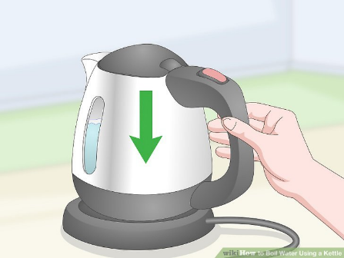

**Flip the power switch on the backside of the kettle to the “On” position.** On most models, the power switch will be located on or near the handle. Once you hit this switch, a small light will appear on the base to indicate that the kettle is plugged in and active.

* If you want to turn the kettle off at any point, you can do so by flipping the power switch to the “Off” position.

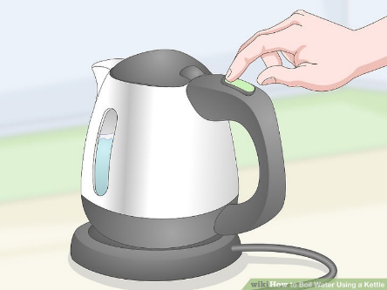

**Allow 2-4 minutes for the water to begin boiling.** Due to their highly-efficient design, electric kettles heat up in about half the time that it takes ordinary stovetop kettles. They’re also programmed to switch off automatically once they reach their targeted temperature, which means you’re free to do other things while your water heats up.

* For your own safety, avoid touching any part of the kettle while it’s in use.

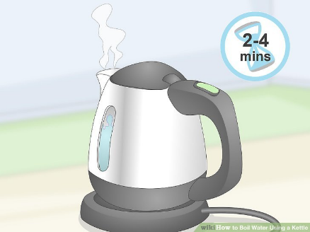

**Handle the kettle with caution while it’s hot.** Lift the kettle by its handle and use your other hand to steady it as you pour. Once you have as much water as you need, return the kettle to its base and take a moment to confirm that the light/switch is off.

* Don’t forget to refill your kettle before using it again.

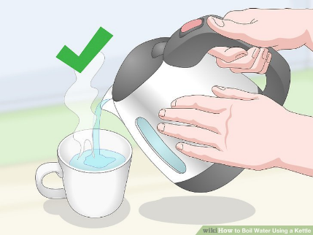

**Remember never leave the kettle unattended when using and report any faulty kettles to the maintenance help desk.**