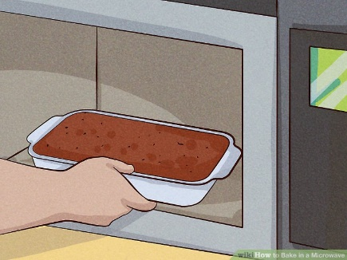
Do’s and Don’ts
- Only use microwave oven proof dishes in the microwave.
- Never place anything metallic in the microwave.
- Follow cooking instructions on the food packaging or recipe designed for cooking in the microwave.
- When cleaning the microwave turn off power supply from the wall socket.
- Do not block the ventilation grills on the microwave.
- Do not place liquids on top of the microwave.
- Take care when removing items from the microwave as they will be hot.
- Do not tamper with the microwave.
- Do not leave unattended while using.

Remember never leave the microwave unattended when using and report any faulty microwaves to the maintenance help desk.

