self-care plan
for
self-isolating
students

Welcome to self-isolation.

Whether you have tested positive, are experiencing symptoms or are self-isolating, this period of self-isolation is important to keep you and others safe, whether you are living in private accommodation, at home or in halls. To find out more about how to keep yourself safe and also what will happen from a practical point of view during your time in self-isolation, please read the Government guidelines and the University guidelines.

We understand that this may be a challenging time for you; or you may take it all in your stride. Whatever you feel about your self-isolation, we have put together some self-care tips to support you through this time, because looking after your wellbeing is very important.

This pack is designed to help you plan your self-care, to invest time in yourself and create a self-care plan that works for you. Your own self-care plan may change depending on your mood, the time of year and any difficulties that you may encounter. Sometimes it is good to have an everyday self-care plan and an ‘extra’ self-care plan for those more challenging times. Once you get into the habit of looking after yourself, this may become something that you do without thinking or planning.
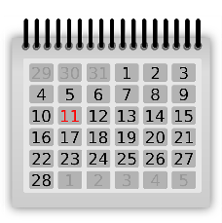
Take one day at a time – break it down
Try to look at it as individual days, taking one day at a time, rather than thinking of it as one long stretch of time.

Self-care
- Self-care means looking after your physical, emotional and psychological health.
- It fosters a healthy relationship with yourself.
- Meeting your basic needs is very important for your health and wellbeing.
- Regular exercise, sleep and healthy food can boost your self-esteem and help you look and feel better, as well as improve your concentration.
- Self-care isn’t selfish!

What do I already do?
- Write down how you already look after yourself (this might include eating healthily, drinking water, exercising regularly, doing meditation, mindfulness, writing a journal).
Structure your day
Creating a daily routine allows you to work better, be more proficient and stay fulfilled. Routine and structure can make us feel safe and in control.
- Create and stick to a realistic routine.
- Plan the day ahead, use a daily planner if you need to.
- Fill in your lecture times.
- Sometimes, taking things in bite-sized pieces can feel less overwhelming.
- Try to start with small, achievable goals and work from there – togetherall has a goal setter tool that you can use to set your goals.
- Use your other free time to do a variety of different things, whether that is yoga, watching a movie, contacting a friend.
- Write how you feel – togetherall has a private journal where can write your thoughts and feelings.

Sign up to togetherall, using your University email address, for free 24-hour support and access to courses and resources on stress, anxiety, loneliness, overthinking, and quietening the mind.

Self-awareness
This is about taking the time to notice and recognise your thoughts and feelings and how they present themselves within you.
Understanding more about yourself and learning what you are good at and where you can make improvements, without judgement, can allow you to set and achieve your goals. Sometimes you might notice a cycle or pattern to how you respond to either certain situations or certain people or behaviour.

Practice self-compassion
It is easy to be hard on ourselves or for that critical voice to be present; however, this can have a negative impact on our emotional wellbeing and our self-esteem. If you notice that you are being hard on yourself, try being kind: think about what you would say to your best friend and try it on yourself. Practising self-compassion can boost your self-esteem and self-worth.
Being self-aware and looking after yourself can make you feel more positive about yourself and your life.

How am I feeling?
You may experience a range of emotions, from anxiety, irritation, and boredom, to frustration, or even relief … there are so many emotions that you could feel.
It is important to remember that your feelings will pass; that this feeling that you are having right now will not last forever; that your feelings are fluid and will change.
Try not to dwell on this period of time as a whole, and instead look at it one day at a time. If you are struggling with your feelings, it is good to acknowledge it.
It is okay to say:
- ‘No, I’m not okay.’
- ‘I’m struggling.’
- ‘I’m finding this really difficult right now.’
- ‘This is harder than I thought it would be.’
Write down your difficult feelings and thoughts to get them outside of your body and onto paper.
You have the power to distract yourself from your negative thoughts and to focus on positive thoughts.
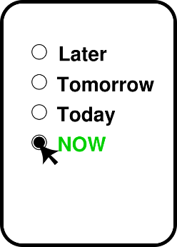
Keep it in the present
Having more time on your hands sometimes means that you have more time to think, which can lead to overthinking, catastrophising or ‘what if’ questions.
- Try not to worry about the past or what might happen in the future.
- You cannot change the past and you have no control over the future; however, you can control what you do right now.
- Try to keep your focus on the ‘here and now’.
- Be curious about how you’re feeling. Complete the thought: ‘Right now, I am feeling…’

Do something that you can control
The pandemic is not something that you can individually control, however you can control what you do with your time in self-isolation. You cannot control how other people behave or what they say, but you can control how you respond.
- Log onto your lectures; start your learning
- Connect with each other
- Look after yourself
- Get the sleep that your body needs
Daily tips
- Stretch and breathe
- Drink water
- Keep your space clear
- Do something you enjoy
- Open your windows

Be your own best friend
- Be kind to yourself
  - Give yourself a break
- Positive thinking
  - You will get through this
- Be creative
  - Draw, paint or write to express yourself
- Connect with others
  - Share your experience and your feelings
- Stay active
  - Even if you dance while cleaning your teeth!
- Look after YOU!
  - “You are your biggest investment”
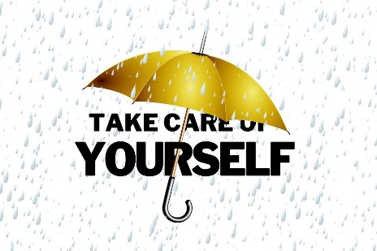

Reach out if you need help
Please don’t struggle or suffer in silence; we are here to support you during this time.
- Speak to your friends, family or Senior Resident
- Contact Student Services: email studentlife@stmarys.ac.uk or wellbeing@stmarys.ac.uk
- Access togetherall
- Complete a counselling referral form

Additional resources
Student Space
Developed by Student Minds, Student Space aims to connect you to the support you need during self-isolation.

Physical health care
It's important to look after yourself, especially if you have symptoms of COVID-19. You can find information about managing symptoms via the NHS website or your GP.

Mind
Mind has some useful information about taking care of your wellbeing.

Apps
togetherall
An online support network available 24/7, guided by trained professionals

My Possible Self
A module-based app to help you take control of your thoughts, feelings and behaviours, and gain a better understanding of your health

Feeling Good
A positive mental training programme that takes you through 12 mental and physical exercises to improve stress, worry and low mood

Catch it
This aims to help you learn how to manage low mood and anxiety by turning negative thoughts into positive ones

SAM
Designed to help you understand, monitor and manage your anxiety

Calm Harm
Find out how tasks and distractions can help you manage self-harm

eQuoo
Adventure games, designed by psychologists, aim to help you increase your emotional fitness and teach you new psychological skills

Space for reflection
Things I am grateful for

Things that are important to me

Things that I enjoy

Space for reflection
My worries

My stressors

Things that make me happy

Space for reflection
Things that I like about myself

Things that give me purpose

My support network

