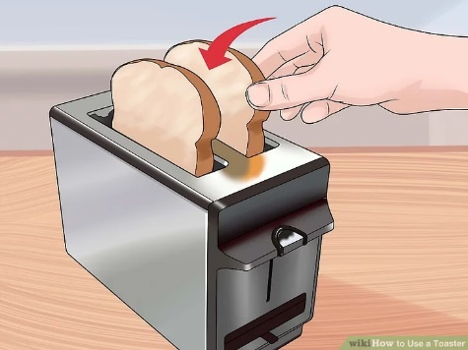

**Set the toasting level.** Use the adjustment knob on the front of the appliance to choose how dark you want the toast to be. On most toasters, the dial runs from 1 to 5, with 1 being the lightest, and 5 being the darkest. Consider setting the dial somewhere in the middle: 2 or 3. This way, if the toast is not dark enough, you can always toast it again.

**Slide one slice of bread into each toaster slot.** You can also toast just one slice of bread. In this case, choose a slot, and slide it in. The direction you orient the slice in the toaster doesn't matter, but most people like to insert it bottom-first. You can toast many things other than bread but stick to toasting bread slices until you are more comfortable using the appliance. Do not jam items into the slots this will possibly cause the toaster to not work correctly and burn the items or even catch fire.

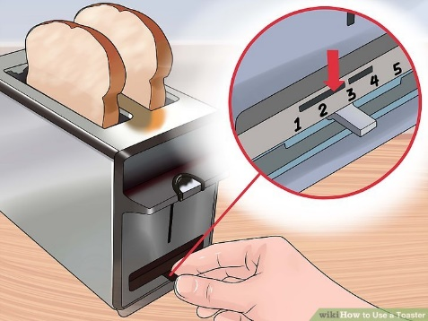

**Lower the lever to start the toasting cycle.** Wait for the food to toast. Keep your nose peeled to smell for burning! The toasting process should not take longer than a minute or two, depending on how dark you want the toast.

* Even though the toaster is timed and will pop the bread out on its own, **you should never leave it unattended.** If the bread starts to burn, you'll have to pop it manually.
* To pop the toaster manually, hold the top corner of the toaster down while you lift the lever up. You should only do this if things start to burn. Note some toasters have a cancel button you can use or turn the power off at the wall socket.

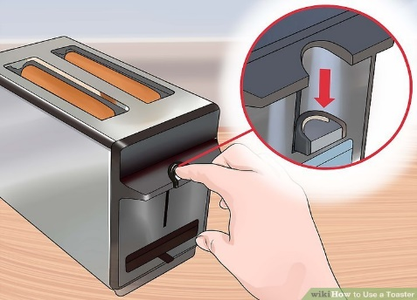

**Remove the food.** When the lever pops back up, it means that the toasting cycle is done. The toaster may "ding." Take the toast out using your fingers or a set of wooden tongs. Then, put your favourite spread onto your toast before consuming!

* Never use anything metal to take the toast out, or you may electrocute yourself.

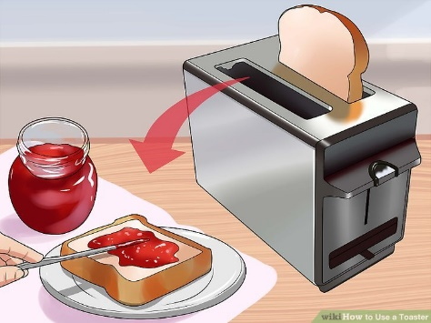

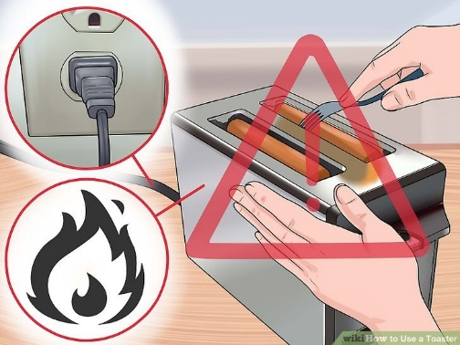

**Practice toaster safety.** Do not, under any circumstances, put a metal implement into the toaster while it is plugged in. Likewise, do not reach your hand into the toasting slots while the appliance is hot. The toaster works by firing metal filaments up to high heat using dangerous electrical currents. If you use your hand, you may burn yourself. If you put a fork into the slots, then you run the risk of electrocuting yourself. If the toast gets stuck in the slots:

* Try depressing the lever for a moment, then popping it up manually—quickly, with force—to fling the toast out the top of the toaster.
* Unplug the toaster before you try to remove food that is stuck. Then, use wooden tongs to remove the item. Wooden tongs will not conduct electricity!

**Remember never leave the toaster unattended when using and report any faulty toasters to the maintenance help desk.**